Contents
References 4
1. Introduction 5
2. Analysis 5
2.1. Client Needs 5
2.2. The Game of Chess 6
2.2.1. History of Chess 6
2.2.2. Game Board 6
2.2.3. Pieces 6
2.2.4. Game Play 7
2.3. Objectives and Requirements 8
2.3.1. Objectives 8
2.3.2. Requirements 8
2.4. Prototyping & Research 10
2.4.1. Blind Prototype 10
2.4.2. Chess Engine Research 11
2.4.3. Object Oriented Coding Research 12
2.4.4. Graphics & User Interface Research 12
2.4.5. Chess Bot Research 13
2.4.6. FEN Strings 15
2.4.7. Initial Program Structure 16
3. Documented Design 17
3.1. High Level Overview 17
3.2. Piece Module 19
3.2.1. Piece Representation 19
3.2.2. Piece Bit Masks 19
3.2.3. Helper Functions 19
3.3. Board Class 20
3.3.1. Board Field 21
3.3.2. Kings Field 21
3.3.3. CastlingRights FIeld 21
3.3.4. Array Index Fields 21
3.3.5. LegalMoves Field 21
3.3.6. Stack Fields 21
3.3.7. MoveGenerator & MoveSelector Fields 22
3.3.8. PlayingComputer Field 22
3.3.9. Checkmate Field 22
3.3.10. Board Constructor Method 22
3.3.11. GenerateBoardFromFENString Function 22
3.3.12. GenerateFENStringFromBoard Function 23
3.3.13. MakeMove Function 24
3.3.14. Unmake Move Function 24
3.3.15. GenerateValidMoves Function 24
3.3.16. GenerateAllLegalMoves Function 25
3.3.17. MakeComputerMove Function 25
3.3.18. GenerateComputerMove Function 25
3.3.19. ColourToPlay Function 25
3.3.20. GetBoard Function 25
3.3.21. Helper Functions 25
3.4. MoveGenerator Class 26
3.4.1. Move Constants 26
3.4.2. Friendly/Opposition Colours and ListIndex Fields 27
3.4.3. Other Fields 27
3.4.4. Constructor & Initialisation Methods 27
3.4.5. GenerateLegalMoves Function 27
3.4.6. GenerateAllLegalMoves Function 28
3.4.7. FilterLegalMoves Function 28
3.4.8. DetectPinsAndCheck Function 29
3.4.9. GenerateSlidingMoves Function 30
3.4.10. GenerateKingMoves Function 31
3.4.11. GenerateKnightMoves Function 31
3.4.12. GeneratePawnMoves Function 32
3.5. Move Class 32
3.5.1. Move Information 32
3.5.2. Move Flags 33
3.5.3. Bitmasks 33
3.5.4. Data and Flag Accessing 33
3.5.5. Class Constructor 33
3.5.6. AddFlag and RemoveFlag Functions 33
3.5.7. MoveName Function 34
3.6. CheckState Structure 34
3.6.1. Checks and Pins Tracking 34
3.6.2. Number of Checks/Pins 34
3.6.3. Constructor Method 34
3.7. MoveSelector Class 34
3.7.1. MiniMaxMoveSearch Function 35
3.7.2. OrderMoves Function 37
3.7.3. MergeSort Subroutine 37
3.7.4. Merge Subroutine 38
3.8. Board Evaluator Class 38
3.8.1. Piece Values 38
3.8.2. Piece-Square Tables 38
3.8.3. Evaluate Function 39
3.8.4. EvaluateMaterial Function 39
3.9. Chess Form Class 40
3.9.1. Current Move Tracking 40
3.9.2. Piece Images 40
3.9.3. Other Fields 40
3.9.4. Class Constructor 41
3.9.5. Mouse Click Detection 41
3.9.6. GeneratePieceMoves Subroutine 42
3.9.7. FormResize Subroutine 42
3.9.8. FormPaint Subroutine 42
3.9.9. Save Game Subroutine 42
3.9.10. Hint Subroutine 42
3.9.11. Exit Subroutine 43
3.10. Main Menu Form Class 43
3.10.1. Class Fields 43
3.10.2. Class Methods 43
4. Technical Solution 44
4.1. High Level Skills Demonstrated 44
4.2. Program.cs 47
4.3. MainMenu.cs 47
4.4. ChessForm.cs 52
4.5. Board.cs 62
4.6. Piece.cs 78
4.7. MoveGenerator.cs 80
4.8. Move.cs 102
4.9. Checkstate.cs 105
4.10. MoveSelector.cs 106
4.11. BoardEvaluator.cs 112
4.12. ChessTests.cs 118
5. Testing 127
5.1. Development Testing 127
5.2. Test Cases 129
5.3. Test Results 142
6. Evaluation 158
6.1. Reflections & Achievements 158
6.1.1. Achievement of Objectives 158
6.1.2. Achievement of Requirements 158
6.1.3. Learning 158
6.2. Feedback 159
6.3. Future Improvements 159

References
- Chess Wikipedia Page dedicated to chess programming: https://www.chessprogramming.org/Board_Representation#Hybrid_Solutions
- YouTube video “Coding Adventure: Chess”, uploaded by user Sebastian Lague on 12th Feb 2021: https://www.youtube.com/watch?v=U4ogK0MIzqk
- Sebastian Lague Chess AI:
https://github.com/SebLague/Chess-Coding-Adventure/tree/Chess-V1-Unity
- YouTube video “Tree Search”, uploaded by user Sebastian Lague on 20th Apr 2018: https://www.youtube.com/watch?v=l-hh51ncgDI
- Article on website Chess.com explaining what a FEN string is:
https://www.chess.com/terms/fen-chess
- Test Video 1, Uploaded alongside this document
- Test Video 2, Uploaded alongside this document
- Test Video 3, Uploaded alongside this document
- Test Video 4, Uploaded alongside this document
- Test Video 5, Uploaded alongside this document
- Test Video 6, Uploaded alongside this document
- Test Video 7, Uploaded alongside this document

Introduction
For my project I intend to create a Chess Game for beginner to intermediate players, which will allow either two players to compete against each other or a single player to compete against a Chess Bot. I am developing this for my client Tom Maitland who is a friend and fellow student at Hills Road.

Analysis

Client Needs
Tom and I have been friends for several years, we met through school and bonded over our joint interest in playing Video Games and were both enrolled in the college Board Game Club at the same time. I have chosen Tom to be the client for my project as he has lots of hobbies and passions which will likely result in an interesting project. The following transcript is of a conversation I had with Tom to establish a problem he has, that I could solve for him:
Me: “Hi Tom, how are you doing today?”
Tom: “Hi, I’m doing well thanks.”
Me: “I’m glad to hear it. I was hoping if we would be able to discuss some of your interests and hobbies, would that be alright with you?”
Tom: “Yeah of course that’s fine.”
Me: “Okay, great! What would you say your biggest passion are?”
Tom: “It’s difficult to say what my overall biggest hobby or passion is because I have so many, but some of my biggest ones would have to be Films, Games and Music.”
Me: “Ah okay that sounds very interesting, what type of games do you like to play most?”
Tom: “I would say some of my favourite game’s would have to be Minecraft, Chess, Apex Legends, and Magic: The Gathering.”
Me: “Would you say that you prefer to play Video Games like Minecraft, or Board/Card games like Chess?”
Tom: “Overall I would have to say I prefer Video Games, as they are more engaging than most Board Games, but that being said I prefer Chess over the majority of Video Games because of how difficult it can be at times.”
Me: “Ah that’s interesting. How long have you been playing Chess for, and what do you think your favourite aspect is?”
Tom: “I’ve played for two to three years, ever since it had a burst of popularity. The part I enjoy the most is the strategy and logic needed to play.”
Me: “Would you say that you are good at Chess?”
Tom: “I think I’m getting better but I still have a lot to learn.”
Me: “Do you ever have difficulty finding people to play or practice Chess with?”
Tom: “Yeah it can be quite frustrating. Hardly any of my friends or family enjoy playing.”
Me: “Have you ever considered playing online?”
Tom: “Yes, I use Chess.com but it doesn’t work when I’m out as I don’t have Wi-Fi.”
Me: “That sounds quite frustrating. Have you ever played against an AI Chess Bot?”
Tom: “No not really. I always assumed that they weren’t very good.”
Me: “If I were to make a Chess Bot that was good enough, would this interest you?”
Tom: “Yes definitely, but would it be difficult to use?”
Me: “I could create an easy-to-use GUI for you to interact with the bot?”
Tom: “That would be really great.”
Me: “Okay brilliant. Thanks for speaking to me its been a massive help!”
Tom: “No worries, I’m looking forward to seeing the end result!”
My conversation with Tom helped me to get a better understanding of his passions and interests, which enabled me to identify a problem he had and to propose a solution which solved it for him. In summary, I will develop a Chess Engine where Tom can play against the computer. The computer will have to be sufficiently challenging to him. It is important that this Engine has an intuitive and nice-looking User Interface so that Tom is able to use it easily and something based in a command terminal would be too difficult. A potential area to expand this project would be adding an Online multi-player feature allowing Tom to challenge against other human players, however as said by him, this is not a necessity as he is able to play against other people using other existing applications, and the main problem is playing whilst offline.

The Game of Chess

History of Chess
Chess is one of the oldest games in the world and can be traced back over 1,500 years to its earliest known form in India, called Chaturanga. Chaturanga spread all over the world evolving over time until 1860 when it reached its current form. Whilst there have been slight changes and tweaks Chess has remained largely unchanged for the last 200 years. Due to its simple nature, and deep roots in society, Chess is one of the most popular board games in the world and is known by almost everyone.

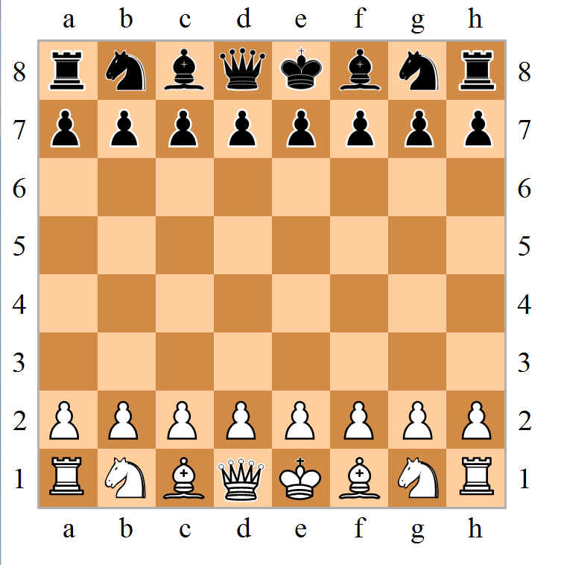
Game Board
A game of chess takes place on an 8x8 Board split up into horizontal ‘ranks’ and vertical ‘files’ arranged as shown in Figure 1. The Chess board labels these ranks and files with unique identifiers based on their position on the chess board. This creates a coordinate system and gives every square on the board a unique position name. For example, the bottom left corner of the board would be ‘a1’ and the top right corner of the board would ‘h8’. Chess is played between two people, and each are given a set of 16 Pieces that are either white or black.
Figure 1: Chess Board and Pieces

Pieces
Within each players set of pieces there are six different types all with different movement patterns and quantities, as detailed in the following sections.

Pawn
Pawns are the weakest piece on the chess board yet have one of the most peculiar movement patterns. Each turn a pawn can move forward one square, except for their first move, when they may move two squares forward. A pawn can capture enemy pieces, that are on the very next diagonal square, in the forward direction. A pawn may not capture a piece that is directly in front of it, nor may it move onto that square. There are a few other special moves with a pawn these being: Pawn Promotion where a Pawn can be changed to any other piece type (excluding king) when it reaches the opposite side of the board from where it started; and En Passant which allows the capture of a pawn, by an enemy pawn on the same rank and an adjacent file, if the pawn has just made an initial two square advance. Each player has eight pawns, and they start the game placed on the second rank (relative to the player), see Figure 1.

Knight
Each player is given two knights that start the game placed on the first rank relative to the player, on the ‘b’ and ‘g’ files, see Figure 1. The Knight has one of the most unique movement patterns in that it may move in the shape of an ‘L’ in any direction it wishes i.e. two squares up or down the file and one square left or right on the rank or alternatively two squares left or right on the rank and one square forwards or backwards on the file. A knight also has the unique ability of being able to ‘jump over’ other pieces to get to its destination.

Bishop
Each player is given two bishops that start the game placed in the ‘c’ and ‘f’ files on the first rank relative to the player, see Figure 1. The Bishop may move diagonally in any direction, for as many squares as it likes, if its path is not blocked by another piece.

Rook
Each player is given two rooks that are placed on the ‘a’ and ‘h’ files on the first rank relative to the player, see Figure 1. The Rook may traverse across the board in either a horizontal or vertical direction, assuming its path is not blocked by another piece. On top of this, the rook also has an ability called Castling which also involves the King piece. If neither the King nor Rook have moved during the game, and there are no pieces in between the King and Rook, the king may move two squares towards the rook, whilst the rook moves to the square the king passed over, moving it to the other side of the king from where it started.

Queen
Each player is given one queen that starts the game placed on the ‘d’ file on the first rank relative to the player, see Figure 1. The Queen is the most powerful piece type as it can move in a straight line in any direction including diagonally if its path is not blocked.

King
Each player is given one king piece that starts the game placed on the ‘e’ file of the first rank relative to the player, see Figure 1. The King is the most important piece on the board yet has one of the weakest movement patterns. The King may move one square in any direction including diagonally and can Castle with the rook as detailed in section 2.2.3.4. If a player’s King piece is captured, then they will lose the game.

Game Play
The basic premise of Chess, is for two players to take alternating turns to move a piece on the board. Players may capture opposition pieces by moving one of their own pieces to the same square as an opposing player’s piece and removing it from the board. The aim of Chess is to put your enemy’s king into a state of ‘checkmate’ which is when a piece threatens the enemy King and there are no moves that can be made to prevent you capturing it.

Objectives and Requirements

Objectives
The objectives of the project are as follows
- To design a Chess Game that helps a Beginner/Intermediate player to develop
- To enable a player to play against the computer or a friend
- To ensure the User Interface is easy to navigate

Requirements
For the project to be a success it is important to establish the requirements that it must satisfy. The requirements for the Chess Game are detailed below. Note: any requirements marked with an asterisk (*) are optional extension tasks. Text in Italics represents a heading or information rather than a requirement.
- Main Menu
  - A New Game Button shall be provided which opens the game selection screen.
  - An Exit Button shall be provided that allows the user to exit application.
  - Load and Save Buttons
    - The user shall be able to save a game of chess to their device, ensuring that every aspect of the game is saved.
    - The user shall be able to continue a game that was previously saved to the user’s device where they left off.
  - The games menu’s shall be well designed and easy to navigate.
- Game Selection Menu
  - The user shall be able to play against a Chess Bot.
  - The user shall be able to select the ‘Difficulty Level’ of the Chess Bot.
  - Two users shall be able to play against each other on the same device.
  - (*) The user should be able to choose a time limit (per player) for the game.
  - A Start button shall be provided that opens the Game Display and starts the game.
  - The user shall be able to choose to play as black or white.
- Game Display
  - An 8x8 Grid of squares alternating between two colours shall be displayed.
  - All pieces shall be located in their correct starting positions.
  - Each players pieces shall be a different colour.
  - The board orientation should be flipped, whenever the player’s colour is black, and this orientation should be reverted back to normal, whenever white is to play, in a pass and play game.
  - (*) Each player’s timer (where selected) shall be displayed on their side of the board.
  - (*) The player shall be able to choose a Hint indicating the best possible move they can make.
- Game Mechanics
  - Moving Pieces
    - Left Clicking a piece should select the piece to be moved.
    - When a piece is selected, valid move squares shall be highlighted.
    - Left Clicking a valid move square shall place the piece on the square.
    - When a piece is selected, Left Clicking any square other than a valid move square shall cause the piece to be deselected.
  - Pawn Movement
    - Pawns shall be able to move one square in the forward direction, unless blocked by another piece.
    - Pawns shall be able to move two squares forwards, if they have not yet moved from their starting position.
    - Pawns shall capture enemy pieces by moving diagonally forward on to their square.
    - If an enemy pawn moves forward two squares, landing on a square where it is directly adjacent to one of the player’s pawns, the player’s pawns shall be able to capture this pawn (this turn only) by moving diagonally behind it.
    - If a pawn reaches the final rank on the opposite side of the board from its starting position (Rank 8 for White, Rank 1 for Black), then it shall be promoted to being a Queen.
  - Knight Movement
    - The Knight shall be able to move two squares forward/backward and 1 square left/right or alternatively two squares left/right and 1 square forward/backward.
    - The Knight shall be able to ‘jump over’ other pieces.
    - The Knight shall capture enemy pieces by moving on to their square.
  - Bishop Movement
    - The bishop shall be able to move diagonally in any direction, until its path is blocked by another piece.
    - The bishop shall capture enemy pieces by moving on to their square.
  - Rook Movement
    - The rook shall be able to move in straight lines both vertically and horizontally, until its path is blocked by another piece.
    - The rook shall capture enemy pieces by moving on to their square.
  - Queen Movement
    - The queen shall be able to move in a straight line in any direction, until its path is blocked by another piece.
    - The queen shall capture enemy pieces by moving on to their square.
  - King Movement
    - The King shall be able to move to any of its adjacent squares if they are not occupied by another piece of the same colour.
    - The King may ‘castle’ with either of the rooks, by moving two squares towards the rook, and moving the corresponding rook to the square the king bypassed i.e. the rook moves to the other side of the King.
    - The King shall only be able to castle if the following conditions are met:
      - The King has not yet moved.
      - The Rook that is castling has not yet moved.
      - The path between the king and the castling rook is not blocked.
      - The King is not in check.
    - The King shall capture enemy pieces by moving on to their square.
  - Check
    - The King is in ‘check’ when an enemy piece can capture it on their next turn.
    - A player shall not be able to make a move that will put their own King in check.
    - If a player’s King is in check, they must make a move that will take the King out of the check. This can be done by:
      - Moving the King out of check.
      - Blocking the attack on the King with another piece.
      - Capturing the enemy piece threatening the King.
  - Checkmate
    - If a player’s King is in check, but there are no legal moves that remove the threat, then this is Checkmate, and this player loses the game.
  - Stalemate
    - If a player is not in Check, but there are no legal moves for this player to make, then the game is stalemate, and the result is a draw.
  - (*) Implement loss by timeout.
- Chess Bot:
  - The Chess Bot shall be able to evaluate a board position.
  - The Chess Bot shall choose the best possible move in a reasonable time.
  - The Chess Bot shall select moves that represent the selected ‘Difficulty Level’.

Prototyping & Research

Blind Prototype
In order to better understand how to make this project, a prototype chess game was developed in C# using the WinForms extension. A ‘blind’ prototype was created prior to any research, in order to independently identify any problems in approach, without relying on external sources to solve all my problems. The prototype focused on the main elements of game play to ensure that the basic structure of the game was developed in the right way. More advanced features such as the Chess Bot, pawn promotion, were not prototyped.
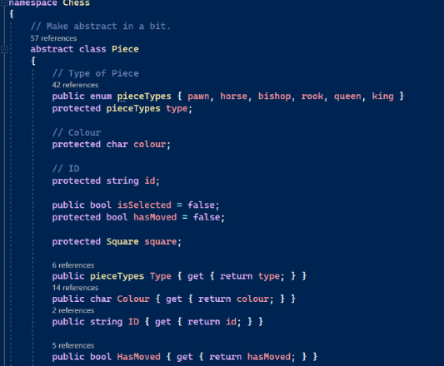
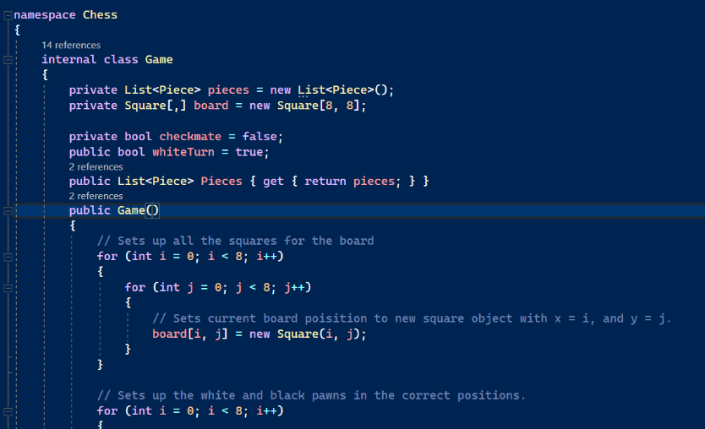
The prototype chess game relied heavily on an Object Oriented Programming (OOP) approach. Classes were created for most of the objects in the game (e.g. Board, Square, Pieces etc), see Figure 2, which meant there was no room for confusion when receiving data, as all the data was encapsulated inside the corresponding class. Furthermore, an inheritance-based system was used for all the pieces, creating a class for each type of piece that derived from a base piece class, that had attributes and methods required by all pieces e.g. x-y coordinates.
Figure 2: Blind Prototype – Game and Piece Class

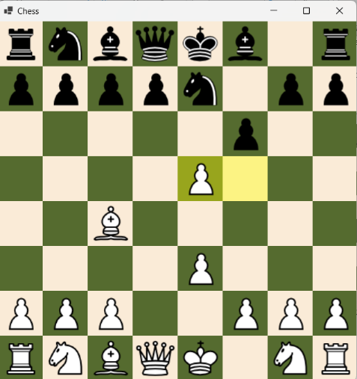
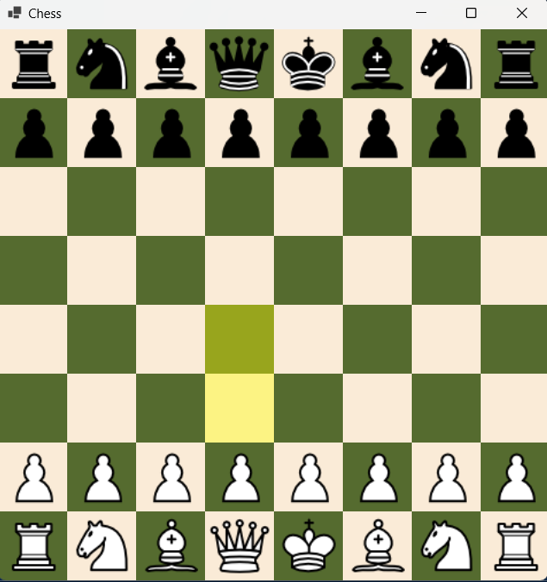
The prototype game was successfully completed as can be seen in Figure 3. All basic game play features were successfully implemented.
Figure 3: ‘Blind’ Prototype Screen Grabs
The use of a Game class to manage the state of the game (e.g. player turn, checkmate etc.) proved to be effective, however, the extensive use of OOP over complicated the game code as there was a lot of code repetition, specifically for generating moves. A procedural programming approach would have minimised this problem through the use of general purpose functions. Furthermore, by using so many different classes, there were some issues when trying to alter fields inside a class, as there were issues with objects being passed by value and by reference.
Another approach that proved overly complex, was the use of an 8x8 array of Square objects, to represent the board. This approach resulted in the generation of moves requiring the use of a tuple (an ordered list) of integers, and complex mathematics for coordinate geometry.
Having completed the blind prototype research was performed to understand how to improve the design of the final Chess Game.

Chess Engine Research
Research into the coding of Chess Engines was undertaken to identify ways of optimising the code. Wikipedia has a Chess Programming page [Ref 1], which was extremely useful and had a lot of information on all the aspects of creating a chess engine. Additionally, a popular programming YouTuber, Sebastian Lague covers a potential approach to creating a Chess Engine, see Ref 2.
When creating a chess engine, the first decision that must be made is whether to take a Piece-Centric or Square-Centric approach, which are basically opposites of one another and consequently, drive the entire design. In a piece-centric approach, the program keeps lists, arrays or sets of all the pieces still on the board – with their associated information (e.g. what square they occupy). Whereas a square-centric representation keeps track of all the squares on the board and if a piece is currently occupying them. However, several programmers have taken a hybrid approach to the problem of representing a chess board, implementing features from both representations.
To aid understanding of the different approaches examples of Piece-Centric representations were researched with a good example being the chess engine made by Sebastian Lague [Ref 3]. It can be seen in the code that Lague used a Piece centric approach for his project, as inside the Board Class definition there are several lists for each type of piece.
The video also helped consider different approaches to creating the base game of chess. Whilst my approach was heavily object orientated Sebastian’s approach made minimal use of classes, and instead relied more heavily on numerical representation of pieces using a clever method that represented the type of piece with numbers 1-6, and the colour of the piece with either the number 8 or 16, see Figure 4. This meant that when represented in binary, the first two bits of the number represent the colour, and the last three bits represent the piece type. This allows for easy use of bit mask to establish the piece being represented.
00 000
Colour Piece Type
Figure 4: Piece Representation
A square-centric approach was chosen for this project as this allowed an integer array of length 64 to be used in place of an 8x8 array of Square objects, which proved problematic in the ‘Blind’ prototype. This approach significantly simplifies the code, especially in relation to the generation of moves, as a simple integer value can be added to move in any direction, rather than a tuple of integers, and complex mathematics for coordinate geometry. Additionally, the use of a binary number to represent piece type has also been adopted.

Object Oriented Coding Research
The next decision to be made for the project was whether to use an Object Oriented or procedural programming style. Sebastian Lague’s codebase [Ref 3] was again used to explore this. Lague used an Object-Orientated approach creating several classes for different objects in the game such as a Piece class, Board class, Player class and many more. However, a significant difference between his code and the ‘Blind’ prototype was the classes that Lague used. Lague only created object classes when strictly necessary, whereas in hindsight the ‘Blind’ prototype had lots of objects that were not strictly required such as the Square class, and the numerous classes for each type of piece. This made the ‘Blind’ prototype overly complicated.
The use of object oriented programming brings several advantages over procedural programming such as code readability and encapsulation which both reduce the chances of errors in code. Therefore, for the Chess Game the same OOP approach will be adopted as for the ‘Blind’ prototype, however, the number of classes used will be significantly reduced, and an inheritance-based Piece representation system will not be used. Similarly, C# will be used as the programming language as this forces the use of OOP techniques.

Graphics & User Interface Research
Another aspect of the project that is important to research is how the Chess Board and pieces will be rendered, as well as any User-Interface components. There are several software development tools that could be used, all with their different advantages and disadvantages.
The ‘Blind’ prototype used WinForms in C# Visual Studio, which is designed for creating windows applications. Whilst the board and pieces rendered well, there were several issues, for example, when pieces were selected or moved, everything had to be re-rendered on the screen, resulting in a blip in the graphics which did not look good. Furthermore, the way that WinForms was built results in lots of arithmetic having to be performed in order to render the chess pieces in the correct place on the screen.
An alternative approach that could be taken would be to use a Game Engine for the rendering side of the project and use standard C# for the logic and reasoning of the engine. There are lots of popular Game Engines, the most popular of these being Unreal Engine, Unity, and Godot. One advantage of using a Game Engine to create the chess engine, is that the end result would likely look much more aesthetically pleasing, since Game Engines have lots of built-in assets to use, and other helpful GUI features, as opposed to WinForms where the standard assets are more basic and do not look as good. Of the available Game Engines, Unity Engine is the only one that uses the C# programming language, making it a good candidate for this project as C# is my strongest language. On top of this, I have had previous experience using Unity so there shouldn’t be much of a learning curve, allowing me to focus on creating the Chess Engine.
Ultimately, WinForms in C# Visual Studio was chosen to develop the Chess Game, as it is a much simpler framework to use which will allow the focus of the project to be on developing the chess engine rather than learning how to use a complex game engine. Furthermore, since WinForms is more low-level than Unity Game Engine, it is likely that it will run faster than Unity which is important for a chess engine that is heavily reliant on speed.

Chess Bot Research
A YouTube series by a popular programming YouTuber, Sebastian Lague covers a potential approach to creating a Chess Bot [see Ref 4]. This video gave a deep insight into how a Chess Bot can work, making it easier to develop an approach for this project. Sebastian Lague used a material-based approach, giving each piece its own numerical value, that is added/subtracted from an overall score whenever a piece is captured. This score is altered by various factors such as the position on the board of pieces that favour them being in certain locations.
The Chess Bot navigates a tree of every possible combination of moves, with the top node of the tree representing the value of the best current move that could be made and each level of nodes below representing the value of subsequent moves that could be made by each player. The Chess Bot picks the branch with the best outcome for itself. The process of searching every single possible combination is a factor of the number of pieces on the board and the number of possible moves for each piece and can consequently, take a very long time to complete.
To reduce the processing time, a technique is required to reduce the number of branches of the tree which have to be assessed. Lague’s YouTube series outlines an approach known as Alpha-Beta Pruning. This method prunes branches of the tree, for which the moves being considered would never be selected as there are other branches – that have already been searched – that are more successful for other player and consequently, would not be selected by that player. Pruning these branches saves time as the Chess Bot does not have to fully explore the branch.
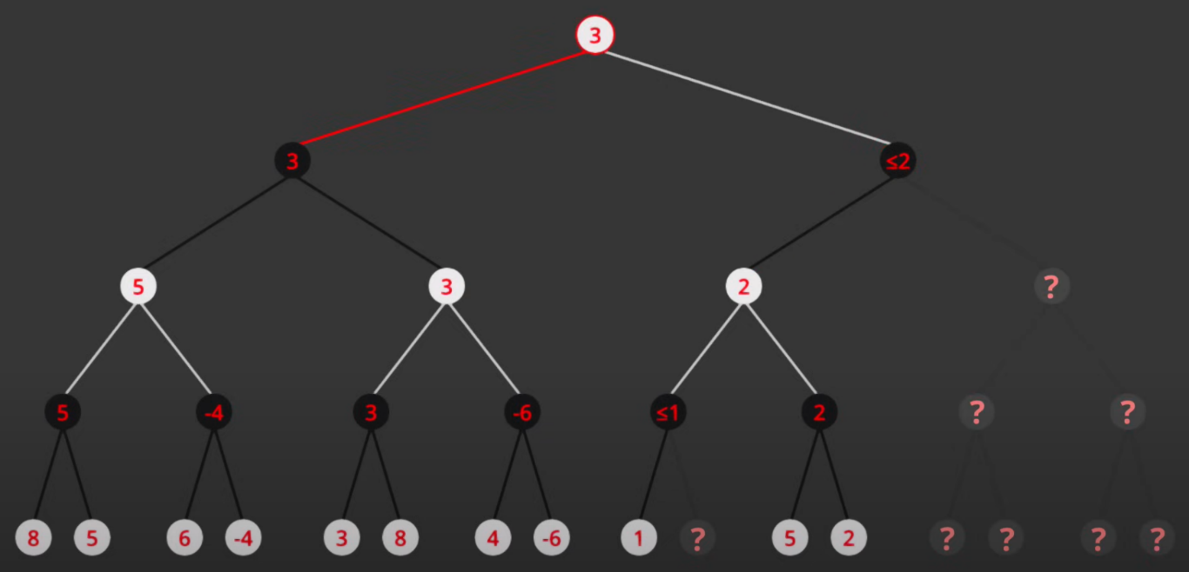
Figure 5 shows a screen grab from Lague’s video. The bottom level of the tree represents a static evaluation of the board with more negative numbers favouring black and more positive numbers favouring white. The tree is navigated from left to right, evaluating all the way to the bottom of the tree before moving right. In this example the tree has been fully navigated and two prunes can be seen. The first prune occurred on the lowest level of black nodes where there is a value of “≤1”. The rest of this branch was pruned as white would never choose an option that would take it down this path as it already has a more favourable option (value of 3) available by going down the left hand half of the tree. The second prune occurred at the highest level of black nodes where there is a value of “≤2”. Again the rest of this branch was pruned as white would never chose the right hand half of the tree once it understands that black would chose a move with a value ≤2 which is worse for white than the left hand half of the tree which has a value of 3.
Figure 5: Screen Grab from Ref 4 Showing the Process of Alpha-Beta Pruning
Lague’s Chess Engine [Ref 3] was downloaded and played a number of time, to establish which aspects worked well. It was clear that the Chess Bot, was very advanced and managed to beat the human player with ease by setting up traps and exploited mistakes to the fullest potential. It had a good grasp on attacking chess techniques such as pinning pieces, fork attacks, and counter threats. Due to the engine’s skill level, it was not possible to fully test the defensive capabilities of the algorithm, but Lague included a feature that put two Chess Bots head to head against one another and the defence of the algorithm seemed to be a capable. After seeing the capability of Lague’s Chess Bot it is clear that a less capable solution would be required to allow a beginner or intermediate player to develop their game.
Having undertaken this research, the following pseudo code algorithm represents the basic operation of the Move Selection function
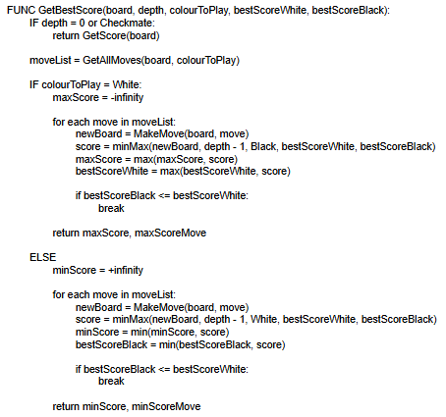

FEN Strings
In researching the Chess Game, extensive references to FEN string were seen and recognised as being a useful way to represent the board. A FEN String is a standardised form of representing a chess position, and all the associated data within it. There are several fields within the FEN string each representing different aspects of the chess board. The first field represents the layout of the board in the current position, starting from the top left corner of the chess board the characters within the string represent different pieces. Upper case characters represent white pieces, whereas lowercase characters represent black pieces. Each piece type is represented by the first letter of their name, except the knight, (‘p’ – pawn, ‘n’ – knight, ‘b’ – bishop, ‘r’ – rook, ‘q’ – queen, ‘k’ – king). Where there is an empty square on the chess board, a number will be placed in the string that represents the number of consecutive empty squares. Once the end of the rank is reached a ‘/’ character is used to show that the rank below is containing the following pieces.
The second field of the FEN string dictates the current colour to play. White to play is represented by a ‘w’ character, and a ‘b’ character shows that black is the colour to play.
The third field of the FEN string represents each colour’s king’s castling rights. Once again, the rights of the white king are represented by uppercase characters, and the rights of the black king by lowercase characters. A ‘K’ character is used to show that the given king can castle to its kingside, and a ‘Q’ character is used to show that the given king can castle to its queenside. So, for example, a position where both kings can castle to both sides, would be represented by the field “KQkq”. If neither kings can castle to either side of the board, a ‘-‘ character is used to show that the field is empty.
The next field of the FEN string represents how many moves both players have made since the last pawn advance or piece capture, also known as the number of half moves. This field is useful to enforce the 50-move draw rule. When this counter reaches 100 (allowing each player to make 50 moves), the game ends in a draw. [Ref 5]
The final field of the FEN string represents the number of fully completed moves that have been made since the start of the game. This number is incremented by 1 every time black completes a turn [Ref 5].

Initial Program Structure
Having completed all the required research and undertaken prototyping, the structure of the program was designed. Whilst this evolved in some areas during the development process, the overall structure and intent remains the same as shown in the following figure.
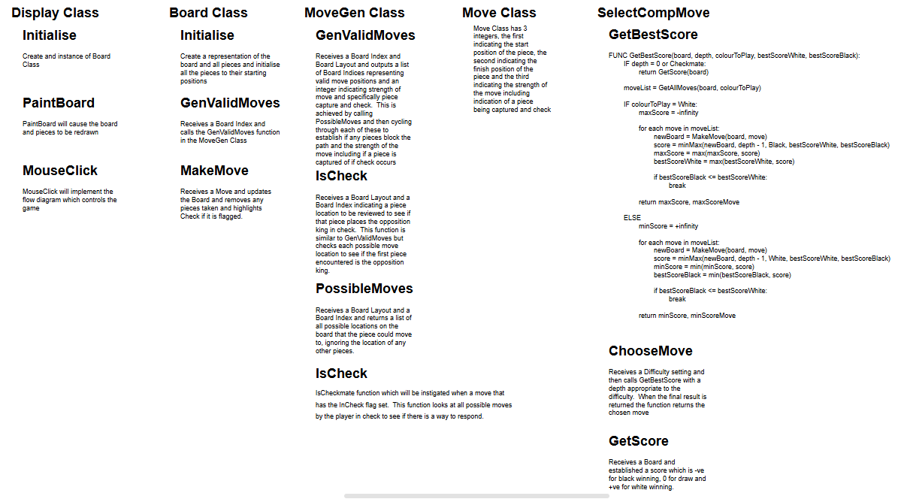

Documented Design

High Level Overview
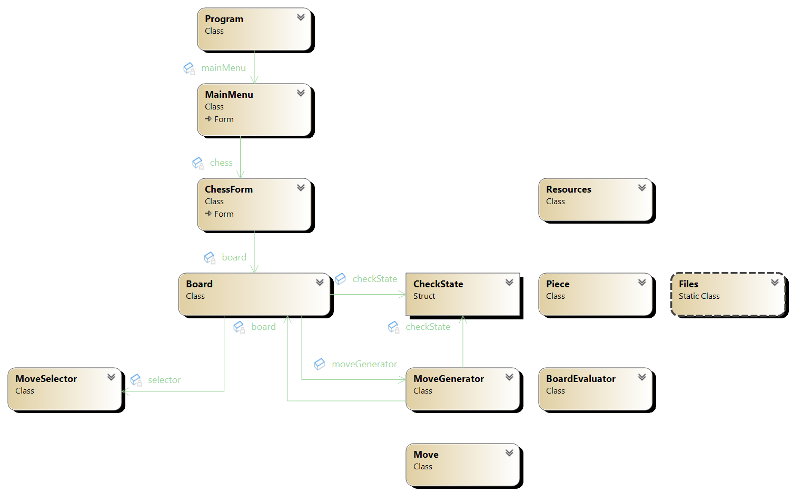
Within this program there are lots of modules and objects working together to display the chess board, dictate the logic and flow of the game, generate moves and more. There are nine main modules/classes within my program, these being: MainMenu, ChessForm, Board, Piece, Move, MoveGenerator, CheckState, MoveSelector, and BoardEvaluator. There are other smaller modules that perform very specific tasks but are not entirely important to the game flow. The relationship between the main modules/classes is explained in depth in the following sections and shown diagrammatically in Figure 6. Note, the term Module is used to describe a class that consists purely of static methods and is never instantiated.
Figure 6: Chess Game Class Diagram
The first class that the User will encounter is the MainMenu Form, which as the name suggests, is a Windows Form that displays the Main Menu of the game, and allows the user to load a saved game, or start a new game with customisable settings. Whether the user decides to load a game or start a new one, the settings for this game will be passed as arguments to a new ChessForm that is instantiated and set as the main form for the program.
Within the ChessForm class is where the logic for the flow of the chess game will occur, and where the UI for the Chess is created and displayed to the form. This form will detect when players select (click) pieces and will call functions from other classes, to discern the possible moves of said pieces. Within this class, an instance of the Board class is created.
The Board class is where the board and piece representation is stored, and where other important aspects of the game are tracked, such as the colour to play, check/checkmate status, legal moves etc. This class contains lots of important functions such as the Make and Unmake move functions which is crucial to the flow of the game. The actual chess board is represented as a one-dimensional 64 long array of integers, each integer within the array represents a square on the board and the piece that resides upon it. The definition of the piece represented by each integer-value can be found within the Piece Module, alongside other helper functions for different pieces. Furthermore, within the Board class there are also instances of the MoveGenerator and MoveSelector classes which each have their own respective purposes.
The MoveGenerator class is used to generate lists of legal moves on the board, whether this be for a particular piece, or for all the pieces on the board. When creating lists of moves, all the information about a move is stored in an instance of a Move object. The Move class stores the starting and ending squares of the move, the moving piece, any pieces captured, and any ‘special’ information about the move (e.g. promotion, check, etc.). The MoveGenerator class is also responsible for detecting pins and checks present on the chess board, which will limit the mobility of a lot of pieces within the board. When creating these lists of checks and pins, an instance of the CheckState object is created that stores all this information in one object, where it can easily be accessed. This CheckState object is used to iterate over pseudo-legal moves and filter out non-legal from the legal ones (this legal list of moves is the one that is returned).
The MoveSelector class, is where the decision-making process of the Chess Bot occurs. Within this decision-making process, the MoveSelector class makes use of the BoardEvaluator class, to get a static evaluation of the current board position, providing a score where smaller values favour black, and greater values favour white.
The Board class acts as an interface between the user and the chess board, events (e.g. piece is clicked) are detected and processed within the ChessForm class, which then passes data to its instance of the board class, which will then use this data and then (depending on the event) will create a move or list of moves, and return this piece of data back to the ChessForm, or it will apply some logic to the chess board, which will then be displayed on the ChessForm. The flow of the game (and the passing of data between these two classes) is in accordance with the following flow chart.
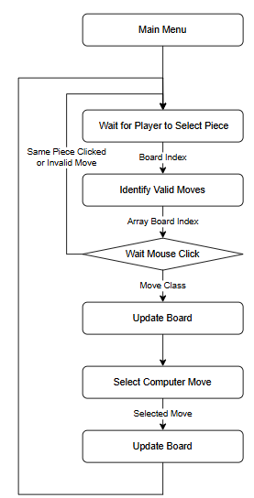
The following sections describe in more detail each of the main modules/classes. Note that any figures containing screen grabs from Visual studio group both method and functions under the heading of methods.

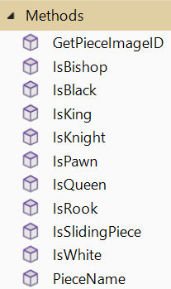
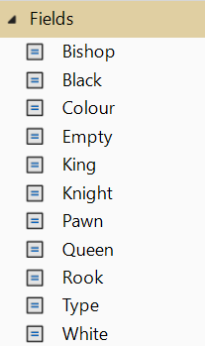
Piece Module
The purpose of this module is to provide a defined integer-value for every piece that can be represented on the board (e.g. white pawn, black pawn). This function also provides “helper” functions that can take pieces as arguments and will discern useful information about the given piece. The fields and methods in the Piece Module are as shown in Figure 7.

Piece Representation
Figure 7: Piece Class Fields & Methods
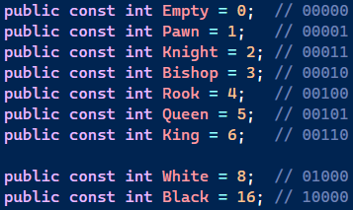
Pieces are represented by an integer-value as shown in Figure 8. The values are chosen to give a 5-Bit Binary number which represents the piece, with the most significant two bits representing the piece’s colour and the least significant three bits representing the type.
Figure 8: Piece Type Constants
Empty squares are represented by a zero (no colour or piece type), meaning that for an array of squares (array of integers), the default value will be that of an empty square. By using these specific values, a particular piece’s integer representation can be calculated by performing a binary OR operation on its type and colour i.e. PieceType OR PieceColour => Piece.

Piece Bit Masks
Another benefit of using the binary representation of pieces described in section 3.2.1, is that bitmasks can be used to discern the colour or type of the piece from its value.
Figure 9 shows constant value bitmasks that can be used to discern a particular piece’s colour or type. A binary AND operation must be performed on a piece, and the bitmask, for the desired result e.g. Piece AND Type Bitmask => PieceType.
Figure 9: Piece Bit Masks

Helper Functions
In this module, there are a lot of useful static functions that can be called from other classes, that return certain information about a given piece.
Screenshot | Name + Description
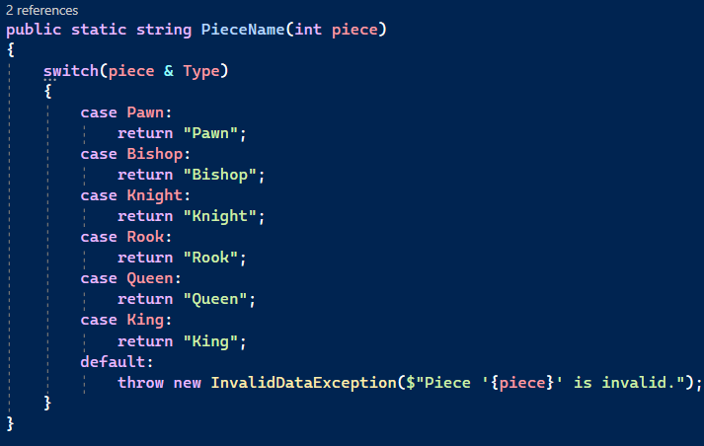 | PieceName(int piece) – This function takes the integer representation of a piece, and returns a string, that is the corresponding piece’s name. If the integer passed as an argument does not match any of the valid piece types, then an error is thrown.
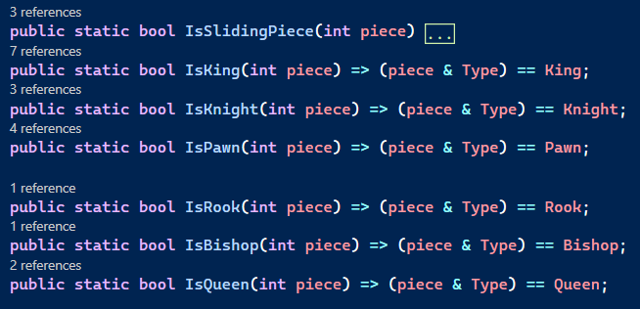 | IsPieceType(int piece) – These set of functions take an integer representation and return a boolean value, if the piece passed as an argument is the corresponding piece to the function (e.g. IsKing returns true, if the given piece is a king). The piece type bitmask is used to determine the given piece’s type.
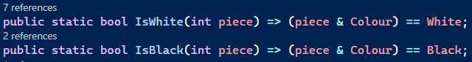 | IsWhite(int piece) – Returns true, if the piece passed as an argument is white.  IsBlack(int piece) – Returns true, if the piece passed as an argument is black.
 | GetPieceImageID(int piece) – This function takes an integer representation of a piece, and return the string name of its corresponding Image ID. This function is used when retrieving image files for the pieces whilst drawing the chess board.
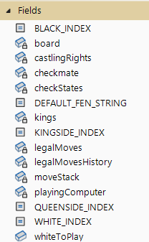
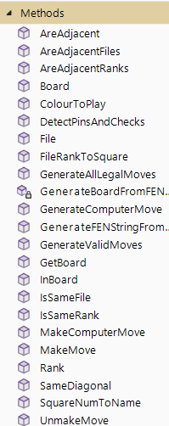

Board Class
The Board Class is where the representation of the chess board is stored and altered, along with all the associated game variables (e.g. colour to play, checkmate status). Changes to the chess board are made and applied to its internal representation of the board, within this class. The fields and methods in the Board Class are as shown in Figure 10.

Figure 10: Board Class Fields & Methods

Board Field
The board is represented by an array of integers, of length 64, with each element within the array representing a specific square on the chess board. On the chess board, the bottom left corner (‘a1’) is represented by index zero in the array, and the top right corner (‘h8’) is represented by index sixty-three. The integer value at each index in the array represents the piece that resides on the corresponding square, as detailed in section 3.2.1. The board representation is kept as a private member and can only be changed/edited from within the board class but can be accessed from outside the class through a public member that returns element of the array at a given index.

Kings Field
To make check-detection easier, the position of both the black and white kings is tracked. The first element in the array represents the position (index within board array) of the white king, and the second element represents the position of the black king.

CastlingRights FIeld
To keep track of each colour king’s right to castle to both the kingside and queenside, a 2x2 array of boolean values is created, the first boolean array tracks the white king’s castling rights, and the second array tracks the black king’s rights. Within each array the first boolean dictates Kingside Castling Right (where true means the king can castle to this side) and the second dictates Queenside Castling Rights.

Array Index Fields
The first two constants are used when accessing 2D arrays that store colour-dependent information depending on the array you look at. White is designated to index 0, and black to index 1. The second two constants are used for the Castling Rights array(s), designating the Kingside rights to index 0, and the queenside rights to index 1. These sets of constants make the code a lot easier to read and give reason to the indexes rather than just a number, which could also be easily written incorrectly, leading to errors.

LegalMoves Field
This list of moves represents all the legal moves available on the board for the current colour to play. As with other member variables, it is kept as private so it cannot be edited outside the Board class but has a public access variable so it’s data can be read (just not altered).

Stack Fields
To keep track of the moves that are being made within the game, a stack of Moves is created, and as moves are made they are pushed to the top of the stack. Since, a stack is a LIFO (Last In First Out) data structure, whenever a move is to be unmade the top move of the stack can be popped, and this will be the most recently made move. For this same reason, a stack that contains move lists is used to store the legal moves on the board at any given point in the game’s move history. When a move is made, the current legal moves are pushed to the top of the stack, and the new legal moves are generated. When a move is unmade, the top element of the legal move history stack is popped, and the current legal moves is set to this move list. Both these stacks are kept as completely private members, since any alteration from outside the class could lead to serious errors when unmaking moves, and there is no need for any other classes to need access to the data within these stacks.

MoveGenerator & MoveSelector Fields
These two variables are instances of the user defined classes, MoveGenerator and MoveSelector. Both these instances are kept as private members since only the Board class should be directly interacting with them, and other classes should be using interfaces within the Board class if they wish to get information from these objects. The MoveGenerator object is used to generate the legal move set for the board, the legal moves for pieces that become selected by the user (selection of pieces does not occur within the board class), and to detect any pins and/or checks on the board. The MoveSelector object is used to discern the best possible move that the computer can make in any given position, after searching all possible combinations of moves to a given depth.

PlayingComputer Field
A boolean value is used to track whether the player is playing against the computer or another human. This variable is private, as it should not be edited outside the board class, however there is a public member that allows (read only) access to this boolean.

Checkmate Field
This boolean value indicates whether a state of checkmate has been reached. As with other variables it is a private member, with a public member for read-only access.

Board Constructor Method
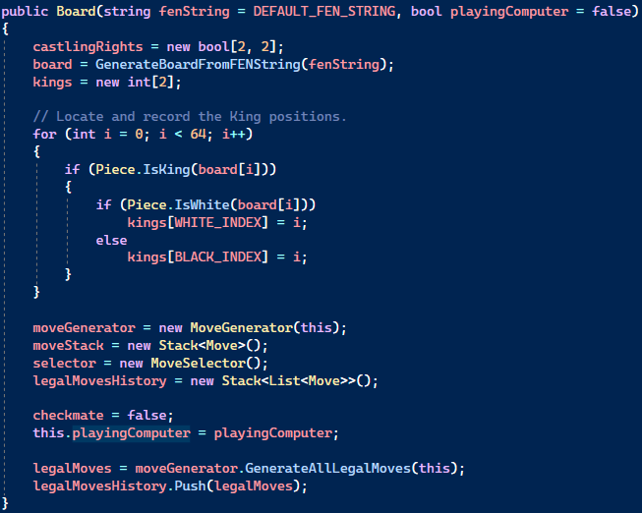
The purpose of the constructor method for the Board class is to initialise all the previously defined variables as can be seen in Figure 11.
Figure 11: Board Constructor Method
This constructor takes two parameters, a FEN string defining piece positions on the board, and a boolean to indicate whether the player is competing against the computer. This method makes use of another function within the Board class that takes a FEN string as a parameter, and populates the board-array, whilst also initialising the white to play, and castling rights variables. After the board has been populated the method locates both kings and records their locations within the king position array. Furthermore, at the end of this method, the legal moves for the current board are generated, assigned to the legal moves variable, and then pushed to the moves history stack.

GenerateBoardFromFENString Function
This function initialises the board array, based on a FEN string passed as an argument, as shown in Figure 12. The function reads the string a character at a time and populates the board depending on the character read (starting from the top left corner of the board). A digit in the string represents a number of empty squares, and a slash (‘/’) character represents a new row on the chess board. Chess pieces are represented by the first letter of their name (except for the knight with is represent by an ‘n’), and their colour is represented by their case, with a lower case character representing white pieces and upper case representing black piece.
The second part of the FEN string represents what colour is to play. If this second field is not provided, then the function defaults the colour to play as white and exits the function.
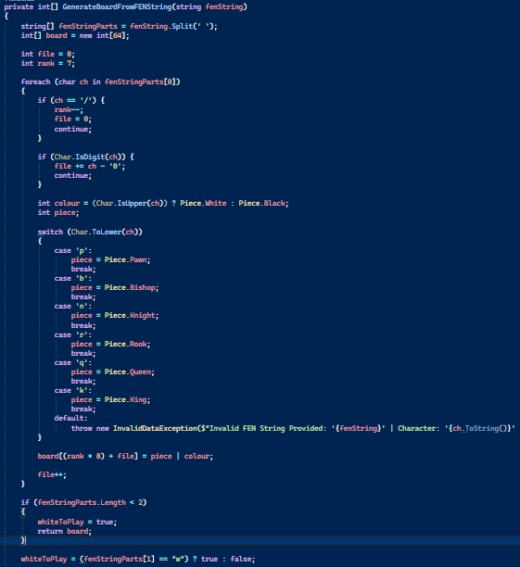
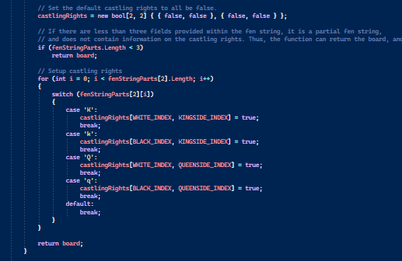
The third field of the FEN String represents the castling rights of both colour kings. A ‘k’ character is used to show that a king can castle kingside, a ‘q’ character is used to show to that a king can castle queenside, and the case of this character represents which king can perform this castle. If this third field is not provided the castling rights are all defaulted to false, and the function is exited.
Figure 12: GenerateBoardFromFENString Function

GenerateFENStringFromBoard Function
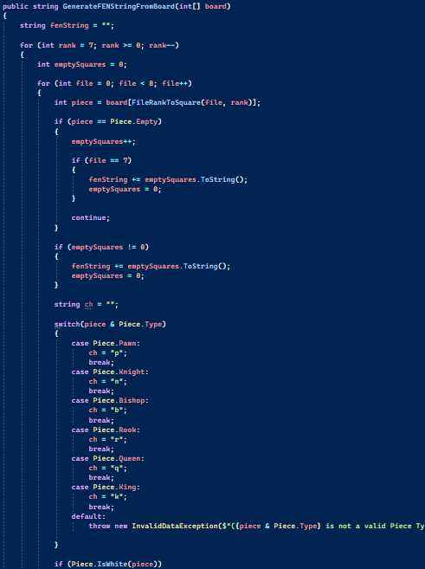
This function is the opposite of the GenerateBoardFromFENString function. It takes the current state of the board (and it’s associated variables) and from this generates and returns a FEN string as shown in Figure 13. Instead of iterating through a FEN string and adding pieces to the board based on characters, this function iterates through the board-array and adds characters to the fen string depending on the pieces residing on the square. After this, the colour to play and castling rights fields are added onto the end of the fen string with a space separating every field.

Figure 13: GenerateFENStringFromBoard Function

MakeMove Function
This function is responsible for applying a move to the board-array and ensuring that all board-associated variables are correctly updated in relation to the move being made. This function takes two parameters, a move object to be carried out, and a boolean indicating if move is being performed so the calling function can test whether the move is legal. The function returns a boolean value indicating if the move was made successfully.
The first step of this function is to create a variable to store the moving piece, for readability and ease of access, and ensure the piece is not an empty square. If it is empty the function will return false. Next the board sets the square from which the piece is moving to be empty and sets the value of the square to which it is moving to the value of the moving piece. If there is a promotion flag present in the move object, the function will change the end square on the board to contain a queen of the same colour as the moving piece.
After physically applying the move to the board-array, the function then begins to update the board variables to reflect the status of the board following the move. The function checks if the moving piece is a king, and if it is it carries out the following steps.
- the kings position array is updated (for the moving king)
- the move is checked to see if there is a Kingside or Queenside castling flag present.
  - If present, the board then the appropriate rook mill be moved and its starting square set to empty.
Regardless of whether the piece is a king, the function checks to see if this move has flags to indicate that it removes the kings ability to castle on the kingside and/or queenside, and if it does, it will update the castling rights array accordingly. After this, the colour to play is switched, and if the current move is a test move, the move is pushed to the move stack, and the legal moves are pushed to the legal moves stack, and the function returns true.
If the move isn’t a test move, the function then uses the instance of the move generator class to detect pins and checks on the updated board. The legal moves are then pushed to their stack, and the move generator object is used again to generate all legal moves on this new board state.
Finally, if there any of the kings are in check on the board, a check flag is added to the move object, and if there are zero legal moves, then the checkmate boolean is set true and a checkmate flag is added to the move object. After this final check, the move is pushed to the move stack, and the function returns true.

Unmake Move Function
This function is the inverse of the Make Move function, and will undo the most recently made move, updating the board-array and any relevant variables. This function returns a boolean value, indicating if the move was successfully unmade.

GenerateValidMoves Function
This function takes a square on the board as a parameter, then generates and returns a list of legal moves for the piece on this given square. This function uses the instance of the move generator class previously defined, and calls the GenerateAllLegalMoves function, passing in the square, and a copy of the board as arguments, and returns the result of this function. The purpose of this function is mainly to separate the User Interface side of the chess application from the move generation and validation, see section 3.4, as this subroutine is called from the Chess Form class and is a “pass-through” function.

GenerateAllLegalMoves Function
This function uses the MoveGenerator class instance previously defined, and calls its GenerateAllLegalMoves function, returning the result.

MakeComputerMove Function
This function takes an integer as a parameter that defines the “move-depth” that the computer should search to and uses the previously defined instance of the MoveSelector object and calls the MiniMaxMoveEvaluation function, which returns a tuple of integers. The first integer is irrelevant for the purpose of making a computer move, the second integer represents the index of the move within the current legal moves list, that the computer has selected. If the second integer is -1 then the function will return false, since this indicates that there was an error in the move selection as -1 is not a valid index. Otherwise, the function will call the board’s make move function with this selected move, and return the subsequent result indicating if the move was made successfully.

GenerateComputerMove Function
This function is the same as the Make Computer Move Function (see section 6.3.17) with the exception that this function returns the move selected, without applying it to the chess board. This function’s main purpose is for generating hint moves for the player.

ColourToPlay Function
This function returns the integer value of the colour that is to play, by assessing the “whiteToPlay” boolean.

GetBoard Function
This function simply returns a copy of the board array. By using a function for this purpose, it encapsulates the board class’s data.

Helper Functions
The following functions are all static and can be called from outside the board class, without an instance being created. Most of them are used for data validation purposes, or other board-related issues.
Screenshot | Name + Description
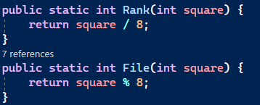 | Rank/File(int square) - These functions take a square on the board and return its corresponding rank or file, by using the DIV and MOD operations.
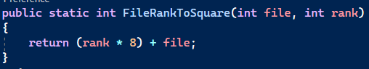 | FileRankToSquare(int file, int rank) – This function takes a file and rank, and return the square number of this position.
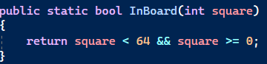 | InBoard(int square) – This function takes a square number, returns true if it is within the board (0 <= x < 64), and false if not.
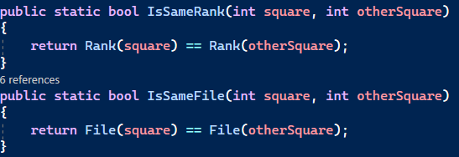 | IsSameRank/File(int square, int otherSquare) –  These functions take two squares, converts them to files/ranks, and returns true if they are the same file/rank, and false otherwise.
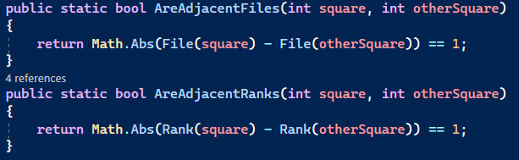 | AreAdjacentFiles/Ranks – These two functions take two squares as parameters, convert them into two files or ranks, and returns true if the absolute difference between the two values is one (they are adjacent), and false otherwise
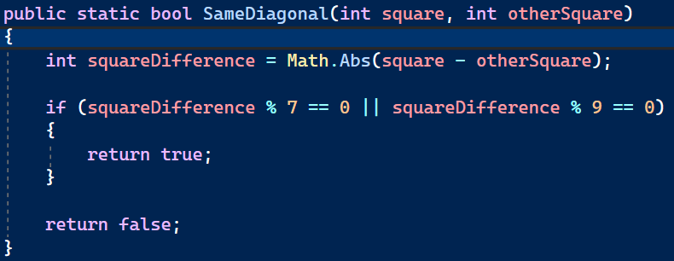 | SameDiagonal(int square, int otherSquare) – This function takes two squares and returns true, if they both lie along the same diagonal. Firstly, it calculates the absolute difference between the two squares. If you apply the modulus function to the difference between the two squares, and the difference between two adjacent diagonal squares (7 or 9), if the result is zero, then the two squares lie along the same diagonal.

MoveGenerator Class
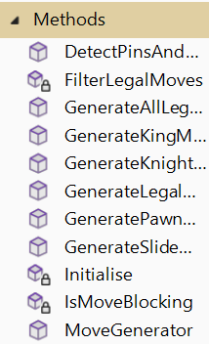
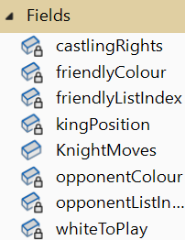
The purpose of this class is to generate the possible moves for all the pieces on the board, ensuring that every move is legal. When determining if a move is legal there are several factors to consider, such as checks, which is when a piece is attacking the King, or pins, where a piece is not permitted to move, in most or all directions, as the act of it moving will reveal a check on the king. The fields and methods in the MoveGenerator Class are as shown in Figure 14.
Figure 14: MoveGenerator Class Fields & Methods

Move Constants
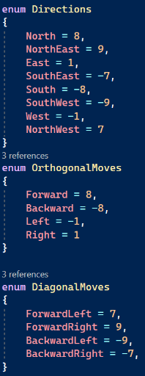
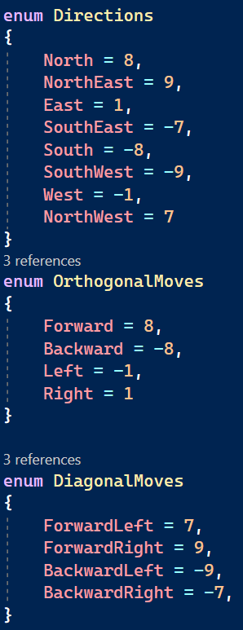
The enums and array shown in Figure 15, contain the increments required to move in every direction on the chess board and to move the Knight. The Directions Enum contains all available directions, whereas the Orthogonal and Diagonal enums contain the increments for these respective directions only. By using an Enum for these values, it makes the code more readable, as it is clear in which direction pieces are moving. Furthermore, the “KnightMoves” array, contains the move increments for all the possible squares a Knight can jump to.
Figure 15: Move Constants

Friendly/Opposition Colours and ListIndex Fields
These variables are used to keep track of which colour’s turn it is, and hence which colour should be considered friendly, and which should be considered opposition. On top of this, a friendly/opposition list index is tracked, that is used when accessing the king’s position, or the king’s castling rights.

Other Fields
Within this class the KingPosition integer is used to track the current player’s king position. There is also an instance of the board class from which context for move generation can be drawn. Lastly, CastlingRights is an array of booleans to track the castling rights of the current colour to play.

Constructor & Initialisation Methods
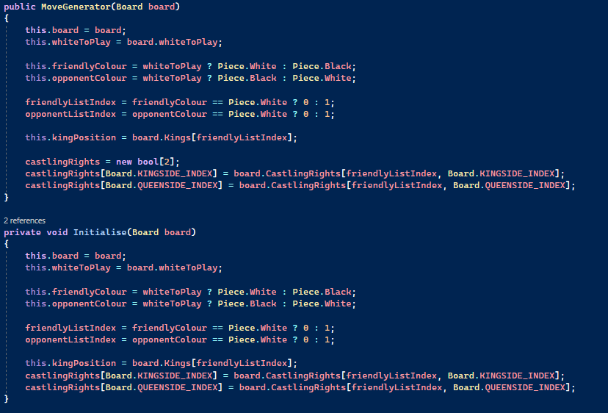
The constructor for this class takes a Board object as an argument, and uses the data from it, to initialise variables, such as friendly/opposition colours. One problem with this approach, is that after every move made, these variables change, and since move selection is event-based and occurs in a different class, this class cannot know when to change the variables, and what to change them to. This is where the Initialise function is required, whenever this class is called to generate a list of moves, the initialise function is also called ensuring that the information stored about the board is correct and up to date.
Figure 16: MoveGenerator Constructor & Initialisation Methods

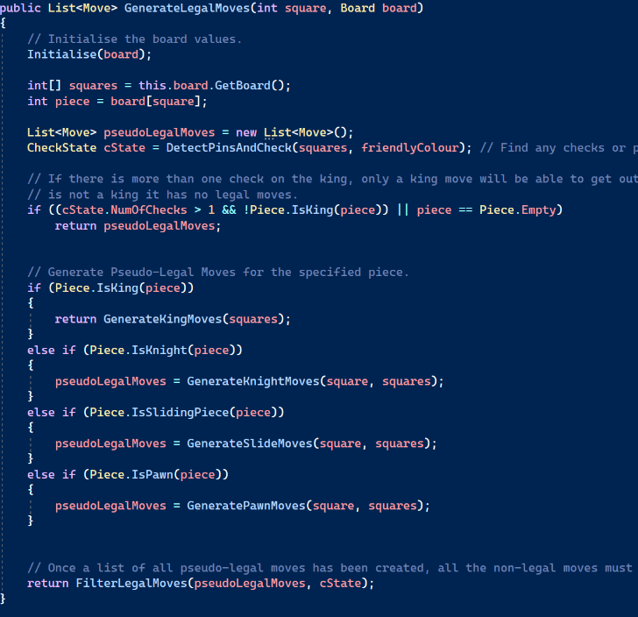
GenerateLegalMoves Function
This function generates a list of legal moves for the piece, that resides on a given square. Firstly, the Initialise function is called, and two variables are created to reference the board array, and the piece on the board at the square given as an argument. Next, an empty list of moves is created, which will be used to store the pseudo-legal moves of the piece, and a check state is generated by calling the “DetectPinsAndChecks” function. After this the procedure checks to see if:
- The piece is not a king, but there is more than one check, which would indicate a pinned piece.
- The piece is an empty square.
If either of these conditions are true, then the function returns an empty list of moves, as this piece has no valid moves. Otherwise, the procedure calls a separate function (corresponding to the piece type) which generates all the pseudo-legal moves for the piece. Finally, the pseudo-legal list, and the check state are passed into the FilterLegalMoves function, see section 3.4.7, that removes any illegal moves (resulting for check or pinned pieces), and the result of this function is returned.
Figure 17: GenerateLegalMoves Function

GenerateAllLegalMoves Function
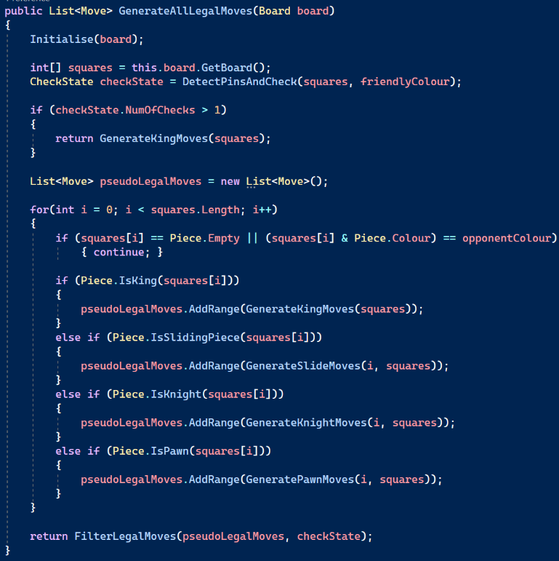
This function works almost entirely the same as the GenerateLegalMoves function, with one difference. Instead of having a particular square as a parameter, this function loops through all the squares on the board (skipping over empty ones) generating the pseudo-legal moves for these pieces and adding them to one big list of moves. Once this has finished, the filter legal move’s function is called on the entire list, and the result is returned.
Rather than calling the GenerateLegalMoves function for every square on the board, this function is used as it is more time efficient, as otherwise the check state, initialise etc. would be re-evaluated repeatedly, which is not necessary. This purpose of this function is also different to that of the GenerateLegalMoves function, which is intended to be called when a user-controlled event occurs. Instead this function is called every time a move is made to enable Checkmate detection, and also for move searching within the MoveSelector class.
Figure 18: GenerateAllLegalMoves Function

FilterLegalMoves Function
This function takes a list of pseudo-legal moves, and a CheckState object as parameters, removes any illegal moves and returns a list of fully legal moves, as shown in Figure 19. An empty list is created, to which the legal moves are added in accordance with the following rules.
- If there is only one check on the board then the program gets the list of pinned squares from the CheckState object and if the start position of the pseudo-legal moves is listed this indicates the piece is pinned and consequently this function returns an empty list.
- If there is only one check on the board and the current piece is not pinned, then all the pseudo-legal moves are checked to see if the move ends on a square that either captures the checking piece or blocks the check (assuming it is a sliding attack). If so the move is added to the legal moves list.
- If there are no checks on the board but there are pins then every pseudo-legal moved is checked to see if:
  - the piece being moved (as indicated by the pseudo-legal moves starting position) is pinned and if so only adds moves to the legal move list from the pseudo-legal moves if the move results in either capturing the pinning piece or not exposing the king to check by the pinning piece.
- If there are no checks or pins affecting the current piece on the board, then the function returns the list of pseudo-legal moves
- Otherwise it will return the new updated list.

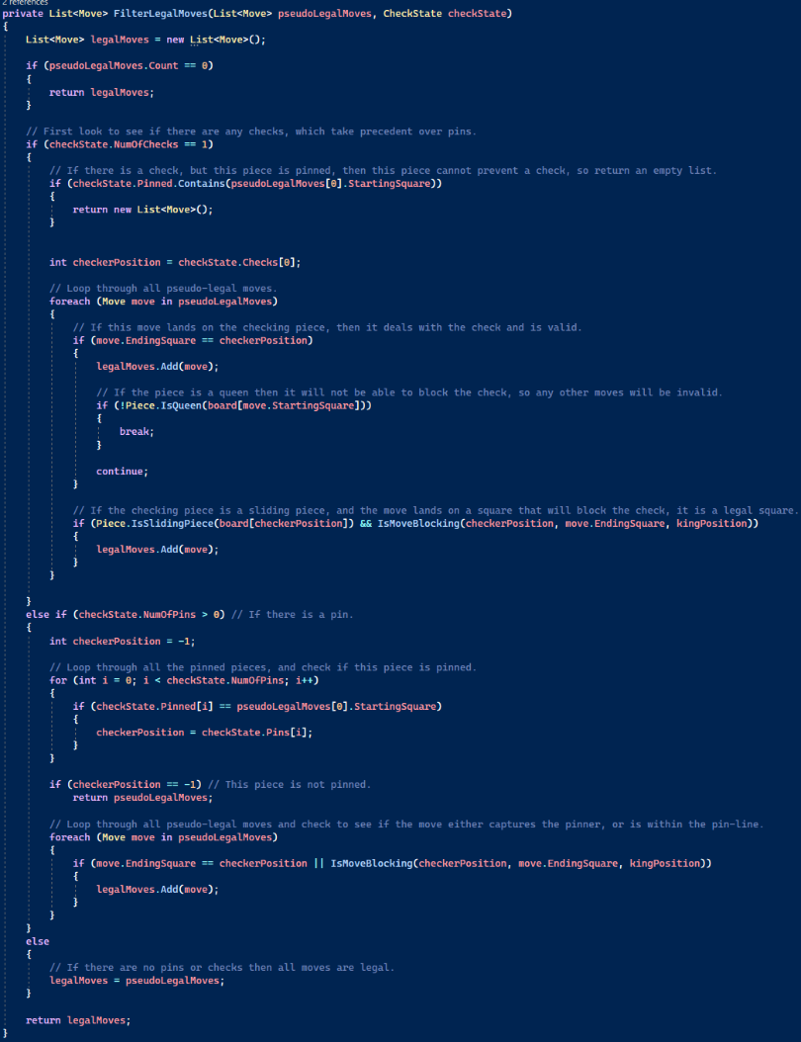
DetectPinsAndCheck Function
Figure 19: FilterLegalMoves Function
This function takes a board array, and a colour value, that represents which colour of king is being assessed for check. The function begins by creating three empty lists to store the positions of checking pieces (piece placing the king in check), pinning pieces (piece preventing an opposition piece from moving as it would place their king in check), and pinned pieces (piece which are pinned by and opposition piece). Next, it loops through every direction in the Directions enum, and iterates across the board in this direction looking for checkers and pins, until the move goes out of bounds/off the board. Whenever the program encounters a friendly piece, whilst iterating through each direction, it will first look to see if there is currently a pinned piece (no pinned piece is represented by -1 as this is not a valid board position), if there is already a pinned piece in this direction, the program will break out of this inner-loop, as there cannot be a pin across two pieces. Otherwise, the program will store the current index of the friendly piece in the pinned piece variable and continue to the next iteration of the loop. Whenever an opponent piece is encountered, one of the following conditions must be met for the piece to be considered a threat to the king:
- If the piece is a Queen.
- If the current direction is orthogonal movement and the piece is a rook.
- If the current direction is diagonal movement and the piece is a bishop.
- If the current direction is diagonal movement, the piece is a pawn, the pawn is adjacent to the king, and the king is in the pawn’s attacking direction.
Assuming one of these conditions is met, the program will then see if there is currently a pinned piece, if there is then the position of the pinned piece, and the pinning piece will be added to the corresponding lists, otherwise the current position will be added to the checks list, and the program breaks out of searching this direction. After all directions have been searched, the program will then look for checks from Knight’s by generating all the moves the king could make if it were a knight and checking to see if an opponent knight is on these end squares. Finally, the function will return a new check state object, using the three lists created as the data.

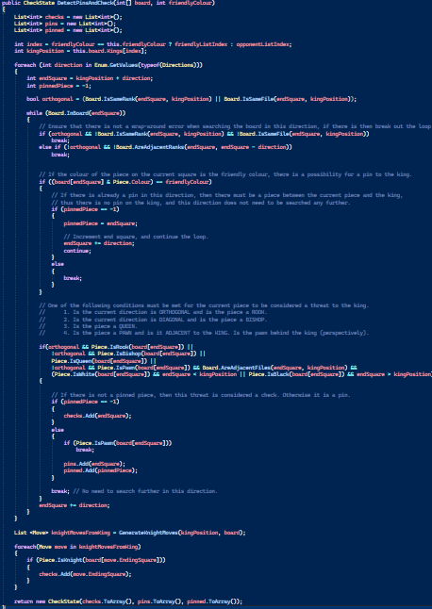
GenerateSlidingMoves Function
Figure 20: DetectPinsAndCheck Function
A sliding move is one in which the moving piece is a queen, bishop, or rook, as these pieces do not have a range cap on their movement and can move until they reach the edge of the board or are blocked by another piece. This function takes a square, and a board-array and will generate all the sliding moves for the piece on the given square.
When generating sliding moves there are two directions you can iterate over, diagonal and orthogonal, the queen piece can travel in both directions whereas the bishop may only travel diagonally, and the rook may only travel orthogonally. So, this function uses two loops that work almost identically but, one generates orthogonal moves if the piece is a rook or queen, and the other generates diagonal moves if the piece is a bishop or a queen.
To generate the sliding moves, there is an outer foreach loop that iterates over all the directions in the orthogonal or diagonal direction enums. Within this loop, the current direction is added to the starting square, and a while loop will continue to travel in this direction until the square is outside the boards bounds, a wrap around error occurs, or another piece is reached. If one of these conditions is not violated then a new move object will be created from the original starting square to the current position, adding all relevant piece and captured piece information, and this move will then be added to the move list. Wrap around errors occur when a piece travels off the side of the board and ends up on the other side of the board (due to the board being represented as a one dimensional array). For orthogonal movement, a wrap-around error has occurred if neither the rank nor file of the current square are the same as the rank or file of the original starting square. For diagonal movement, a wrap-around error has occurred if the ranks of the current square and previous square are not adjacent, meaning that a rank has been skipped due to the jump size of diagonal movement.
One final thing is done when generating moves for sliding pieces. If the moving piece is a rook then the function must check to see if this move will result in the loss of castling rights for the king. To do this, the file of the rook is retrieved, and the corresponding castling right (File A = Kingside, File H = Queenside) is checked, and if it is set to true then a flag will be added to indicate this move loses the castling right.
Finally, the move list is returned after generating all orthogonal and diagonal moves.

GenerateKingMoves Function
This function takes a board-array as a parameter and generates all the moves for the king of the current colour to play. The king piece can travel one square in each direction providing there is not a friendly piece present on the end square, there is no wrap-around error, the move is not outside the board, and making the move does not put the king in check.
The function loops through every direction that the king can travel, and calculates the end square number, if this square is outside the board then the loop will continue to the next iteration. Furthermore, if the king is on the right most file, and the current direction will move it to the right, then the loop will continue to the next iteration, similarly if the king is on the leftmost file and is attempting to move more left.
If these conditions have been met then the function will then check to see if the end square on the board contains an opponent piece or an empty square, if so, a new move object will be created. Next, the castling rights of the king are checked, and if either of them is currently true the corresponding flag will be added to indicate that this move will result in the loss of this side’s castling right. Both flags may not be added by default since, on this turn the king may not be able to castle to one side, but by adding both flags, when unmaking the move, the program would assume that before this move the king could castle to both sides.
After this, the current move will be made on the board, as a test move, and the king position will be updated. If there are no checks present on the board, then the move is completely legal and thus can be added to the move list, otherwise it is not added. The move is then unmade and the king position is set back to its original value. Unlike other pieces, king moves cannot be filtered and made legal since the movement of the king will result in a completely new check state, so instead this approach of testing the move by making it must be taken.
After looking at every direction, if there are any checks present on the board, then the function will return the move list. Otherwise, the function will check if the king is able to castle. First the kingside castling right is checked, assuming it is allowed, the function will iterate over all the squares between the king and the rook and if they are not empty the king cannot castle and the loop is exited. If there are no pieces between the king and the rook, then a new move object is created with the corresponding flags ( Kingside Castling Flag). A kingside castle will always cause a loss of kingside castling rights, and if the queenside rights have not already been lost, this move will also lose the right for queenside castling. The move is then tested for checks, with the same method as the previous king moves, and is added to the move list if no checks are present. This same method is also applied for the Queenside Castling. After both castling moves have been added (if legal) the function will return the move list.

GenerateKnightMoves Function
This function takes a square, and board-array and will generate all the possible moves a knight can make from this position. The function iterates through every direction in the KnightMoves enum, and for each move checks that the end square is within the board bounds and continues to the next iteration if not. Next, the number of squares travelled to get from the start square to the end square is calculated, and if this number is greater than three (which is the range that the knight piece can move in squares), the loop continues to the next iteration. After this, a new move object is created and added to the move list, provided that the end square on the board is either empty or contains an opponent piece.

GeneratePawnMoves Function
This function takes a square, and a board array and will generate the moves for the pawn residing on the given square. The function returns a list of all the possible moves (pseudo-legal)
First, the colour of the moving pawn is checked, and a multiplier is created for the move, -1 if the piece is black (which will cause the pawn to move down the board), and 1 if the piece is white since the direction is upwards (and thus does not need to be inverted). After this, the pawns front and double front move end squares are calculated, and a flag indicating a pawn promotion is created if the end square of the front move is on the top or bottom ranks of the board.
The function then checks if the front move is inside the board boundaries, and if the square is empty, if so, then a new move is created and added to the move list. After this, if the front move was valid, the function checks that the pawn has not yet moved (meaning it is on it’s colours respective starting rank) and if the double front move square is empty on the board, and if so, the double front move is created and added to the move list.
After this, the left and right capturing squares are calculated, and the function checks that an enemy piece resides on the square, it checks that there has not been a wrap-around error (ranks must be adjacent to one another), and also checks that the square is within the board boundaries. Assuming all the above conditions are met, the capture is added to the move list, and the move list is returned.

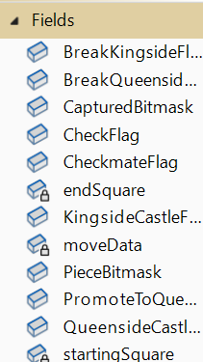
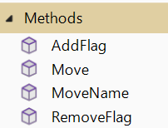
Move Class
The Move class stores all the relevant information about a move that can be made on the chess board. For example, a move object will store the start and end squares of a move, it will store the piece that is moving, any pieces that are captured with this move, and more. The fields and methods in the Move Class are as shown in Figure 21.

Figure 21: Move Class Fields & Methods

Move Information
The following variables make up the move, storing all the relevant information about the given move. There are two integers that represent the starting square of the move, and the end square of the move. The third variable is an unsigned (non-negative) integer in which the moving piece, captured piece, and all move flags are stored. For the move data, a similar approach is used as for the Piece module where different bits of the number represent different parts of the move’s data. The least significant 5 bits represent the moving piece, the next 5 bits represent the captured piece, and the rest of the move data stores the move’s flags as detailed in section 3.5.2. All these variables are private members as they should not be edited directly from outside the class as this could lead to the move’s data being corrupted/incorrect.

Move Flags
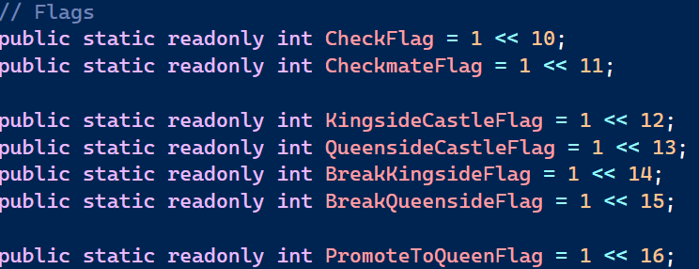
The variables shown in Figure 22 are singular bit flags that represent different possible aspects that a move may contain. For example, a move where a pawn reaches the end rank, where it is promoted to a queen, which in turn puts the opponent king in check, would contain both a Check Flag and a Promote To Queen Flag to indicate both these properties. It should be noted a move is not limited to having a certain number of flags and will contain all that it requires. All these flags are static so they can be accessed from anywhere within the program, and are marked as read-only since they should not be altered from their original values.
Figure 22: Move Flags

Bitmasks
As previously mentioned, the first 10-Bits of the move data integer represent the moving and captured pieces. The bitmasks, shown in Figure 23 can be applied to the move data variable to isolate both these pieces respectively, allowing the user to access the data stored about these pieces.
Figure 23: Move Class Bit Masks

Data and Flag Accessing
The Move Class has a number of public members that allow outside access to the private data and flag members of the move class. The flags return a boolean value, indicating whether the given flag is present (is a ‘1’) within the move object. To get this result a binary AND operation is applied to the Flag and Move Data variable, which is then compared to the flag by itself, if these two values are equal then the flag is present.

Class Constructor
The constructor method for this class takes five integers as arguments. The first two integers represent the start & end squares of this move, and it is required that they are provided when creating a new move object. The next two integers represent the moving piece, and a piece that may be captured when this move is applied to the chess board, the moving piece must be provided as an argument when creating a new move object, however the captured piece variable is by default zero (an empty square) and so does not need to be provided. The final parameter of the constructor is a flags variable that contains any flags the move may contain. All the constructor method does is take these arguments provided and stores them within the corresponding variables in the move class. To store data in the move data variable a binary OR operation is applied to the current move data and the data to be stored.

AddFlag and RemoveFlag Functions
The functions shown perform the task of adding/removing a specific flag to the move data member. These functions return a boolean value indicating if the addition/removal of the given flag was successful. If adding a flag the function will return false if the flag is already present, and if removing a flag the function will return false if the flag is not present. A flag is added to the move data in the same way as in the class constructor, but to remove a flag a binary AND operation is applied to the move data and the binary inverse of the flag.

MoveName Function
This function simply returns a string containing the square name (e.g. ‘a1’, ‘h8’) of the move’s starting square, followed directly by the square name of the move’s end square. This function is mainly used for debugging purposes when attempting to track the moves being searched in the computer’s move selection algorithm.

CheckState Structure
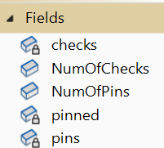
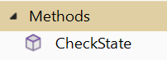
This simple structure simplifies the tracking of checks and pins on the board by storing the locations of where checks and pins originate from for a given board state. This structure is created within the DetectPinsAndChecks function within the MoveGenerator class. The fields and methods in the CheckState structure are as shown in Figure 24.
Figure 24: CheckState Structure Fields & Methods

Checks and Pins Tracking
There are three arrays within this struct, all of which are private and cannot be edited from outside the array, however there are public properties that allow these arrays to be accessed from outside the struct (just not edited). All these arrays store integers, each being a square on the board. The ‘checks’ array stores the squares from which a check on the king piece originates. The ‘pins’ array stores the squares from which a pin on a piece originates, and the ‘pinned’ array stores the squares of all pieces that are pinned to the king.

Number of Checks/Pins
The NumOfChecks and NumOfPins variable represent the number of checks, and the number of pins respectively for the current board position. Both variables are public since they are marked as read-only and cannot be edited after assignment.

Constructor Method
This constructor method is extremely basic and takes the three arrays that this structure will store as arguments, assigns them to the corresponding arrays, and then sets the number of checks/pins variables to the length of the corresponding array.

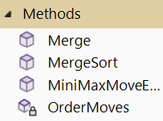
MoveSelector Class
This class is used to search through all the possible moves that a computer can make and select the move that will lead to the best possible evaluation for the computer’s side.
Figure 25: MoveSelector Class Methods

MiniMaxMoveSearch Function
This function, see Figure 26, is responsible for recursively searching through a tree of every single combination of moves that can be made on the chess board (to a given depth) and deciding what the best possible outcome for the colour to play will be. The function also uses alpha-beta pruning as detailed in section 2.4.5, to optimise the time taken to decide on the best possible outcome.
This function returns two integer values, the first of which is an evaluation score representing the best possible score for the colour to play, and the second integer is the index of the move that caused this evaluation. The function has four parameters that are passed to it on every recursive call, a copy of a board object which is needed for access to the various board fields (e.g. legal moves on the board, checkmate status etc), an integer that represents the depth of moves that should be searched to, and two more integers which respectively represent the current best possible evaluation for white, and the current best possible evaluation for black.
As this function recursively (depth first) searches through all the possible moves on the board, a tree type data structure is created where each child node of a given node, is the chess board’s state after a given move has been made. Using this logic, child nodes are created with the board’s Make Move function and each time a child node is created, this function is recursively called on the child node. Due to the directed nature of tree graphs, parent nodes (positions) can access the data of all it’s children, but a child node is not able to access the data of its parent.
The base case of this algorithm is reached when the depth variable provided reaches zero, or if the board has reached a state of Checkmate or Stalemate (i.e. a scenario in which no more moves may be made). When the base case occurs, the function will return a static evaluation of the chess board (provided by the BoardEvaluator class), and a default index of negative one. An index of -1 is returned at the base case, since this node cannot access the index of it’s move within the move list of its parent node.
When this function is called (assuming the base case has not yet been reached) a copy of the list of legal moves on the current board is made, this list is then passed through the OrderMoves subroutine which looks at the data of each move within the list and sorts the moves in order of how likely they are to be “good”. By exploring moves that are likely to be better first, the alpha-beta pruning will be much more efficient as it will encounter the best scores earlier leading to more branch pruning (more on this later).
The algorithm will take one of two paths depending on the current colour to play. If white is to play the function will attempt to maximise the score, since (more) positive evaluation scores are better for white, and if black is to play, the function will attempt to minimise the score, since (more) negative scores are better for black. Two integers will then be created to keep track of the maximum (or minimum if black) evaluation score, and the index of the move within the current move list that will cause this evaluation.
After this, each move within the current list of legal moves is iterated over. The board will apply each move and then a recursive call of this MiniMaxMoveSearch function is called, decrementing the depth variable by one, storing the tuple integer result, how this result is used depends on whether the current colour to play is white or black.
If White is to play, then the evaluation score is compared to the current maximum evaluation score, and if greater the max evaluation score variable is updated to contain the result, and the index is updated to be the index of the current move in the move list. After this, the best white evaluation variable is set to be the larger value between itself and the evaluation score.
If black is to play, the evaluation score is compared to the minimum evaluation score and if smaller than it, this minimum evaluation variable is updated, and the index variable is updated to be the index of the current move in the move list. After this, the best black evaluation variable is set to be the lesser value between itself and the evaluation score.
After doing this, regardless of the colour to play, the best evaluation for black is compared to the best evaluation for white, and if it is less than or equal to it, then the algorithm knows that none of the following moves will be chosen since there is a better move that will be made, thus the remaining moves do not need to be made, hence these move branches are ‘pruned’.
When all moves have been explored, or there are no remaining moves to explore due to pruning, the function will return the maximum evaluation and it’s corresponding index within the move list if the colour to play is white, and the minimum evaluation and it's corresponding index if the colour to play is black.
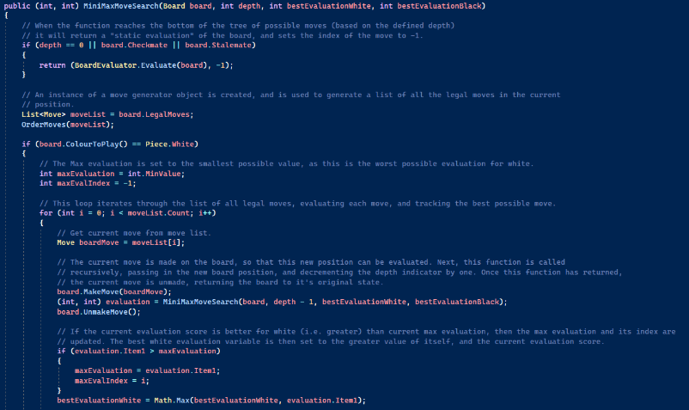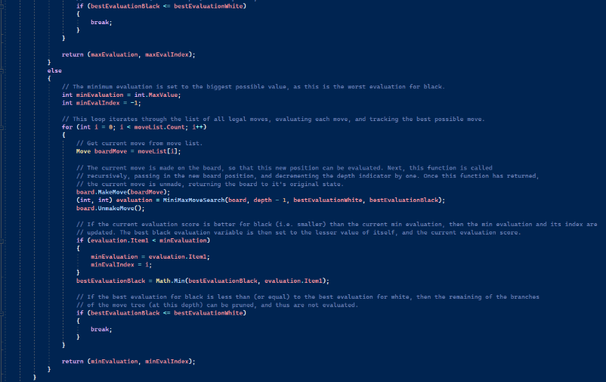
Figure 26: MiniMaxMoveSearch Function

OrderMoves Function
This function takes a list of moves and assigns a ‘priority’ score to every move within the list, based on how likely it is to have a positive effect for the colour to play. These moves will then be sorted in ascending order of their priority scores (low score = high priority). The purpose of this function is to optimise the speed of the MiniMaxMoveSearch algorithm, by placing moves with a potentially better outcome earlier in the tree. This is beneficial as moves later in the tree are more likely to be pruned, resulting in less time wasted exploring pointless sequences of moves.
An array of integers, the same length as the move list is created, to store the move scores. Every move within the move list has its priority score calculated and assigned to the same index within the move scores array. All moves are assigned a base score of one thousand, the move is then checked to see if it captures any pieces, and if so the difference in piece values between the piece captured and capturing piece is subtracted from the move score. Following this, the difference in square-scores (see section 3.8.2) of the starting square and end square is subtracted from the move score.
Finally, the MergeSort Subroutine is called to sort the move list based on the move scores. This merge sort will affect the list outside of this function since lists are passed by reference, despite this the function still returns the newly sorted list, in case it is needed for any reason.

MergeSort Subroutine
This subroutine takes a list of moves and an array of move scores, both of which are the same size, and sorts both lists in ascending order based on the values within the move scores array.
The merge sort algorithm is recursive and uses the principle of “divide and conquer” by splitting the array in half continuously until there are multiple arrays containing only one element, at which point the algorithm ‘merges’ the arrays back together (using the Merge subroutine) in sorted order, so that by the time the array is back to its original size, it is completely sorted.
This method implements the merge sort algorithm, and also sorts the lists in place, meaning that it has constant size (O(1)). There are four parameters, two of which are the move list and move scores array, to be sorted, and the other two are left and right pointers for the lists. First, the algorithm checks that the left pointer is less than the right pointer, and if so, it knows the base case has not yet been reached since the pointers have not overlapped. Next, a middle point between the left and right pointers is calculated, and the MergeSort is recursively called on the left side of both arrays, and then the right side of both arrays. This will continue until the pointers overlap, meaning that the array now has a length of 1, at which point the Merge function is called that merges the left and right sides of the array back together.

Merge Subroutine
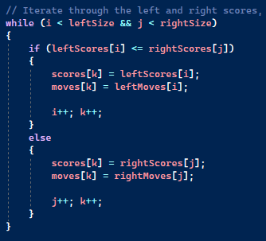
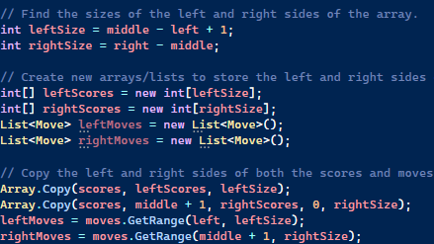
This subroutine, see Figure 27, takes left, middle, and right pointers, alongside the two lists that are being sorted as arguments. The first part of this subroutine takes the values of both the left and right sides of both arrays provided and copies them into their own new respective list/array. After this, three pointers are created, two are set to zero to show the first elements within the left and right-side arrays, the third pointer represents the current position in the main array/list. Next, the two halves of the lists are iterated overusing these indices, and the main arrays are edited, inserting the elements in sorted order. Once the end of one of the halves is reached, the remaining elements of the other array are added to the main arrays, since they are already in sorted order.
Figure 27: Merge Subroutine

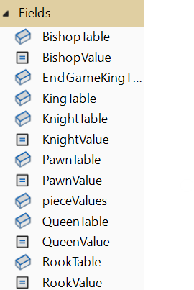
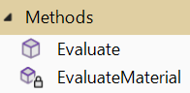
Board Evaluator Class
The purpose of this class is to provide a way to evaluate a position on a chess board, giving an objective score regardless of the current colour to play, that indicates which colour is in an advantageous position.

Figure 28: Board Evaluator Fields & Methods

Piece Values
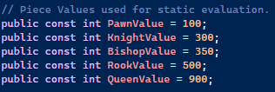
Within chess all the pieces have different values that indicate their worth compared to each other, and in the most part these values are widely accepted to be the same. In this class there are public constant integer values that store the values for all the different pieces. These values never change hence being constants, and they are public so that they can be accessed from outside the class. Furthermore, there is also a public read-only dictionary that uses an integer piece-type value as a key, with the corresponding piece-score as the value, allowing quicker and easier access to the scores.
Figure 29: Piece Values

Piece-Square Tables
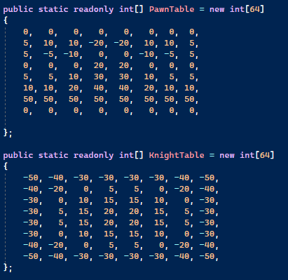
Due to the differing movement patterns of all the pieces in chess, each piece has unique positions on the chess board where they are more useful, and others where they are less so. For example, knights are strongest towards the centre of the board, as opposed to the edge where they can make a limited number of moves. When evaluating moves for a given board configuration, it is important to take the location of all the pieces into account as this can affect the strength of the position for a given player, even if the overall material is equal. This feature can be implemented using a technique called Piece-Square Tables where each piece has its own array of 64 integers, with each integer representing the relative strength of a square on the chess board for this piece type, see Figure 30.
It should be noted that the values in the Piece-Square Tables should be inverted for the two different colours (as negative scores favour black, and positive ones favour white). It is also important that for some pieces, such as the king and pawn, the piece-square tables are directional and not symmetric as with the other pieces, so when assessing the values for a black piece, the index from the opposite end of the table should be used.
The BoardEvaluator class contains six Piece-Square tables for all the different piece type, all of which are public making them accesible outside this class, and read-only meaning the values cannot be altered.
Figure 30: Piece-Square Table Examples
Similar to the Piece-Values dictionary, these piece-square tables are contained within a public readonly dictionary (with the piece-type integer value as the key) to allow for quick access to the tables.

Evaluate Function
This function takes a board object as an argument, and performs an evaluation of the current position, returning an integer score with negative (smaller) values favouring black, and positive (bigger) values favouring white.
The default evaluation score is set to be zero (which would indicate a draw). The function then checks if the board is currently in a state of checkmate, and if so will return the worst possible score ±1 for the current colour to play, meaning the colour that has been checkmated. If the board is not in checkmate then the function checks if there is a draw present on the board, and if so will return zero.
Otherwise, the program will add the value of the material on the board to the evaluation score, by calling the EvaluateMaterial function, and will then return this value.

EvaluateMaterial Function
This function takes a board-array as an argument and sums the material score of all the pieces on the board (considering their position as well) and will then return this score.
When calculating the score for the pieces, the function creates a multiplier that is -1 if the piece is black, and 1 if the piece is white, so the values within the Piece-Square Table and Piece Value variables become negated. Furthermore, if the piece being evaluated is a pawn or king and is also black the index used to access the piece-square table is changed so that the table is effectively flipped upside down, giving the correct corresponding square scores.

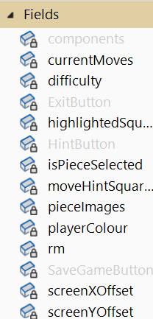
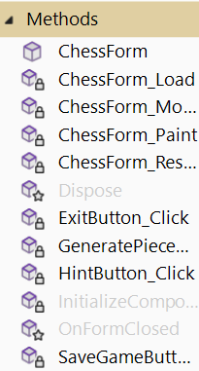
Chess Form Class
Figure 31: Chess Form Fields & Methods

This class inherits from the WinForms defined Form class and acts as the frontend of this program, displaying, the chess board and all it’s pieces to the user, amongst other user-interface elements.

Current Move Tracking
Whenever a piece is selected by a user, it’s available moves should be highlighted on the chess board in a different colour. To get this effect, this class stores two lists, a list of the available moves (currentMoves) for the currently selected piece and then derived from this list, a list of squares (highlightedSquares) on the chess board that should be highlighted. Furthermore, the class has a boolean member (isPieceSelected) that indicates whether a piece is currently selected on the board, since this is not always the case.
On top of this, the class has another field member that stores squares that should be highlighted (moveHintSquares) when the hint button is clicked by the user. The squares highlighted are the starting and ending squares of the move selected by the computer.
All the above members are marked as private since they do not need to be accessed or altered from outside this class.

Piece Images
To effectively display the chess board, all the pieces must have an image file that can be accessed and displayed on the chess form. These images are stored within the “Resources” file of the C# solution, and to access them a Resource Manager object must be created. This class has a private member that is a Resource Manager object allowing it to access the piece images.
Since it would not be time effective to fetch the images from the Resource Manager every time the chess board is redrawn, this class has a dictionary (pieceImages) that uses a piece integer value as a key and stores the corresponding piece’s image as the value for this key. This allows quick access to the piece images and cuts down on buffering when re drawing the chess form.

Other Fields
This class stores the main instance of the Board class used within the program, this is the instance that the user will be looking at and making changes to. This field is private since it should only be accessed and edited from within the chess form class (meaning it is dictated by user-controlled events).
This class also keeps track of the human player’s colour, so that the board can be orientated correctly, as well as the difficulty setting selected by the player for playing against the ChessBot or generating hint moves.
Furthermore, this class also stores an X and Y offset variable that dictates where the chess board should be drawn (starting from the top left corner).

Class Constructor
This method takes four arguments, received from the MainMenu form, a FEN string describing the board position, a boolean indicating if the player is playing against the computer, an integer representing the difficulty setting for the player, and the colour that the human player will be playing as.
The purpose of this method is to initialise the members of this class. The board object is created, passing in the FEN String and Playing on a computer boolean provided as arguments, and all the arrays are initialised to be empty arrays of the correct size. The subroutine then checks if the player colour is black, they are playing against the computer, and the current colour to play is white, and if so, the board’s Make Computer Move function is called, and if unsuccessful an error message is displayed.
Furthermore, within the constructor the Piece-Image dictionary is initialised by iterating over every piece type, using a black and white version of this piece as a key in the dictionary, and at this position storing the corresponding image after fetching it with the Resource Manager. The Image ID function simply returns the name of a particular piece within the resource file.

Mouse Click Detection
This subroutine is responsible for detecting a mouse click on the chess form and then determining and carrying out the click’s intended purpose.
When a mouse click occurs this subroutine will first determine if the click resides within the bounds of the chess board, by comparing the mouse’s X and Y coordinates to the chess board’s dimensions added to the board’s screen offset. If the click does not reside within the chess board, then the subroutine is exited. Otherwise, the subroutine will convert the mouse coordinates into a square on the chess board.
The subroutine checks if there is no piece currently selected, and if so, will do the following things. If the square clicked on the board is empty, or if the piece residing on the square clicked is not the current colour to play, the subroutine is exited. Otherwise, all the possible moves for the piece residing on this square are generated, by calling the GeneratePieceMoves function, the piece selected boolean is set to true, and the form is then refreshed/redrawn.
If a piece has been selected, but the square clicked on contains a piece that is the current colour to play, this same process is carried out and all the possible moves for this piece are generated.
If a piece has been selected, and the square clicked is one of the currently highlighted squares, then the subroutine will locate this move within the list of currently available moves and will apply it to the chess board by calling the MakeMove function. If there is an error whilst applying this move then an error message will be displayed, if not the subroutine will check to see if Checkmate, or a draw has occurred. If neither of these game-ending state have occurred the board will make a computer move (if the player is facing the computer) and consequently check the game state again, or the board will flip and await the other player’s turn.

GeneratePieceMoves Subroutine
This function takes a square on the chess board as a parameter and will generate all the possible moves for the piece residing on the square, whilst updating this class’s relevant member variables. First, the subroutine will set the piece selected boolean to true, and the current moves list is set to the returned value of the board’s GenerateValidMoves function. The subroutine then iterates over every move within the move list and adds the end square of each move to the highlighted squares array.

FormResize Subroutine
This simple subroutine is called whenever the form is resized, and simply calculates the middle point of the form, and then subsequently updates the X and Y offset variables for the chess board so that it is located within the center of the screen.

FormPaint Subroutine
This subroutine is called whenever a change to the form or chess board occurs, thus resulting in the contents of the form needing to be updated/redrawn.
First, a reference to the form graphics is created, and a new pen object is made that will be used to draw the chess board and pieces. Next, a nested for loop is used to draw an 8x8 chess board of alternating colors. Note that these colors are switched whenever the board ‘s orientation is flipped so that the square that pieces reside upon does not change colour.
After this, the subroutine checks if a piece is currently selected, and if so, will iterate over the highlighted squares array and for each square within, will calculate it’s coordinates on the screen and paint the square with the highlighted colour at this position. The subroutine also does this for the hint squares stored within the hint move array.
Finally, the subroutine will iterate over the board array and for each square that contains a piece, the screen coordinates will be calculated, and the corresponding image for the piece residing on this square will be drawn at this position.

Save Game Subroutine
This subroutine is called whenever the save game button is clicked, and as the name suggests, stores the current position and state of the game to a text file, so that the game can be resumed later. To do this, the subroutine first calls the board’s GenerateFENStringFromBoard function and writes the result to the save file. Next, the subroutine will check if the player is facing against the computer, and if so, will write the string “true” to the save file followed by the game difficulty on the next line. Otherwise, the subroutine will write “false” to the save file. Finally, the subroutine will write the player’s colour to the save file and will close the file. If there are any errors whilst saving the game, an error will be thrown and caught by the program.

Hint Subroutine
This subroutine is called whenever the hint button is clicked by the user. This subroutine will simply call the board’s GenerateComputerMove function, passing in the difficulty setting as the depth argument, and will set the start and end squares of this move to the two elements of the hint move array, and will then redraw the form.

Exit Subroutine
This subroutine is called whenever the exit game button is clicked by the user and will shutdown any currently open forms.

Main Menu Form Class
Like the Chess Form class, this form inherits from the base WinForms defined Form class and acts as a user interface.

Class Fields
This class contains a few member variables, all of which are private, since they do not need to be accessed outside this class. These members are used to keep track of the game settings that are passed to a ChessForm object when it is created. On top of this, the class also has an instance of a ChessForm object which is the main instance used in the program.

Class Methods
Method Name | Description
NewGameButton_Click | This method is called whenever the new game button is clicked, and will hide the main menu panel, and show the game setting’s panel.
ExitButton_Click | This method is called whenever the exit button is clicked and will cause the application to close alongside any other open forms.
LoadGameButton_Click | This method is called whenever the load game button is clicked. This method will open a saved text file, and read the contents of it, the first field will be a fen string, the next a boolean indicating if the player is facing the computer, and if true a difficulty setting, and finally the player’s colour. All this information will be passed as arguments into a new ChessForm object, which will be displayed, after this form is hidden.
DifficultySlider_Scroll | This method is called whenever the difficult slider is moved, and it sets the selected difficult variable to the current slider value.
ComputerCheckBox_CheckedChanged | This method is called whenever the computer check box check is changed, and will update the playing computer boolean accordingly, as well has hiding/showing the game setting depending on the check.
ColourButton_CheckedChanged | This method is called whenever the selected colour button is changed and will accordingly update the selected starting colour of the player.
StartGameButton_Click | This method is called whenever the start game button is clicked, and will hide the current form, create a new chess form with the selected settings, and display this form.

Technical Solution

High Level Skills Demonstrated
In the development of the Chess Game the following skills have been demonstrated. These are only skills that were listed as examples on the AQA website, there are other high level algorithms and skills contained within the project.
Skill | Description of Use | References
Use of Stacks | Stacks are used to track a series of board properties throughout the game.  The move history, history of legal moves on the board, and board check state are all recorded in stacks, within the board class, which are kept up to date as moves are made and unmade.  Stack operations can be seen in the Make and Unmake move functions. | Board.cs  [4.5]  [3.3.6]  [3.3.13]  [3.3.14]
Use of OOP | Classes are used extensively throughout the project.  Dynamic generation of objects can be seen at move generation, as the board is iterated over, and its current state will influence the move objects created, alongside the data residing within these obects.  Use of interfaces to pass arguments and the use of private members with public fields can be seen within every class.  Composition is extensively used in several classes, for example, the Board class contains instances of the MoveGenerator, and MoveSelector classes. | Whole project  Move  Generator.cs  [4.7]  Whole project  Board.cs  [4.5]  Move  Generator.cs  [4.7]  ChessForm.cs  [4.4]
Tree Traversal | As the chess bot undertakes the task of selecting the best possible move on the chess board, every single combination of moves on the board must be searched.  As this process occurs a depth-first search tree traversal of the “move-tree” can be seen. This tree is also dynamically generated as the possible moves on the board are made and unmade. | Move  Selector.cs  [4.10]  [3.7.1]
Recursive Algorithms | Recursive Algorithms are used when searching/traversing the move tree, as well as when sorting a list of moves, using the merge sort. | Move  Selector.cs  [4.10]  [3.7.1]  [3.7.3]
Optimisation | Alpha-Beta pruning algorithm is coded to optimise tree traversal and minimise execution time.  Furthermore, the merge sort algorithm is used to sort move in order of how likely they are to be valuable to the colour to play, which further enhances the Alpha-Beta pruning algorithm.  Furthermore, small additions like storing the legal move history, and history of check states, optimise the move-tree searching, as these do not need to be recalculated when a move is unmade, thus saving time. | Move  Selector.cs  [4.10]  [3.7.1]  [3.7.2]  Board.cs  [4.5]  [3.3.6]
Merge Sort | Merge-Sort algorithm is used to order potential moves prior to tree traversal in order to optimise traversal time | Move  Selector.cs  [4.10]  [3.7.3]  [3.7.4]
Use of Files | Image files for all the pieces are stored and must be loaded when displaying the chess board.  A chess board’s state can be saved/loaded to a text file, allowing games to be resumed, | Chess  Form.cs  [4.4]  [3.9.2]  [3.9.4]  Main  Menu.cs  [4.3]
Lists | Lists are used to store the current legal moves on the chess board. | Board.cs  [4.5]  Move  Generator.cs  [4.7]
Complex User-Defined Algorithm | Pin and Check Detection.  Legal Move filtering.  Make and Unmake Move subroutines.  Generation of King moves.  Castling detection. | Move  Generator.cs  [4.7]  [3.4.8]  [3.4.7]  [3.4.10]  Board.cs  [4.5]  [3.3.13]  [3.3.14]
Multi-Dimensional Array | 2D array used to track kingside and queenside castling rights, for both King pieces. | Board.cs  [4.5]
Dictionaries/Hash tables | Used for accessing piece-values and piece-square tables quickly and efficiently.  Used for storing piece-images at runtime for quick access. | Board  Evaluator.cs  [4.11]  Chess  Form.cs  [4.4]
Records | Check State object is a record. | Check  State.cs  [4.9]

Program.cs
using System;

namespace ChessEngineNS
{
public class Program
{
// Main instance of the main menu form.
private static MainMenu mainMenu;

/// <summary>
/// The main entry point for the application.
/// </summary>
[STAThread]
public static void Main()
{
// Initialise the application.
ApplicationConfiguration.Initialize();

// Initialise the main instance of the main menu form.
mainMenu = new MainMenu();

// Run this instance of the main menu form on the application.
Application.Run(mainMenu);
}
}
}

MainMenu.cs
using System;
using System.Collections.Generic;
using System.ComponentModel;
using System.Data;
using System.Drawing;
using System.Linq;
using System.Text;
using System.Threading.Tasks;
using System.Windows.Forms;
using System.Resources;
using ChessEngine.Properties;
using System.Diagnostics;

namespace ChessEngineNS
{
public partial class MainMenu : Form
{
public static readonly string saveFilePath = "SaveFile.txt";

// Instance of the chess form that will be created and ran.
private ChessForm chess;

// Variables to track the currently selected game settings.
private int selectedDifficulty;
private bool playingComputer;
private int playerColour;

private int randomisedColour;

// The class constructor initialises the game settings variables, and generates a random colour
// that will be the player's starting colour is they select the random option.
public MainMenu()
{
InitializeComponent();

selectedDifficulty = DifficultySlider.Value;
playingComputer = true;
playerColour = Piece.White;

Random random = new Random();
randomisedColour = random.Next(0, 2) == 0 ? Piece.White : Piece.Black;
}

// This subroutine is called when the new game button is clicked. It hides the main menu panel,
// then shows the new game panel, and moves it to the centre of the screen.
private void NewGameButton_Click(object sender, EventArgs e)
{
MainMenuPanel.Hide();

NewGamePanel.Location = new Point(139, 44);
NewGamePanel.Show();
}

// This subroutine is called when the exit game button is clicked, and shuts the application
// and any forms currently open.
private void ExitButton_Click(object sender, EventArgs e)
{
Application.Exit();
}

// This subroutine is called whenever the load game button is clicked, and will read the game's
// save file and load the game that is saved within this file.
private void LoadGameButton_Click(object sender, EventArgs e)
{
try
{
// Open the game save file using a stream reader.
using (StreamReader sr = new StreamReader(saveFilePath))
{
// The first line of the save file is the fen string of the current position.
string fenString = sr.ReadLine();

// If this string is empty, then the save file does not contain a board state,
// so exit the subroutine.
if (fenString == null)
return;

// The next line is a string that indicates whether the player is facing the
// computer.
bool playingComputer = sr.ReadLine() == "true" ? true : false;
int difficulty = 5;

// If the player is facing the computer, read the next integer stored within
// the file which represents the difficulty setting. Otherwise, the difficulty
// will remain as five (so the player can recieve the best hints).
if (playingComputer)
{
difficulty = Convert.ToInt32(sr.ReadLine());
}

// The next integer stored in the save file is the player's colour.
int playerColour = Convert.ToInt32(sr.ReadLine());

// Hide this form.
Hide();

// Assign the chess member variable to a new instance of the Chess Form class
// passing in the values stored in the save file. Show this form.
chess = new ChessForm(fenString, playingComputer, difficulty, playerColour);
chess.ShowDialog();
}
}
// If any errors are caught during this process, display the corresponding error message.
catch (Exception ex)
{
Trace.WriteLine("The save file could not be read.");
Trace.WriteLine($"Error Message: {ex.Message}");
}
}

// This subroutine updates the selected difficulty setting whenever, the slider is adjusted.
private void DifficultySlider_Scroll(object sender, EventArgs e)
{
selectedDifficulty = DifficultySlider.Value;
}

// This subroutine updates the playing computer boolean, and accordingly will hide/show the
// game settings panel, whenever the computer checkbox's check changes.
private void ComputerCheckBox_CheckedChanged(object sender, EventArgs e)
{
if (!playingComputer)
{
playingComputer = true;
GameSettingsPanel.Show();

ColourButton_CheckedChanged(sender, e);
}
else
{
playingComputer = false;
GameSettingsPanel.Hide();

playerColour = Piece.White;
}
}

// This subroutine is called whenever the start game button is clicked, and will create and
// display a new chess form, using the selected game settings.
private void StartGameButton_Click(object sender, EventArgs e)
{
// Hide this form.
Hide();

// If the player is not facing the computer, set the selected difficulty to five
// so that the player can recieve the best possible hint moves.
if (!playingComputer)
{
selectedDifficulty = 5;
}

// Create a new instance of the chess form, passing in the default fen string, and the other
// selected game settings. Show this form.
chess = new ChessForm(Board.DEFAULT_FEN_STRING, playingComputer, selectedDifficulty, playerColour);
chess.ShowDialog();
}

// This subroutine updates the user's player colour whenever the check of one of the colour checkboxes
// is changed.
private void ColourButton_CheckedChanged(object sender, EventArgs e)
{
if (WhiteColourButton.Checked)
{
playerColour = Piece.White;
}
else if (BlackColourButton.Checked)
{
playerColour = Piece.Black;
}
else
{
playerColour = randomisedColour;
}
}
}
}

ChessForm.cs
using System;
using System.Collections.Generic;
using System.ComponentModel;
using System.Data;
using System.Drawing;
using System.Linq;
using System.Text;
using System.Threading.Tasks;
using System.Windows.Forms;
using System.Resources;
using ChessEngine.Properties;
using System.Diagnostics;
using System.Collections;

namespace ChessEngineNS
{
// The purpose of this class is to provide a graphical user interface for the Chess Board, and to control the flow of the game
// based on user driven events.
public partial class ChessForm : Form
{
// A resource manager is needed so that the image files for pieces can be fetched from a file.
private ResourceManager rm;
// This is where the main instance of the board class is defined.
private Board board;

private int screenXOffset;
private int screenYOffset;

// These variables all allow the board to highlight all the possible moves, for the currently selected piece.
// The list of moves represents all the current available moves, whereas the list of selected squares, represents all the integer values for squares that
// should be highlighted. The isPieceSelected boolean, indicates whether or not a piece is currently selected, and thus whether any squares should be highlighted.
private List<Move> currentMoves;

private int[] highlightedSquares;
private bool isPieceSelected;

private int[] moveHintSquares;

private int playerColour;
private int difficulty;

Dictionary<int, Image> pieceImages;

Color darkColour;
Color lightColour;
Color highlightColour;
Color hintColour;

// Within the constructor method, all the member variables are initialised and the form is generated and drawn.
public ChessForm(string fenString, bool playingComputer, int difficulty, int playerColour)
{
InitializeComponent();

rm = Resources.ResourceManager;
// When initialising the board class two arguments must be passed. One defines whether the player is playing against
// a computer or against another player. The other defines the current board layout, and other parameters of the game.
board = new Board(fenString, playingComputer);
highlightedSquares = new int[1];
moveHintSquares = new int[2] { -1, -1 };
isPieceSelected = false;

// Set the difficulty and player colour variables to the values provided as arguments.
this.difficulty = difficulty;
this.playerColour = playerColour;

// Calculate the offset for the board.
ChessForm_Resize(this, new EventArgs());

// If the player colour is black, then the player must be facing the computer, and thus the computer needs to make
// the first move.
if (playerColour == Piece.Black && playingComputer && board.ColourToPlay() == Piece.White)
{
bool successful = board.MakeComputerMove(difficulty);

// If the move failed, then show an error box.
if (!successful)
{
MessageBox.Show("Computer Move Failed.");
}
}

// Initialise the piece-image dictionary, and iterate over every piece, and add the corresponding image for both
// colours to the dictionary, using it's unique piece integer value as the key.
pieceImages = new Dictionary<int, Image>();
for (int piece = Piece.Pawn; piece <= Piece.King; piece++)
{
pieceImages[Piece.White | piece] = (Image)rm.GetObject(Piece.GetPieceImageID(Piece.White | piece));
pieceImages[Piece.Black | piece] = (Image)rm.GetObject(Piece.GetPieceImageID(Piece.Black | piece));
}

// A light and dark colour are defined for the two different square types, along with a colour for any squares to
// be highlighted as a possible move.
darkColour = Color.DarkOliveGreen;
lightColour = Color.AntiqueWhite;
highlightColour = Color.FromArgb(150, 255, 255, 0);
hintColour = Color.FromArgb(150, 255, 0, 0);

Invalidate();
}

// When the form first loads, the invalidate method is called, to force it to render.
private void ChessForm_Load(object sender, EventArgs e)
{
Invalidate();
}

// This method is called whenever the form detects when mouse button has been pressed. The purpose of this method
// is to detect these mouse clicks, and interpret what the computer should do based on where the mouse click occurs
// and what particular aspect of the form was clicked.
private void ChessForm_MouseDown(object sender, MouseEventArgs e)
{
// If the mouse click occurs outside the bounds of the board, then ignore it, as no pieces can have been clicked.
if (e.X < screenXOffset || e.X > screenXOffset + 640 || e.Y < screenYOffset || e.Y > screenYOffset + 640)
return;

// The mouse X and Y coordinates are converted into a board file and rank (accordingly), which are then converted
// into a square number. When calculating the file and rank, the X and Y offset must be subtracted from the mouse
// coordinates so that they are within the range of 0 <= x,y <= 640 (the board size).
int file = (e.X - screenXOffset) / 80;
int rank = (playerColour == Piece.White) ? 7 - ((e.Y - screenYOffset) / 80) : (e.Y - screenYOffset) / 80;
int square = Board.FileRankToSquare(file, rank);

// If a piece has not been selected then one of the following events can occur.
if (!isPieceSelected)
{
// If the square clicked is empty, exit the function.
if (board[square] == Piece.Empty)
return;

// If the square clicked contains a piece, that is not the colour to play, exit the function.
if (board.ColourToPlay() != (board[square] & Piece.Colour))
return;

// Otherwise, call a function to select the piece, and generate all moves for said piece, and then re-draw the form.
GeneratePieceMoves(square);
Invalidate();

return; // Exit function.
}

// If a piece has already been selected, and the square clicked contains a piece, that IS the colour to play then
// change the piece selected, and redraw the board.
if (board.ColourToPlay() == (board[square] & Piece.Colour))
{
GeneratePieceMoves(square);
Invalidate();

return;
}

// If a piece is selected, and an empty square or opponent piece is clicked, and the square clicked is not contained
// within the list of possible moves, de-select this piece and redraw the form.
if (!highlightedSquares.Contains(square))
{
isPieceSelected = false;
Invalidate();
return;
}

// Otherwise, the square clicked is a valid move for the selected piece. Iterate through all the current moves, and
// determine which one has been chosen, and make the move.
foreach (Move m in currentMoves)
{
// If the ending square of the current move, is not the square clicked, continue to the next iteration.
if (m.EndingSquare != square)
continue;

// Make the move.
bool successfulMove = board.MakeMove(m);

playerColour = board.IsPlayingComputer ? playerColour : board.ColourToPlay();
moveHintSquares = new int[2] { -1, -1 };

// If the move was successful de-select this piece and redraw the form.
if (successfulMove)
{
isPieceSelected = false;
Refresh();

// Look for Checkmate or draw.
if (board.Checkmate)
{
string winningColour = board.ColourToPlay() == Piece.White ? "Black" : "White";
MessageBox.Show($"Checkmate - {winningColour} Wins!");
}
else if (board.Stalemate)
{
MessageBox.Show("Stalemate - Draw!");
}

// If the player is competing against the computer, call the board to make a computer move, and if the move
// is successfully made, redraw the form.
if (board.IsPlayingComputer)
{
bool successfulComputerMove = board.MakeComputerMove(difficulty);

if (!successfulComputerMove && !board.Checkmate)
MessageBox.Show("Computer Move Failed");

Refresh();
}
}

// Look for Checkmate or draw.
if (board.Checkmate)
{
string winningColour = board.ColourToPlay() == Piece.White ? "Black" : "White";
MessageBox.Show($"Checkmate - {winningColour} Wins!");
}
else if (board.Stalemate)
{
MessageBox.Show("Stalemate - Draw!");
}
}

}

// The purpose of this method is to "select" the piece at a given square. To select a piece the method first
// sets the isPieceSelected boolean to true, and then estabishes the list of possible moves, and sets the highlighted
// squares to all end squares of these moves.
private void GeneratePieceMoves(int square)
{
isPieceSelected = true;

currentMoves = board.GenerateValidMoves(square);
highlightedSquares = new int[currentMoves.Count];

for (int i = 0; i < currentMoves.Count; i++)
{
highlightedSquares[i] = currentMoves[i].EndingSquare;
}
}

// This subroutine will calculate the X,Y offset on the screen from which the chess board should be drawn from.
private void ChessForm_Resize(object sender, EventArgs e)
{
screenXOffset = (this.ClientSize.Width / 2) - 320;
screenYOffset = (this.ClientSize.Height / 2) - 320;
}

// The purpose of this method is to draw the chess board, and all the pieces onto the form.
private void ChessForm_Paint(object sender, PaintEventArgs e)
{
// A brush object and a reference to the form graphics are created.
SolidBrush brush = new SolidBrush(Color.Black);
Graphics graphics = e.Graphics;

// An 8x8 board is drawn with alternating square colours.
for (int x = 0; x < 8; x++)
{
for (int y = 0; y < 8; y++)
{
brush.Color = ((x + y) % 2 == 0) ? lightColour : darkColour;

if (playerColour == Piece.Black)
{
brush.Color = (brush.Color == darkColour) ? lightColour : darkColour;
}

graphics.FillRectangle(brush, new Rectangle((x * 79) + x + screenXOffset, (y * 80) + screenYOffset, 80, 80));
}
}

// If a piece is selected then the highlighted squares are iterated through to change their colour.
if (isPieceSelected)
{
foreach (int square in highlightedSquares)
{
// Calculate the screen X,Y coordinates of the current square, ensuring to flip the orientation of the board
// if the current player colour is black.
int screenX = (Board.File(square) * 79) + Board.File(square);
int screenY = (playerColour == Piece.White) ? (7 - Board.Rank(square)) * 80 : Board.Rank(square) * 80;

brush.Color = highlightColour;
// Repaint the corresponding square on the screen, adding the X,Y offset to the calculate screen
// coordinates, to get the correct screen position.s
graphics.FillRectangle(brush, new Rectangle(screenX + screenXOffset, screenY + screenYOffset, 80, 80));
}
}

// If there is a hint currently to be displayed on the board, highlight the corresponding squares.
if (moveHintSquares[0] != -1)
{
foreach (int square in moveHintSquares)
{
int screenX = (Board.File(square) * 79) + Board.File(square);
int screenY = (playerColour == Piece.White) ? (7 - Board.Rank(square)) * 80 : Board.Rank(square) * 80;

brush.Color = hintColour;
graphics.FillRectangle(brush, new Rectangle(screenX + screenXOffset, screenY + screenYOffset, 80, 80));
}
}

// The 64-Integer board array is iterated through (skipping over empty squares), and any pieces are drawn to the screen.
for (int i = 0; i < 64; i++)
{
// Skip over empty squares.
if (board[i] == Piece.Empty)
continue;

// Retrieve the Image File for the piece at this given location on the board.
Image img = pieceImages[board[i]];

// Calculate the screen X and Y positions.
int screenX = Board.File(i) * 80;
int screenY = (playerColour == Piece.White) ? (7 - Board.Rank(i)) * 80 : Board.Rank(i) * 80;

// Draw the piece to the screen in it's corresponding position (applying the offset).
graphics.DrawImage(img, screenX + screenXOffset, screenY + screenYOffset);
}
}

// This subroutine converts the current game state into a series of strings which are then written
// to a text file, which can be read from at a later point, to load the current game.
// This subroutine is called whenever the save game button is clicked.
private void SaveGameButton_Click(object sender, EventArgs e)
{
try
{
// Open the game save text file using a stream writer object.
using (StreamWriter sw = new StreamWriter(MainMenu.saveFilePath))
{
// Generate the fen string for the current board and write it to the text file.
string fenString = board.GenerateFENStringFromBoard(board.GetBoard());
sw.WriteLine(fenString);

// If the player is facing the computer, write a boolean string to indicate so, and
// the difficulty integer value to the text file.
if (board.IsPlayingComputer)
{
sw.WriteLine("true");
sw.WriteLine(difficulty);
}
else
{
sw.WriteLine("false");
}

// Write the player's colour to the text file.
sw.WriteLine(playerColour);
}
}
// If there are any errors while performing then display the corresponding error message.
catch (Exception ex)
{
Trace.WriteLine($"The game could not be saved. Error Message: {ex.Message}");
}
}

// This subroutine closes the form application.
private void ExitButton_Click(object sender, EventArgs e)
{
this.Close();
}

// This subroutine generate's the best possible move for the current colour to play
// in the current position, adds the start and end squares of this to the move hint squares
// array, and calls for the form to be redrawn. This method is triggered whenever the user
// clicks the hint button.
private void HintButton_Click(object sender, EventArgs e)
{
Move move = board.GenerateComputerMove(difficulty);

moveHintSquares[0] = move.StartingSquare;
moveHintSquares[1] = move.EndingSquare;

Invalidate();
}
}
}

Board.cs
using ChessEngine;
using System;
using System.Collections.Generic;
using System.Diagnostics;
using System.Linq;
using System.Reflection.Metadata;
using System.Text;
using System.Threading.Tasks;

namespace ChessEngineNS
{
public class Board
{
// Default starting position fen string.
public const string DEFAULT_FEN_STRING = "rnbqkbnr/pppppppp/8/8/8/8/PPPPPPPP/RNBQKBNR w KQkq";

public const int WHITE_INDEX = 0;
public const int BLACK_INDEX = 1;

public const int KINGSIDE_INDEX = 0;
public const int QUEENSIDE_INDEX = 1;

// Keep track of king positions for easier check and pin detection.
// kings[0] = White, kings[1] = Black
public int[] Kings => kings;
private int[] kings;

public bool[,] CastlingRights => castlingRights;
private bool[,] castlingRights;

// These two booleans indicate whether the player is competing against another human player or against a computer.
public bool IsPlayingComputer => playingComputer;
private bool playingComputer;

// This boolean indicates if white is the current colour to play.
public bool WhiteToPlay => whiteToPlay;
private bool whiteToPlay;

// This array of integers represents the current board state. Each element in the array represents a square of the board
// and the particular piece that resides upon it, which is defined by the value within the piece class.
public int this[int i] { get { return board[i]; } }
private int[] board;

// This stack tracks all the moves that have been made in a game, since stacks are a LIFO data structure, the top of the stack
// is the move most recently made, and the bottom is the first move made.
private Stack<Move> moveStack;
private Stack<List<Move>> legalMovesHistory;
private Stack<CheckState> checkStates;

public List<Move> LegalMoves => legalMoves;
private List<Move> legalMoves;

public CheckState CheckState => checkState;
private CheckState checkState;

// These are instances of the Move Generator and Move Selector classes that are used throughout this class, for their own purposes.
private MoveGenerator moveGenerator;
private MoveSelector selector;

// This boolean indicates whether a state of checkmate is present.
public bool Checkmate => checkmate;
private bool checkmate;

// This boolean indicates whether a state of stalemate is present on the board.
public bool Stalemate => stalemate;
private bool stalemate;

// The class constructor initialises all the variables above, with the board being set up as defined in the FEN String.
public Board(string fenString = DEFAULT_FEN_STRING, bool playingComputer = false)
{
castlingRights = new bool[2, 2];
board = GenerateBoardFromFENString(fenString);
kings = new int[2];

// Locate and record the King positions.
for (int i = 0; i < 64; i++)
{
if (Piece.IsKing(board[i]))
{
if (Piece.IsWhite(board[i]))
kings[WHITE_INDEX] = i;
else
kings[BLACK_INDEX] = i;
}
}

moveGenerator = new MoveGenerator(this);
moveStack = new Stack<Move>();
checkStates = new Stack<CheckState>();
selector = new MoveSelector();
legalMovesHistory = new Stack<List<Move>>();

checkmate = false;
stalemate = false;
this.playingComputer = playingComputer;

checkState = moveGenerator.DetectPinsAndCheck(board, ColourToPlay());

legalMoves = moveGenerator.GenerateAllLegalMoves(this);
}

// This function takes a FEN string defining the board layout and populates an integer array representing the squares on the board.
// Furthermore, the function also determines the colour to play, and the castling rights of both kings as per the FEN string.
private int[] GenerateBoardFromFENString(string fenString)
{
string[] fenStringParts = fenString.Split(' ');
int[] board = new int[64];

int file = 0;
int rank = 7;

foreach (char ch in fenStringParts[0])
{
if (ch == '/') {
rank--;
file = 0;
continue;
}

if (Char.IsDigit(ch)) {
file += ch - '0';
continue;
}

int colour = (Char.IsUpper(ch)) ? Piece.White : Piece.Black;
int piece;

switch (Char.ToLower(ch))
{
case 'p':
piece = Piece.Pawn;
break;
case 'b':
piece = Piece.Bishop;
break;
case 'n':
piece = Piece.Knight;
break;
case 'r':
piece = Piece.Rook;
break;
case 'q':
piece = Piece.Queen;
break;
case 'k':
piece = Piece.King;
break;
default:
throw new InvalidDataException($"Invalid FEN String Provided: '{fenString}' | Character: '{ch.ToString()}' is invalid");
}

board[(rank * 8) + file] = piece | colour;

file++;
}

if (fenStringParts.Length < 2)
{
whiteToPlay = true;
return board;
}

whiteToPlay = (fenStringParts[1] == "w") ? true : false;

// Set the default castling rights to all be false.
castlingRights = new bool[2, 2] { { false, false }, { false, false } };

// If there are less than three fields provided within the fen string, it is a partial fen string,
// and does not contain information on the castling rights. Thus, the function can return the board, and exit the function.
if (fenStringParts.Length < 3)
return board;

// Setup castling rights
for (int i = 0; i < fenStringParts[2].Length; i++)
{
switch (fenStringParts[2][i])
{
case 'K':
castlingRights[WHITE_INDEX, KINGSIDE_INDEX] = true;
break;
case 'k':
castlingRights[BLACK_INDEX, KINGSIDE_INDEX] = true;
break;
case 'Q':
castlingRights[WHITE_INDEX, QUEENSIDE_INDEX] = true;
break;
case 'q':
castlingRights[BLACK_INDEX, QUEENSIDE_INDEX] = true;
break;
default:
break;
}
}

return board;
}

// This function takes an integer array representing all the squares on the board, and generates its corresponding FEN string.
public string GenerateFENStringFromBoard(int[] board)
{
string fenString = "";

for (int rank = 7; rank >= 0; rank--)
{
int emptySquares = 0;

for (int file = 0; file < 8; file++)
{
int piece = board[FileRankToSquare(file, rank)];

if (piece == Piece.Empty)
{
emptySquares++;

if (file == 7)
{
fenString += emptySquares.ToString();
emptySquares = 0;
}

continue;
}

if (emptySquares != 0)
{
fenString += emptySquares.ToString();
emptySquares = 0;
}

string ch = "";

switch(piece & Piece.Type)
{
case Piece.Pawn:
ch = "p";
break;
case Piece.Knight:
ch = "n";
break;
case Piece.Bishop:
ch = "b";
break;
case Piece.Rook:
ch = "r";
break;
case Piece.Queen:
ch = "q";
break;
case Piece.King:
ch = "k";
break;
default:
throw new InvalidDataException($"({piece & Piece.Type} is not a valid Piece Type");

}

if (Piece.IsWhite(piece))
{
ch = ch.ToUpper();
}

fenString += ch;
}

if (rank != 0)
{
fenString += "/";
}
}

fenString += ColourToPlay() == Piece.White ? " w" : " b";

for (int col = WHITE_INDEX; col <= BLACK_INDEX; col++)
{
for (int side = KINGSIDE_INDEX; side <= BLACK_INDEX; side++)
{
if (castlingRights[col, side])
{
string castle = side == KINGSIDE_INDEX ? "k" : "q";
fenString += (col == WHITE_INDEX) ? castle.ToUpper() : castle;
}
}
}

return fenString;
}

// This function takes a move object, and applies it to the board, updating any relevant board information, and ensuring that there is not an error
// while carrying out said move. The function will return true if the move was made successfully. This function takes a boolean value that when true indicates the move provided is only being assessed to establish it legality (within other // functions).
public bool MakeMove(Move move, bool testMove = false)
{
// Create a variable and assign the piece that is moving on the board (for readability).
int movingPiece = board[move.StartingSquare];

// If the moving piece is an empty square, the move is invalid so return false.
if (movingPiece == Piece.Empty)
return false;

// Get the corresponding list index for the colour of the moving piece.
int colourIndex = Piece.IsWhite(movingPiece) ? WHITE_INDEX : BLACK_INDEX;

// Set the starting square of the move to be empty, and the end square to be the moving piece.
// This automatically captures a piece if one resides on the end square.
board[move.StartingSquare] = Piece.Empty;

if (move.PromoteToQueen)
board[move.EndingSquare] = Piece.Queen | (movingPiece & Piece.Colour);
else
board[move.EndingSquare] = movingPiece;

// If the moving piece is a king, then the king position variable is updated accordingly.
if (Piece.IsKing(movingPiece))
{
kings[colourIndex] = move.EndingSquare;

if (move.KingsideCastle || move.QueensideCastle)
{
int rookStartingSquare = move.KingsideCastle ? FileRankToSquare(Files.H, Rank(move.StartingSquare)) : FileRankToSquare(Files.A, Rank(move.StartingSquare));
int rookEndSquare = move.KingsideCastle ? move.EndingSquare - 1 : move.EndingSquare + 1;

board[rookEndSquare] = board[rookStartingSquare];
board[rookStartingSquare] = Piece.Empty;
}
}

// If the current moves causes the king to lose its right to kingside and/or queenside castle, then update
// the corresponding boolean in the castling rights array.
if (move.BreakKingsideCastle)
castlingRights[colourIndex, KINGSIDE_INDEX] = false;

if (move.BreakQueensideCastle)
castlingRights[colourIndex, QUEENSIDE_INDEX] = false;

// Switch the colour to play.
whiteToPlay = !whiteToPlay;

// If the current move has been marked as a "test move" then the move will be pushed stack
// and exit the function before looking for checkmate, to avoid recursive calling of this function.
if (testMove)
{
moveStack.Push(move);
legalMovesHistory.Push(legalMoves);
checkStates.Push(checkState);
return true;
}

// Push the current check state to the top of the check states stack.
checkStates.Push(checkState);
// Look for checks and pins on the (now) playing king.
checkState = moveGenerator.DetectPinsAndCheck(board, ColourToPlay());

// Add the current legal moves to the legal move stack, and then generate and update the legal
// moves on the board.
legalMovesHistory.Push(legalMoves);
legalMoves = moveGenerator.GenerateAllLegalMoves(this);

// If a check is present update move flag, and look for checkmate.
if (checkState.NumOfChecks > 0)
{
// If there are no legal moves, then checkmate must be present.
if (LegalMoves.Count == 0)
{
checkmate = true;
move.AddFlag(Move.CheckmateFlag);
}

move.AddFlag(Move.CheckFlag);
}
// If no check is present, but there are no legal moves on the board, the current colour to play's king is in stalemate
// and the game is a draw.
else if (legalMoves.Count == 0)
{
stalemate = true;
}

// Push the provided move, onto the move stack.
moveStack.Push(move);

return true;
}

// The purpose of this function is to "undo" the most recently made move on the board.
// The function will return true if the move was successfully unmade.
public bool UnmakeMove()
{
// If the move stack is empty, return false, since there are no moves to unmake.
if (moveStack.Count == 0)
{ return false; }

// If the legal move history stack is empty, return false, since there has been an error with the stacks.
if (legalMovesHistory.Count == 0)
{ return false; }

// If the check states stack is empty, return false, since there has been an error with the stacks.
if (checkStates.Count == 0)
{ return false; }

// Pop the most recent move from the move stack, and switch the colour to play.
// Since stacks are a LIFO (Last-In-First-Out) data structure, anytime a move is made and pushed to the stack, it will be the top element
// meaning that all moves must be unmade sequentially, from most recent to oldest, preventing the board from losing it's integrity when moves are
// made and unmade.
Move move = moveStack.Pop();
whiteToPlay = !whiteToPlay;

// Calculate the index used to access colour-sensitive arrays, based on the colour of the piece being moved.
int colourIndex = Piece.IsWhite(board[move.EndingSquare]) ? WHITE_INDEX : BLACK_INDEX;

// If the moving piece is a king, update king position accordingly, and check if the current move
// was a castling move.
if (Piece.IsKing(board[move.EndingSquare]))
{
kings[colourIndex] = move.StartingSquare;

// If the current move was a castke (to either side) calculate the starting and end squares for the rook (depending on which side was castled to)
// and move the rook back to it's original position
if (move.KingsideCastle || move.QueensideCastle)
{
// Starting and end squares for when the castle move is being undone.
int rookStartingSquare = move.KingsideCastle ? move.EndingSquare - 1 : move.EndingSquare + 1;
int rookEndSquare = move.KingsideCastle ? FileRankToSquare(Files.H, Rank(move.StartingSquare)) : FileRankToSquare(Files.A, Rank(move.StartingSquare));

board[rookEndSquare] = board[rookStartingSquare];
board[rookStartingSquare] = Piece.Empty;

}
}

// If the current moves caused the king to lose its right to kingside and/or queenside castle, then update
// the corresponding boolean in the castling rights array.
if (move.BreakKingsideCastle)
castlingRights[colourIndex, KINGSIDE_INDEX] = true;

if (move.BreakQueensideCastle)
castlingRights[colourIndex, QUEENSIDE_INDEX] = true;

// Set the moving piece back to it's starting position, and replace any captured pieces, as indicated in the move object.
board[move.StartingSquare] = move.Piece;
board[move.EndingSquare] = move.Captured;

// Set checkmate to be false, no need to look if the move caused checkmate, since no moves may be made after checkmate has occurred.
checkmate = false;
stalemate = false;

// Pop the top element of the legal move's history stack and assign this move list to be the current legal moves.
// The same should be done with the check state's stack and the current check state.
legalMoves = legalMovesHistory.Pop();
checkState = checkStates.Pop();

return true;
}

// This function takes an integer indicating the depth to which the move-tree should search, and will make the best
// possible move for the current colour to play, in the current position. This function will return a boolean value
// indicating if the move was successfully made.
public bool MakeComputerMove(int depth)
{
// Call the MiniMaxMoveSearch algorithm which will search the move-tree of the current position to the
// given depth. Pass in the minimum integer value as the best score for white (since it must be overridden by any score that is better)
// and the maximum integer value as the best score for black. (-ve is best for black, +ve is best for white).
(int, int) selection = selector.MiniMaxMoveSearch(this, depth, int.MinValue, int.MaxValue);

// If the index of the move to be made is -1 a move has not been selected so return false.
// OR, if the index of the move to be made is an index greater than the number of current legal moves
// there has been an error when using stacks to track the legal move history, so return false.
if (selection.Item2 == -1 || selection.Item2 > legalMoves.Count - 1)
{ return false; }

// Otherwise, make the selected move on the chess board.
return MakeMove(legalMoves[selection.Item2]);
}

// This function takes an integer indicating the depth to which the move-tree should be searched, and will return
// the best possible move for the colour to play, in the current position.
public Move GenerateComputerMove(int depth)
{
// Get the index of the best possible move to be made within the current position.
int moveIndex = selector.MiniMaxMoveSearch(this, depth, int.MinValue, int.MaxValue).Item2;

// Ensure the index returned is valid.
if (moveIndex == -1 || moveIndex > legalMoves.Count - 1)
throw new Exception("Index of -1 was returned from MoveSelection Algorithm");

// If index is valid, return the selected move.
return legalMoves[moveIndex];
}

// This pass-through function will generate and return the legal moves for the piece residing on a given square.
public List<Move> GenerateValidMoves(int square)
{
return moveGenerator.GenerateLegalMoves(square, this);
}

// This function will generate and return a list of all the legal moves in the current position (for the colour to play).
public List<Move> GenerateAllLegalMoves()
{
return moveGenerator.GenerateAllLegalMoves(this);
}

// !!! NOTE: This is a test function and should not be used in any other capacity.
// This function returns the check-state in the current position of the current colour to play.
public CheckState DetectPinsAndChecks()
{
return moveGenerator.DetectPinsAndCheck(board, ColourToPlay());
}

// This function returns the integer value (as defined in the piece module) for the current colour to play,
public int ColourToPlay()
{
if (whiteToPlay)
return Piece.White;
return Piece.Black;
}

// This function returns the board array (board layout/position).
public int[] GetBoard()
{
return board;
}

// Return the rank of a given square.
public static int Rank(int square) {
return square / 8;
}

// Return the file of a given square.
public static int File(int square) {
return square % 8;
}

// This function returns the square number of a square with a given file and rank.
public static int FileRankToSquare(int file, int rank)
{
return (rank * 8) + file;
}
public static bool InBoard(int square)
{
return square < 64 && square >= 0;
}
public static bool IsSameRank(int square, int otherSquare)
{
return Rank(square) == Rank(otherSquare);
}
public static bool IsSameFile(int square, int otherSquare)
{
return File(square) == File(otherSquare);
}
public static bool AreAdjacentFiles(int square, int otherSquare)
{
return Math.Abs(File(square) - File(otherSquare)) == 1;
}
public static bool AreAdjacentRanks(int square, int otherSquare)
{
return Math.Abs(Rank(square) - Rank(otherSquare)) == 1;
}

public static bool AreAdjacent(int square, int otherSquare)
{
return AreAdjacentFiles(square, otherSquare) || AreAdjacentRanks(square, otherSquare);
}

// This function returns a boolean value indicating if two squares reside upon the same diagonal.
public static bool SameDiagonal(int square, int otherSquare)
{
// Calculate the absolute difference between the two squares.
int squareDifference = Math.Abs(square - otherSquare);

// If this square difference is divisible by 7 or 9 (the difference between two adjacent diagonal squares), then the squares must
// lie on the same diagonal, so return true.
if (squareDifference % 7 == 0 || squareDifference % 9 == 0)
{
return true;
}

return false;
}

// This function returns the name of a given square. A square name is it's file letter (a -> h) followed by
// it's rank (1 -> 8).
public static string SquareNumToName(int square)
{
string retString = "";

switch (File(square))
{
case 0:
retString += "a";
break;
case 1:
retString += "b";
break;
case 2:
retString += "c";
break;
case 3:
retString += "d";
break;
case 4:
retString += "e";
break;
case 5:
retString += "f";
break;
case 6:
retString += "g";
break;
case 7:
retString += "h";
break;
}

retString += $"{Rank(square) + 1}";
return retString;
}
}
}

Piece.cs
using System;
using System.Collections.Generic;
using System.Linq;
using System.Text;
using System.Threading.Tasks;

namespace ChessEngineNS
{
// The purpose of this module is to provide a defined integer-value for every piece that can be represented on the chess board
// (e.g. white pawn, black pawn etc..). This module also contains several helper functions tjat cam take pieces as arguments
// and will discern useful information about the given piece.
public class Piece
{
// Piece-Type Integer Values
public const int Empty = 0; // 00000
public const int Pawn = 1; // 00001
public const int Knight = 2; // 00011
public const int Bishop = 3; // 00010
public const int Rook = 4; // 00100
public const int Queen = 5; // 00101
public const int King = 6; // 00110

// Piece-Colour Integer Values
public const int White = 8; // 01000
public const int Black = 16; // 10000

// Piece Bitmasks
public const int Type = 0b00111; // (Piece AND Type) => PieceType
public const int Colour = 0b11000; // (Piece AND Colour) => PieceColour

#region helper_functions
public static string PieceName(int piece)
{
switch(piece & Type)
{
case Pawn:
return "Pawn";
case Bishop:
return "Bishop";
case Knight:
return "Knight";
case Rook:
return "Rook";
case Queen:
return "Queen";
case King:
return "King";
default:
throw new InvalidDataException($"Piece '{piece}' is invalid.");
}
}

public static bool IsSlidingPiece(int piece) {
return (piece & Type) >= Bishop && (piece & Type) <= Queen;
}

public static bool IsKing(int piece) => (piece & Type) == King;
public static bool IsKnight(int piece) => (piece & Type) == Knight;
public static bool IsPawn(int piece) => (piece & Type) == Pawn;

public static bool IsRook(int piece) => (piece & Type) == Rook;
public static bool IsBishop(int piece) => (piece & Type) == Bishop;
public static bool IsQueen(int piece) => (piece & Type) == Queen;

public static bool IsWhite(int piece) => (piece & Colour) == White;
public static bool IsBlack(int piece) => (piece & Colour) == Black;

public static string GetPieceImageID(int piece) {
return (IsWhite(piece)) ? $"w{PieceName(piece)}" : $"b{PieceName(piece)}";
}

#endregion

}
}

MoveGenerator.cs
using System;
using System.Collections.Generic;
using System.Linq;
using System.Reflection.Metadata.Ecma335;
using System.Text;
using System.Threading.Tasks;
using System.Transactions;

namespace ChessEngineNS
{
// An instance of this class will be used to generate moves for both players
// in order to keep track of the friendly colours and whoever’s turn it is to play.
internal class MoveGenerator
{

// This enum represents the increments between adjacent squares in all directions.
enum Directions
{
North = 8,
NorthEast = 9,
East = 1,
SouthEast = -7,
South = -8,
SouthWest = -9,
West = -1,
NorthWest = 7
}

// This enum represents the increments needed to move from a square to any of it's
// orthogonal neighbours.
enum OrthogonalMoves
{
Forward = 8,
Backward = -8,
Left = -1,
Right = 1
}

// This enum represents the increments needed to move from a square to any of it's
// diagonal neighbours.
enum DiagonalMoves
{
ForwardLeft = 7,
ForwardRight = 9,
BackwardLeft = -9,
BackwardRight = -7,
}

// These are the increments for all the move's that a knight can make on the chess board.
public int[] KnightMoves = { -15, 15, -17, 17, -10, 10, -6, 6 };

// These piece-colour integer values represent the colour of pieces that should be considered
// as allies or opponents when generating moves and captures.
private int friendlyColour;
private int opponentColour;

// These integers represent the indexes used to access arrays that are dependant on a piece's colour
// and dictate which list should be used for allie pieces, and which is for opponent pieces.
private int friendlyListIndex;
private int opponentListIndex;

// This boolean indicates if white is the current colour to play.
private bool whiteToPlay;

// These variables represent the current colour to play's king's position and castling rights on the chess board.
private int kingPosition;
private bool[] castlingRights;

// This is a copy of the board's current checkstate.
private CheckState checkState;

// This is a copy of the board object's current state.
private Board board;

// The class constructor takes a copy of a board object and initialises all the member variables above
// depending on the current board state.
public MoveGenerator(Board board)
{
castlingRights = new bool[2];
Initialise(board);
}

// This function is called whenever move's on the board are to be generated, and the board state within this class must
// be updated for the moves generated to be valid.
private void Initialise(Board board)
{
// Make a copy of the board's current state, and update the white to play boolean.
this.board = board;
this.whiteToPlay = board.WhiteToPlay;

// If white is to play, then the ally pieces are white, and enemy pieces are black.
this.friendlyColour = whiteToPlay ? Piece.White : Piece.Black;
this.opponentColour = whiteToPlay ? Piece.Black : Piece.White;

// If the friendly colour is white, then uses the white index to access colour-sensitive arrays for ally pieces,
// and if the opponent colour is white use this index to access the arrays for enemy pieces.
friendlyListIndex = friendlyColour == Piece.White ? Board.WHITE_INDEX : Board.BLACK_INDEX;
opponentListIndex = opponentColour == Piece.White ? Board.WHITE_INDEX : Board.BLACK_INDEX;

// Find the position of the friendly king.
this.kingPosition = board.Kings[friendlyListIndex];

// Get the castling right's of the friendly king.
castlingRights[Board.KINGSIDE_INDEX] = board.CastlingRights[friendlyListIndex, Board.KINGSIDE_INDEX];
castlingRights[Board.QUEENSIDE_INDEX] = board.CastlingRights[friendlyListIndex, Board.QUEENSIDE_INDEX];

// Get the current checkstate.
checkState = board.CheckState;
}

// This function takes a board object as an argument and will generate a list of all the legal moves for the colour to play
// in the current position.
public List<Move> GenerateAllLegalMoves(Board board)
{
// Update the board variables.
Initialise(board);

int[] squares = this.board.GetBoard();

// If there is more than one check on the chess board, only a move from the king piece can resolve the check.
// This means the function should return the king's legal moves, as there are no other ones available.
if (checkState.NumOfChecks > 1)
{
return GenerateKingMoves(squares);
}

List<Move> moves = new List<Move>();

// Iterate over every square on the board, and for squares that contain pieces, generate the legal moves for the piece
// on the square.
for (int i = 0; i < squares.Length; i++)
{
if (squares[i] == Piece.Empty || (squares[i] & Piece.Colour) == opponentColour)
{ continue; }

// Generate the pseudo-legal moves for the piece residing on the current square, and pass this
// pseudo-legal move list into the FilterLegalMoves funcion, removing any moves that would leave the king
// in check, and add the result from this function to the list of legal moves.
if (Piece.IsKing(squares[i]))
{
// Illegal king moves are filtered out at generation, so the filter legal moves
// function does not need to be called on the king's move list.
moves.AddRange(GenerateKingMoves(squares));
}
else if (Piece.IsSlidingPiece(squares[i]))
{
moves.AddRange(FilterLegalMoves(GenerateSlideMoves(i, squares), checkState));
}
else if (Piece.IsKnight(squares[i]))
{
moves.AddRange(FilterLegalMoves(GenerateKnightMoves(i, squares), checkState));
}
else if (Piece.IsPawn(squares[i]))
{
moves.AddRange(FilterLegalMoves(GeneratePawnMoves(i, squares), checkState));
}
}

// Return the list of legal moves.
return moves;
}

// This function returns a list of legal moves for the piece residing on a given square, for a given board-layout.
// This function is called from the board class by a pass-through function called from the Chess Form, whenever the
// user clicks on a piece to view and/or select a move.
public List<Move> GenerateLegalMoves(int square, Board board)
{
// Initialise the board values.
Initialise(board);

int[] squares = this.board.GetBoard();
int piece = board[square];

List<Move> pseudoLegalMoves = new List<Move>();

// If there is more than one check on the king, only a king move will be able to get out of check. Therefore, if the piece
// is not a king it has no legal moves.
if ((checkState.NumOfChecks > 1 && !Piece.IsKing(piece)) || piece == Piece.Empty)
return pseudoLegalMoves;

// Generate Pseudo-Legal Moves for the specified piece.
if (Piece.IsKing(piece))
{
return GenerateKingMoves(squares);
}
else if (Piece.IsKnight(piece))
{
pseudoLegalMoves = GenerateKnightMoves(square, squares);
}
else if (Piece.IsSlidingPiece(piece))
{
pseudoLegalMoves = GenerateSlideMoves(square, squares);
}
else if (Piece.IsPawn(piece))
{
pseudoLegalMoves = GeneratePawnMoves(square, squares);
}

// Once a list of all pseudo-legal moves has been created, all the non-legal moves must be filtered out from the fully legal ones.
return FilterLegalMoves(pseudoLegalMoves, checkState);
}

// This function takes a list of pseudo-legal moves for a piece, removes and illegal moves and returns a new list of fully legal moves.
private List<Move> FilterLegalMoves(List<Move> pseudoLegalMoves, CheckState checkState)
{
// If the pseudo-legal moves for a king piece are passed to this function, then return the list unaltered
// since move kings are legalised at generation and do not need to be filtered.
if (pseudoLegalMoves.Count > 0 && Piece.IsKing(pseudoLegalMoves[0].Piece))
{
return pseudoLegalMoves;
}

List<Move> legalMoves = new List<Move>();

if (pseudoLegalMoves.Count == 0)
{
return legalMoves;
}

// First look to see if there are any checks, which take precedent over pins.
if (checkState.NumOfChecks == 1)
{
// If there is a check, but this piece is pinned, then this piece cannot prevent a check, so return an empty list.
if (checkState.Pinned.Contains(pseudoLegalMoves[0].StartingSquare))
{
return new List<Move>();
}

int checkerPosition = checkState.Checks[0];

// Loop through all pseudo-legal moves.
foreach (Move move in pseudoLegalMoves)
{
// If this move lands on the checking piece, then it deals with the check and is valid.
if (move.EndingSquare == checkerPosition)
{
legalMoves.Add(move);

// If the piece is a queen then it will not be able to block the check, so any other moves will be invalid.
if (!Piece.IsQueen(board[move.StartingSquare]))
{
break;
}

continue;
}

// If the checking piece is a sliding piece, and the move lands on a square that will block the check, it is a legal square.
if (Piece.IsSlidingPiece(board[checkerPosition]) &&
IsMoveBlocking(checkerPosition, move.EndingSquare, kingPosition))
{
legalMoves.Add(move);
}
}

}
else if (checkState.NumOfPins > 0) // If there is a pin.
{
int checkerPosition = -1;

// Loop through all the pinned pieces, and check if this piece is pinned.
for (int i = 0; i < checkState.NumOfPins; i++)
{
if (checkState.Pinned[i] == pseudoLegalMoves[0].StartingSquare)
{
checkerPosition = checkState.Pins[i];
}
}

if (checkerPosition == -1) // This piece is not pinned.
return pseudoLegalMoves;

// Loop through all pseudo-legal moves and check to see if the move either captures the pinner, or is within the pin-line.
foreach (Move move in pseudoLegalMoves)
{
if (move.EndingSquare == checkerPosition ||
IsMoveBlocking(checkerPosition, move.EndingSquare, kingPosition))
{
legalMoves.Add(move);
}
}
}
else
{
// If there are no pins or checks then all moves are legal.
legalMoves = pseudoLegalMoves;
}

return legalMoves;
}

// This function generates all moves for a given sliding piece e.g. A Rook, Bishop, or Queen
private List<Move> GenerateSlideMoves(int square, int[] board)
{
List<Move> moves = new List<Move>();
int pieceType = board[square] & Piece.Type;

// If the piece residing on the given square is a rook or queen, generate all the pseudo-legal
// orthogonal moves from this square (as this is allowed by the movement patterns of both pieces).
if (pieceType == Piece.Rook || pieceType == Piece.Queen)
{
// Iterate over every direction (increment) within the orthogonal moves enum.
foreach (int direction in Enum.GetValues(typeof(OrthogonalMoves)))
{
// Calculate the next square in the current orthogonal direction.
int currentSquare = square + direction;

// While the next square remains within the board's bound keep moving in the
// current orthogonal direction.
while (Board.InBoard(currentSquare))
{
// If neither the rank nor file of the starting square and current square are the same, the piece must
// have travelled off the edge of the board, meaning a wrap-around error has occurred. This direction
// should stop being searchd.
if (!(Board.IsSameRank(square, currentSquare) || Board.IsSameFile(square, currentSquare)))
break;

// If the current square contains a friendly piece, the current direction should stop being searched
// as the moving piece may travel no futher.
if ((board[currentSquare] & Piece.Colour) == friendlyColour)
break;

// Create a new move object, using the starting square, current square, moving piece, and captured piece.
Move move = new Move(square, currentSquare, board[square], captured: board[currentSquare]);

// If the moving piece is a rook, then the current move has the potential to cause the colour to play's king
// to lose the right to castle to one side of the board.
if (pieceType == Piece.Rook)
{
// If the rook is residing on the A file, and king currently has the right to queenside castle,
// this move will cause the right to be lost, so add the corresponding flag,
if (Board.File(square) == Files.A && castlingRights[Board.QUEENSIDE_INDEX])
move.AddFlag(Move.BreakQueensideFlag);
// Otherwise, if the rook is residing on the H file, and the king current has the right to kingside
// castle, this move will cause this right to be lost, so add the corresponding flag.
else if (Board.File(square) == Files.H && castlingRights[Board.KINGSIDE_INDEX])
move.AddFlag(Move.BreakKingsideFlag);
}

// Add this move to the moving piece's psuedo-legal move list.
moves.Add(move);

// If this move captures a piece, then this direction may be searched no further, so break out of the loop.
if ((board[currentSquare] & Piece.Colour) == opponentColour)
break;

// Otherwise, increment the square, and continue in the current direction.
currentSquare += direction;
}
}
}

// If the piece residing on the given square is a rook or queen, generate all the pseudo-legal
// diagonal moves from this square (as this is allowed by the movement patterns of both pieces).
if (pieceType == Piece.Bishop || pieceType == Piece.Queen)
{
// Iterate over every direction (increment) in the diagonal moves enum.
foreach (int direction in Enum.GetValues(typeof(DiagonalMoves)))
{
// Calculate the next square in the current direction.
int currentSquare = square + direction;

// Search forward in the current direction, until the current square moves
// outside the board's bound.
while (Board.InBoard(currentSquare))
{
// If the ranks of the current square, and the square before it (in the current direction) are not adjacent
// the moving piece must have travelled off the edge of the board, causing a wrap-around error. Thus, this
// direction should be searched no further.
if (!Board.AreAdjacentRanks(currentSquare - direction, currentSquare))
break;

// If the current square contains a friendly piece, the moving piece may travel no further, so this direction
// should be searched no further.
if ((board[currentSquare] & Piece.Colour) == friendlyColour)
break;

// Add this pseudo-legal move to the move list.
moves.Add(new Move(square, currentSquare, board[square], captured: board[currentSquare]));

// If this move captures a piece, this direction may be searched no further, so exit the loop.
if ((board[currentSquare] & Piece.Colour) == opponentColour)
break;

// Otherwise, increment current square, and continue search in this direction.
currentSquare += direction;
}
}
}

return moves;
}

// This function generates and returns a list of legal moves that the current colour to play's king can make in the current
// board position.
private List<Move> GenerateKingMoves(int[] board)
{
List<Move> moves = new List<Move>();

// Loop over all the directions (increments) in the directions enum.
foreach (int direction in Enum.GetValues(typeof(Directions)))
{
int endSquare = kingPosition + direction;

if (!Board.InBoard(endSquare))
continue;

// If the king is on the right-most edge of the board (File H) and the current direction will take it to the right
// (i.e. NorthEast, East, SouthEast) then the current direction will cause a wrap around error, so do not explore it.
// Similarly, if the king is on the left-most edge of the board (File A) and the current direction will take it to the
// left (i.e. NorthWest, West, SouthWest) do not explore this direction, as it will cause a wrap-around error.
if (Board.File(kingPosition) == 7 && (direction == 1 || direction == 9 || direction == -7) ||
Board.File(kingPosition) == 0 && (direction == -1 || direction == -9 || direction == 7))
{
continue;
}

// The purpose of this block of code is to ensure that the current move, would not put the moving king into check,
// as this is an illegal move.
if ((board[endSquare] & Piece.Colour) == opponentColour || board[endSquare] == Piece.Empty)
{
Move move = new Move(kingPosition, endSquare, board[kingPosition], captured: board[endSquare]);

// The purpose of these two if statements is to test if a flag should be added to indicate that this move
// in particular causes the king to lose the right to castle kingside and/or queenside. It does this by
// looking at the kings castling rights before this move is made, and if it can castle, the corresponding flag is added.
if (castlingRights[Board.KINGSIDE_INDEX])
move.AddFlag(Move.BreakKingsideFlag);
if (castlingRights[Board.QUEENSIDE_INDEX])
move.AddFlag(Move.BreakQueensideFlag);

// Make the current move (marking it as a test move to save processing time), and update the king position variable.
this.board.MakeMove(move, testMove: true);
kingPosition = endSquare;

// If there are no checks currently on the board (for the moving king) add the move to list of legal king moves.
if (DetectPinsAndCheck(this.board.GetBoard(), friendlyColour).NumOfChecks == 0)
{
moves.Add(move);
}

// Reset the king position, and unmake the move.
kingPosition = endSquare - direction;
this.board.UnmakeMove();
}
}

// If there are any checks present on the board, then return the legal move-list as the
// king is not permitted to castle.
if (checkState.NumOfChecks > 0)
return moves;

// If the current colour's king has the right to castle to it's kingside, then iterate over every square between
// itself and the rook located on the H file, to see if there are any pieces blocking the king from castling.
if (castlingRights[Board.KINGSIDE_INDEX])
{
for (int square = kingPosition + 1; square <= Board.FileRankToSquare(Files.H, Board.Rank(kingPosition)); square++)
{
// If the current squrae is empty, continue to the next square.
if (board[square] == Piece.Empty)
continue;

// If any piece, other than a rook is encountered, then it is blocking the king's ability
// to castle kingside so break out of the loop, and search no further.
if (!Piece.IsRook(board[square]))
break;

// Create a new move object with the king's starting positon, it's end positon, and the flag to indicate a kingside castle, and a
// flag to indicate the loss of this right with this move.
Move move = new Move(kingPosition, kingPosition + 2, board[kingPosition], flags: Move.KingsideCastleFlag | Move.BreakKingsideFlag);

// If the king also has the right to queenside castle, add a flag to indicate the loss of this right with this move, otherwise
// add no such flag as the right has already been lost.
if (castlingRights[Board.QUEENSIDE_INDEX])
move.AddFlag(Move.BreakQueensideFlag);

// Make the castle move on the board (marking it as a test move) and like with regular king moves
// validate it does not cause any checks, and if it does not add it to the move list. Then unmake the move.
this.board.MakeMove(move, true);
kingPosition += 2;

if (DetectPinsAndCheck(this.board.GetBoard(), friendlyColour).NumOfChecks == 0)
{
moves.Add(move);
}

kingPosition -= 2;
this.board.UnmakeMove();
}
}

// If the current colour's king has the right to castle to it's queenside, then iterate over every square between itself
// and the rook located on the A file, to see if there are any pieces blocking the king from castling.
if (castlingRights[Board.QUEENSIDE_INDEX])
{
// This loop follows the same algorithm as with the kinside castling, but searching in the opposite direction
// and adding the queenside castling flags instead of the kingside one.
for (int square = kingPosition - 1; square >= Board.FileRankToSquare(Files.A, Board.Rank(kingPosition)); square--)
{
// Skip empty square.
if (board[square] == Piece.Empty)
continue;

// Break out of loop if piece is not rook.
if (!Piece.IsRook(board[square]))
break;

// Make new move object, add the correct corresponding flags.
Move move = new Move(kingPosition, kingPosition - 2, board[kingPosition], flags: Move.QueensideCastleFlag | Move.BreakQueensideFlag);

if (castlingRights[Board.KINGSIDE_INDEX])
move.AddFlag(Move.BreakKingsideFlag);

// Validate that this move does not cause a check, and consequently add it to the move list.
this.board.MakeMove(move, true);
kingPosition -= 2;

if (DetectPinsAndCheck(this.board.GetBoard(), friendlyColour).NumOfChecks == 0)
{
moves.Add(move);
}

kingPosition += 2;
this.board.UnmakeMove();
}
}

// Return the list of legal king moves.
return moves;
}

// This function generates and returns a list of pseudo-legal moves that a knight piece could be from a given square, in a given position.
private List<Move> GenerateKnightMoves(int square, int[] board)
{
// Create empty list of pseudo-legal moves.
List<Move> moves = new List<Move>();

// Iterate over all the moves (increments) in the knight move arrays.
foreach (int direction in KnightMoves)
{
int endSquare = square + direction;

// If move is outside board, disregard it.
if (!Board.InBoard(endSquare))
continue;

// Calculate the difference between the sum of each squares rank and file.
int sqDiff = Math.Abs((Board.Rank(square) + Board.File(square)) - (Board.Rank(endSquare) + Board.File(endSquare)));

// If this difference is greater than 3 then the move being made is out of range and is a wrap-around error.
if (sqDiff > 3)
continue;

// If the move is either empty, or an opponent piece then it is a valid move and can be added to the list.
if ((board[endSquare] & Piece.Colour) == opponentColour || board[endSquare] == Piece.Empty)
{
moves.Add(new Move(square, endSquare, board[square], captured: board[endSquare]));
}
}

// Return the list of pseudo-legal moves.
return moves;
}

// This function generates and returns a list of pseudo-legal moves that a pawn on a given square
// may make, in a given board position.
private List<Move> GeneratePawnMoves(int square, int[] board)
{
List<Move> moves = new List<Move>();

// Get a reference to the pawn piece for readabilty, and so it's colour can be determined, and hence the direction
// that it moves in can be calculated. This direction multiplier will result flip the direction but not magnitude of a
// pawn move (-1 for black, meaning downwards movement, +1 for white, meaning upwards movement).
int piece = board[square];
int direction = Piece.IsWhite(piece) ? 1 : -1;

// Calculate the end square of the pawn's standard front move, and double front move.
int frontMove = square + (direction * (int)OrthogonalMoves.Forward);
int doubleFrontMove = frontMove + (direction * (int)OrthogonalMoves.Forward);

// Calculate the flag's this move should have by determining if the front move will result in a promotion.
int promotionFlag = Board.Rank(frontMove) == 0 || Board.Rank(frontMove) == 7 ? Move.PromoteToQueenFlag : 0;

// First check to see if the front move is in the board, and then check to see if it is empty.
if (Board.InBoard(frontMove) && board[frontMove] == Piece.Empty)
{
// If empty then the move is valid (pawn cannot take forwards).
moves.Add(new Move(square, frontMove, board[square], flags: promotionFlag));

// The front move must be valid in order for the double front move to be valid.
// Check to see if the pawn has moved yet (pawns cannot move backwards), then check to see if the double move square is empty, if so the move is valid.
if (Board.Rank(square) == 1 && Piece.IsWhite(board[square]) && board[doubleFrontMove] == Piece.Empty)
{
moves.Add(new Move(square, doubleFrontMove, board[square]));
}
else if (Board.Rank(square) == 6 && Piece.IsBlack(board[square]) && board[doubleFrontMove] == Piece.Empty)
{
moves.Add(new Move(square, doubleFrontMove, board[square]));
}
}

// Calculate the end squares of the pawns capturing moves.
int leftCapture = square + (direction * (int)DiagonalMoves.ForwardLeft);
int rightCapture = square + (direction * (int)DiagonalMoves.ForwardRight);

// The capture moves are valid if the move is within the board bounds, if there is an opponent
// piece residing on the target square, and if the files of the capture square and pawn square are adjacent
// indicating a wrap-around error has not occurred,
if (Board.InBoard(leftCapture) && (board[leftCapture] & Piece.Colour) == opponentColour && Board.AreAdjacentFiles(square, leftCapture))
{
moves.Add(new Move(square, leftCapture, board[square], captured: board[leftCapture], flags: promotionFlag));
}

if (Board.InBoard(rightCapture) && (board[rightCapture] & Piece.Colour) == opponentColour && Board.AreAdjacentFiles(square, rightCapture))
{
moves.Add(new Move(square, rightCapture, board[square], captured: board[rightCapture], flags: promotionFlag));
}

// Return the list of pseudo-legal pawn moves.
return moves;
}

// This function takes a board-array and a piece-colour integer value, and on this layout detects any squares where the
// piece residing upon is creating a check on the given colour's king piece, detects the squares that contain pieces
// pinned to this colour's king, and also records the squares of the pieces that are pinning these pieces. All this data
// is returned within a custom struct called a "check state".
public CheckState DetectPinsAndCheck(int[] board, int friendlyColour)
{
// Create three empty lists to store the squares of checking pieces, pinning pieces, and pinned pieces.
List<int> checks = new List<int>();
List<int> pins = new List<int>();
List<int> pinned = new List<int>();

// Calculate a list index, based on the friendly colour provided, and set the king position variable
// to be this colour's king location.
int index = friendlyColour == this.friendlyColour ? friendlyListIndex : opponentListIndex;
int kingPosition = this.board.Kings[index];

// Keep track of the opponent's colour (outside this function).
int prevOpponentColour = opponentColour;

// This algorithm operates using an I-SEE-YOU, YOU-SEE-ME principle, and will search out in every direction from the king
// until it encounters other pieces (or reaches the edge of the board) and depending on the current direction, and the piece
// on the current square, will record a check or pin on the current square.
foreach (int direction in Enum.GetValues(typeof(Directions)))
{
// Calculate the next square in the current direction, and set the pinned piece variable a position of -1
// (which is an invalid board indice, and thus indicated no pinned piece is present).
int endSquare = kingPosition + direction;
int pinnedPiece = -1;

// This boolean indicates if the current direction being searched is an orthogonal or diagonal direction.
bool orthogonal = direction == (int)OrthogonalMoves.Backward || direction == (int)OrthogonalMoves.Forward ||
direction == (int)OrthogonalMoves.Left || direction == (int)OrthogonalMoves.Right;

// Search in the current direction until the edge of the board is reached.
while (Board.InBoard(endSquare))
{
// Ensure that there is not a wrap-around error when searching the board in this direction, if there is then break out the loop.
// (Wrap around errors for orthogonal and diagonal movement are explained in the GenerateSlideMoves function).
if (orthogonal && !Board.IsSameRank(endSquare, kingPosition) && !Board.IsSameFile(endSquare, kingPosition))
break;
else if (!orthogonal && !Board.AreAdjacentRanks(endSquare, endSquare - direction))
break;

// If the current square does not contain a piece, increment the square further in this direction, and continue
// to the next iteration of the loop, since no pins or checks will arise from this square.
if (board[endSquare] == Piece.Empty)
{
endSquare += direction;
continue;
}

// If the piece residing on the current square, is an ally, then no checks will arise from this square. However, there is a
// possibility that this piece may be pinned to the king.
if ((board[endSquare] & Piece.Colour) == friendlyColour)
{
// If there is already a pin in this direction, then there must be a piece between the current piece and the king,
// thus there is no pin on the king, and this direction does not need to be searched any further.

// If there is not already a (potential) pinned piece in the current direction, then the piece residing on the current square
// may be pinned to the king, so update the variable to show this. Otherwise, if there is already a (potential) pinned piece
// in this direction, then the neither this nor the other piece are pinned to the kin (since a pin may only occur across one friendly piece)
// so search no further in this direction.
if (pinnedPiece == -1)
{
pinnedPiece = endSquare;

// Increment end square, and continue the loop.
endSquare += direction;
continue;
}
else
{
break;
}
}

// If the piece residing on the current square an opponent piece, then there is a possibility that is may pose a threat
// to the king, and either put the king in check, or apply a pin to a piece.

// One of the following conditions must be met for the current piece to be considered a threat to the king.
// 1. Is the current direction is ORTHOGONAL and is the piece a ROOK.
// 2. Is the current direction is DIAGONAL and is the piece a BISHOP.
// 3. Is the piece a QUEEN.
// 4. Is the piece a PAWN and is it ADJACENT to the KING and the direction is DIAGONAL. Is the pawn behind the king (perspectively).
// 5. Is the piece a KING and is it ADJACENT to the KING.

if (orthogonal && Piece.IsRook(board[endSquare]) ||
!orthogonal && Piece.IsBishop(board[endSquare]) ||
Piece.IsQueen(board[endSquare]) ||
!orthogonal && Piece.IsPawn(board[endSquare]) && Board.AreAdjacentFiles(endSquare, kingPosition) &&
(Piece.IsWhite(board[endSquare]) && endSquare < kingPosition || Piece.IsBlack(board[endSquare]) && endSquare > kingPosition) ||
(Piece.IsKing(board[endSquare]) && Board.AreAdjacent(kingPosition, endSquare)))
{

// If there is not a pinned piece, then this threat is considered a check. Otherwise it is a pin.
if (pinnedPiece == -1)
{
checks.Add(endSquare);
}
else
{
// Pawns cannot apply a pin to another piece.
if (Piece.IsPawn(board[endSquare]))
break;

pins.Add(endSquare);
pinned.Add(pinnedPiece);
}

}
break; // No need to search further in this direction.
}
}

// Generate all the possible knight moves from the king's current position.
opponentColour = friendlyColour == Piece.White ? Piece.Black : Piece.White;
List<Move> knightMovesFromKing = GenerateKnightMoves(kingPosition, board);
opponentColour = prevOpponentColour;

// Any of the end squares of these moves that contain a knight piece, are considered
// checks on the king (colour of the knight does not need to be checked since a knight
// move to a square that contains a friendly piece).
foreach (Move move in knightMovesFromKing)
{
if (Piece.IsKnight(board[move.EndingSquare]))
{
checks.Add(move.EndingSquare);
}
}

// Create and return a new checkstate struct, passing in the lists of checks, pins, and pinned pieces generated.
return new CheckState(checks.ToArray(), pins.ToArray(), pinned.ToArray());
}

// This function takes the indices of three seperate pieces, an attacking piece, the piece that is threatened, and a piece that intends to
// block the attack. This function will return true if the blocking piece interrupts (blocks) the path of attack, and thus defends the threatened
// piece, and false if it does not block the attack.
private bool IsMoveBlocking(int attacker, int blocker, int threatened)
{
// If the blocking piece is not located somewhere between the threatened piece and the attacking piece,
// it cannot be blocking the attacker's threat to the threatened piece.
if (!((blocker > threatened && blocker < attacker) || (blocker < threatened && blocker > attacker)))
{
return false;
}

// If the threatened and attacking pieces reside on the same file or rank, and the blocking piece also resides on the same rank
// or file as BOTH these pieces, then it is blocking the attacker's threat to the threatened piece.
if ((Board.IsSameRank(threatened, attacker) && Board.IsSameRank(blocker, attacker) && Board.IsSameRank(blocker, threatened)) ||
(Board.IsSameFile(threatened, attacker) && Board.IsSameFile(blocker, attacker) && Board.IsSameFile(blocker, threatened)))
{
return true;
}

// If all three pieces ALL reside on the same diagonal, then the threatened piece must be blocking the attack on the threatened piece.
if (Board.SameDiagonal(blocker, threatened) && Board.SameDiagonal(blocker, attacker) && Board.SameDiagonal(threatened, attacker))
{
return true;
}

// Otherwise, the blocking piece does not block the attack on the threatened piece.
return false;
}

}
}

Move.cs
using System;
using System.Collections.Generic;
using System.Diagnostics;
using System.Linq;
using System.Text;
using System.Threading.Tasks;

namespace ChessEngineNS
{
public class Move
{
private int startingSquare;
private int endSquare;
private uint moveData; // 00 00 0 0 00000 00000

// The following flags indicate various information about the move currenly being made. They are single-bit flags
// and a 1 at their given position within the move data integer will indicate that they are present.
public static readonly int CheckFlag = 1 << 10;
public static readonly int CheckmateFlag = 1 << 11;

public static readonly int KingsideCastleFlag = 1 << 12;
public static readonly int QueensideCastleFlag = 1 << 13;
public static readonly int BreakKingsideFlag = 1 << 14;
public static readonly int BreakQueensideFlag = 1 << 15;

public static readonly int PromoteToQueenFlag = 1 << 16;

// These bitmasks isolate the moving and captured pieces within the move data integer.
public static readonly int PieceBitmask = 0b0000011111;
public static readonly int CapturedBitmask = 0b1111100000;

// The following fields allow the basic information about a move object to be retrieved from
// outside this class (ie. start squre, end square, moving piece, captured piece).
public int StartingSquare => startingSquare;
public int EndingSquare => endSquare;
public int Piece => (int)(PieceBitmask & moveData);
public int Captured => (int)((CapturedBitmask & moveData) >> 5);

// The following boolean fields indicate whether the given flag is present within a given
// move's move data integer.
public bool Check => (CheckFlag & moveData) == CheckFlag;
public bool Checkmate => (CheckmateFlag & moveData) == CheckmateFlag;
public bool KingsideCastle => (KingsideCastleFlag & moveData) == KingsideCastleFlag;
public bool QueensideCastle => (QueensideCastleFlag & moveData) == QueensideCastleFlag;
public bool BreakKingsideCastle => (BreakKingsideFlag & moveData) == BreakKingsideFlag;
public bool BreakQueensideCastle => (BreakQueensideFlag & moveData) == BreakQueensideFlag;
public bool PromoteToQueen => (PromoteToQueenFlag & moveData) == PromoteToQueenFlag;

// This class constructor initialises the member variables of this class. The captured piece of a move
// is defaulted to be zero (an empty square) as are the move flags (indicating a move has no flags).
public Move(int startingSquare, int endSquare, int piece, int captured = 0, int flags = 0)
{
this.startingSquare = startingSquare;
this.endSquare = endSquare;

// Initialise the move data integer, and store the given arguments within it
// in their corresponding position, by applying a boolean OR operation.
this.moveData = 0;
this.moveData |= (uint)piece;
this.moveData |= (uint)(captured << 5);
this.moveData |= (uint)flags;
}

public bool AddFlag(int flag)
{
// If the flag is negative, or the flag is already present in the move data
// return false as the adding of the flag cannot occur.
if (flag < 0 || (flag & moveData) == flag)
{
return false;
}

// Apply binary OR operation to moveData and the flag, assign move data to be the result
// of this operation.
moveData |= (uint)flag;
return true;
}

public bool RemoveFlag(int flag)
{
// If the flag is negative, or the flag is not present in the move data, return false since the flag
// cannot be removed.
if (flag < 0 || (moveData & flag) == 0)
{
return false;
}

// Perform a binary AND operation on the move data and the inverse of the flag
// assign this result to the move data variable.
moveData &= (ushort)~flag;
return true;
}

public string MoveName()
{
return Board.SquareNumToName(startingSquare) + Board.SquareNumToName(endSquare);
}
}
}

Checkstate.cs
using System;
using System.Collections.Generic;
using System.Linq;
using System.Text;
using System.Threading.Tasks;

namespace ChessEngineNS
{
public struct CheckState
{
// This array stores the squares on the board that provide a check on the king.
private int[] checks;

// This array stores the squares on the board that are pinning another piece to
// the king.
private int[] pins;

// This array stores the squares on the board that contain pieces that are pinned
// to the king.
private int[] pinned;

// The following fields allow for access to this struct's arrays.
public int[] Checks { get { return checks; } }
public int[] Pins { get { return pins; } }
public int[] Pinned { get { return pinned; } }

public readonly int NumOfChecks;
public readonly int NumOfPins;

// This constructor method initialises all three of this struct's arrays, with
// the arrays provided as arguments.
public CheckState(int[] checks, int[] pins, int[] pinned)
{
this.checks = checks;
this.pins = pins;
this.pinned = pinned;

// Get the number of checks and pins from the length of checks and pins arrays.
this.NumOfChecks = checks.Length;
this.NumOfPins = pins.Length;
}

}
}

MoveSelector.cs
using ChessEngineNS;
using System;
using System.Collections.Generic;
using System.Linq;
using System.Text;
using System.Threading.Tasks;

namespace ChessEngineNS
{
// The purpose of this class is to search all possible sequences of moves on a given board, to a given move
// depth and select the best possible move for the colour to play.
public class MoveSelector
{
// The purpose of this function is to recursively search through all the moves and response moves on the
// chess board passed, to a given depth and evaluate the best possible move to make for the current colour
// to play. It does this by creating a tree of moves, branches of which are 'pruned' for efficiency. Pruning
// occurs when the current best possible evaluation for the black moves is less than the best possible evaluation of the white moves.

// NOTE: Best moves for black are indicated by (more) negative values, and best moves for white are indicated by (more) positive values.

// This function returns an integer tuple, the first item is the best possible evaluation, and the second item is the
// index of the move that causes this evaluation.
public (int, int) MiniMaxMoveSearch(Board board, int depth, int bestEvaluationWhite, int bestEvaluationBlack)
{
// When the function reaches the bottom of the tree of possible moves (based on the defined depth)
// it will return a "static evaluation" of the board, and sets the index of the move to -1.
if (depth == 0 || board.Checkmate || board.Stalemate)
{
return (BoardEvaluator.Evaluate(board), -1);
}

// An instance of a move generator object is created, and is used to generate a list of all the legal moves in the
// current position.
List<Move> moveList = board.LegalMoves;
OrderMoves(moveList);

if (board.ColourToPlay() == Piece.White)
{
// The Max evaluation is set to the smallest possible value, as this is the worst possible evaluation for white.
int maxEvaluation = int.MinValue;
int maxEvalIndex = -1;

// This loop iterates through the list of all legal moves, evaluating each move, and tracking the best possible move.
for (int i = 0; i < moveList.Count; i++)
{
// Get current move from move list.
Move boardMove = moveList[i];

// The current move is made on the board, so that this new position can be evaluated. Next, this function is
// called recursively, passing in the new board position, and decrementing the depth indicator by one. Once
// this function has returned, the current move is unmade, returning the board to it's original state.
board.MakeMove(boardMove);
(int, int) evaluation = MiniMaxMoveSearch(board, depth - 1, bestEvaluationWhite, bestEvaluationBlack);
board.UnmakeMove();

// If the current evaluation score is better for white (i.e. greater) than current max evaluation, then the
// max evaluation and its index are updated. The best white evaluation variable is then set to the greater // value of itself, and the current evaluation score.
if (evaluation.Item1 > maxEvaluation)
{
maxEvaluation = evaluation.Item1;
maxEvalIndex = i;
}
bestEvaluationWhite = Math.Max(bestEvaluationWhite, evaluation.Item1);

// If the best evaluation for black is less than (or equal) to the best evaluation for white, then the
// remaining of the branches of the move tree (at this depth) can be pruned, and thus are not evaluated.
if (bestEvaluationBlack <= bestEvaluationWhite)
{
break;
}
}

return (maxEvaluation, maxEvalIndex);
}
else
{
// The minimum evaluation is set to the biggest possible value, as this is the worst evaluation for black.
int minEvaluation = int.MaxValue;
int minEvalIndex = -1;

// This loop iterates through the list of all legal moves, evaluating each move, and tracking the best possible move.
for (int i = 0; i < moveList.Count; i++)
{
// Get current move from move list.
Move boardMove = moveList[i];

// The current move is made on the board, so that this new position can be evaluated. Next, this function is
// called recursively, passing in the new board position, and decrementing the depth indicator by one. Once
// this function has returned, the current move is unmade, returning the board to it's original state.
board.MakeMove(boardMove);
(int, int) evaluation = MiniMaxMoveSearch(board, depth - 1, bestEvaluationWhite, bestEvaluationBlack);
board.UnmakeMove();

// If the current evaluation score is better for black (i.e. smaller) than the current min evaluation, then
// the min evaluation and its index are updated. The best black evaluation variable is then set to the lesser value of itself, and the current evaluation score.
if (evaluation.Item1 < minEvaluation)
{
minEvaluation = evaluation.Item1;
minEvalIndex = i;
}
bestEvaluationBlack = Math.Min(bestEvaluationBlack, evaluation.Item1);

// If the best evaluation for black is less than (or equal) to the best evaluation for white, then the
// remaining of the branches of the move tree (at this depth) can be pruned, and thus are not evaluated.
if (bestEvaluationBlack <= bestEvaluationWhite)
{
break;
}
}

return (minEvaluation, minEvalIndex);
}
}

// This function takes a list of moves, and will sort them in order of how likely each move is to "be good". This
// function sorts the provided move list in place, and also returns the sorted list.
private List<Move> OrderMoves(List<Move> moveList)
{
// Create an empty array of move "scores" that is the same length as the provided move-list.
int[] moveOrderingScores = new int[moveList.Count];

// Iterate over every move in the provided move-list and assign it a score based on how likely it is to be good.
// The scores assigned to each move are smaller if they are more likely to be valuable moves.
for (int i = 0; i < moveList.Count; i++)
{
// Create a reference to the current move in the move list for readability, and set it's default move priority
// score to be 1000.
Move move = moveList[i];
int movePriority = 1000;

// If this move captures a piece subtract the difference between the captured piece value, and the moving piece
// that is capturing it. This operation results in capturing high-value pieces with low-value pieces (e.g. a
// pawn capturing a queen) being viewed as likely to be more valuable as there is low risk but high reward.
if (move.Captured != Piece.Empty)
{
movePriority -= BoardEvaluator.PieceValues[move.Captured & Piece.Type] + BoardEvaluator.PieceValues[move.Piece & Piece.Type];
}

// Subtract the difference in the square-values of the start and end squares of the current move, for the moving
// piece, from the move score. Thus, a move that results in the moving piece ending on a better square is likely to be more valuable.
movePriority -= BoardEvaluator.PieceSquareTables[move.Piece & Piece.Type][move.EndingSquare] - BoardEvaluator.PieceSquareTables[move.Piece & Piece.Type][move.StartingSquare];

// Set the move ordering score at the current index, to be the calculated value.
moveOrderingScores[i] = movePriority;
}

// Perform a merge sort on the provided list of moves, and the move ordering scores array, sorting them in ascending order.
MergeSort(moveList, moveOrderingScores, 0, moveList.Count - 1);

return moveList;
}

public static void MergeSort(List<Move> moves, int[] scores, int left, int right)
{
// If the left pointer becomes equal to or greater than the right pointer, then the base case has been reached.
if (left < right)
{
// Calculate the middle pointer of the array.
int middle = (left + right) / 2;

// Make two recursive calls of the left and right sides of the array, using the middle pointer
// to split the main array(s) in half.
MergeSort(moves, scores, left, middle);
MergeSort(moves, scores, middle + 1, right);

// Merge and sort the two halfs of the array.
Merge(moves, scores, left, middle, right);
}
}

private static void Merge(List<Move> moves, int[] scores, int left, int middle, int right)
{
// Find the sizes of the left and right sides of the array.
int leftSize = middle - left + 1;
int rightSize = right - middle;

// Create new arrays/lists to store the left and right sides of the moves and scores lists/arrays.
int[] leftScores = new int[leftSize];
int[] rightScores = new int[rightSize];
List<Move> leftMoves = new List<Move>();
List<Move> rightMoves = new List<Move>();

// Copy the left and right sides of both the scores and moves array/lists to their corresponding list.
Array.Copy(scores, leftScores, leftSize);
Array.Copy(scores, middle + 1, rightScores, 0, rightSize);
leftMoves = moves.GetRange(left, leftSize);
rightMoves = moves.GetRange(middle + 1, rightSize);

// Define the indices that will be used to iterate over the arrays/lists
// created above, when iterating over and merging them to the main array/list.
int i = 0;
int j = 0;
int k = left;

// Iterate through the left and right scores, and add them to the main array in sorted order.
while (i < leftSize && j < rightSize)
{
// If the score in the left array at the current index is smaller than the
// score in the right array at it's current index, then set the next element in the
// main array/list to be the score/move at the current index in the left side arrays.
if (leftScores[i] <= rightScores[j])
{
scores[k] = leftScores[i];
moves[k] = leftMoves[i];

// Increment the left and main list indices.
i++; k++;
}
else
{
// Otherwise, add the elements from the right-side lists to the main array/list.
scores[k] = rightScores[j];
moves[k] = rightMoves[j];

// Increment the right and main list indices.
j++; k++;
}
}

// Add any remaining elements from the left-side lists to the main array.
while (i < leftSize)
{
scores[k] = leftScores[i];
moves[k] = leftMoves[i];

i++; k++;
}

// Add any remaining elements from the right-side lists to the main array.
while (j < rightSize)
{
scores[k] = rightScores[j];
moves[k] = rightMoves[j];

j++; k++;
}
}
}
}

BoardEvaluator.cs
using System;
using System.Collections.Generic;
using System.Linq;
using System.Net.Http.Headers;
using System.Text;
using System.Threading.Tasks;

namespace ChessEngineNS
{
// The purpose of this class is to perform a static evaluation of a given board.
public class BoardEvaluator
{
// These constants are integer values used to dictate the "worth" of each piece type.
// The king's piece value is the maximum integer value since it is invaluable.
// These values are absolute and do not take into account the colour of a piece.
public const int PawnValue = 100;
public const int KnightValue = 300;
public const int BishopValue = 350;
public const int RookValue = 500;
public const int QueenValue = 900;

// This dictionary uses a piece-type integer value as a key and stores the corresponding Piece-Value
// as the key's value.
public static readonly Dictionary<int, int> PieceValues = new Dictionary<int, int>()
{
{ Piece.Empty, 0 },
{ Piece.Pawn, PawnValue },
{ Piece.Knight, KnightValue },
{ Piece.Bishop, BishopValue },
{ Piece.Rook, RookValue },
{ Piece.Queen, QueenValue },
{ Piece.King, 0 }
};

// The following tables are called Piece-Square Tables and assign a score to every square on the chess board for
// each piece type. These score can positively or negatively affect a piece's evaluation. It should be noted that
// the scores on all the squares do not take into account the colour of a piece, and so must be multiplied by -1 when
// being used by black. Within these tables, Table[0] = A1, Table[1] = A2, ... Table[63] = H8.

// This is the piece-square table for a pawn. This table is directional, and so the ranks should be flipped
// when used for a black pawn (meaning Table[63] = H1).
public static readonly int[] PawnTable = new int[64]
{
0, 0, 0, 0, 0, 0, 0, 0,
5, 5, 5, -20, -20, 5, 5, 5,
5, 0, 0, 5, 5, 0, 0, 5,
5, 5, 5, 25, 25, 5, 5, 5,
10, 10, 15, 25, 25, 15, 10, 10,
20, 20, 20, 30, 30, 20, 20, 20,
35, 35, 35, 45, 45, 35, 35, 35,
0, 0, 0, 0, 0, 0, 0, 0,

};

// This is the piece-square table for a knight.
public static readonly int[] KnightTable = new int[64]
{
-50, -40, -30, -30, -30, -30, -40, -50,
-40, -20, 0, 5, 5, 0, -20, -40,
-30, 0, 10, 15, 15, 10, 0, -30,
-30, 5, 15, 20, 20, 15, 5, -30,
-30, 5, 15, 20, 20, 15, 5, -30,
-30, 0, 10, 15, 15, 10, 0, -30,
-40, -20, 0, 5, 5, 0, -20, -40,
-50, -40, -30, -30, -30, -30, -40, -50,
};

// This is the piece-square table for a bishop.
public static readonly int[] BishopTable = new int[64]
{
-20, -10, -10, -10, -10, -10, -10, -20,
-10, 0, 5, 5, 5, 5, 0, -10,
-10, 5, 10, 10, 10, 10, 5, -10,
-10, 5, 10, 15, 15, 10, 5, -10,
-10, 5, 10, 15, 15, 10, 5, -10,
-10, 5, 10, 10, 10, 10, 5, -10,
-10, 0, 5, 5, 5, 5, 0, -10,
-20, -10, -10, -10, -10, -10, -10, -20
};

// This is the piece-square table for a rook.
public static readonly int[] RookTable = new int[64]
{
0, 0, 0, 5, 5, 0, 0, 0,
0, 0, 5, 10, 10, 5, 0, 0,
0, 5, 10, 15, 15, 10, 5, 0,
5, 10, 15, 20, 20, 15, 10, 5,
5, 10, 15, 20, 20, 15, 10, 5,
0, 5, 10, 15, 15, 10, 5, 0,
0, 0, 5, 10, 10, 5, 0, 0,
0, 0, 0, 5, 5, 0, 0, 0
};

// This is the piece-square table for a queen.
public static readonly int[] QueenTable = new int[64]
{
-20, -10, -10, -5, -5, -10, -10, -20,
-10, 0, 5, 10, 10, 5, 0, -10,
-10, 5, 10, 15, 15, 10, 5, -10,
-5, 10, 15, 20, 20, 15, 10, -5,
-5, 10, 15, 20, 20, 15, 10, -5,
-10, 5, 10, 15, 15, 10, 5, -10,
-10, 0, 5, 10, 10, 5, 0, -10,
-20, -10, -10, -5, -5, -10, -10, -20
};

// This is the piece square table for a king. This table is directional, and so the ranks should be flipped
// when used for a black king (meaning Table[63] = H1).
public static readonly int[] KingTable = new int[64]
{
20, 30, 10, 0, 0, 10, 30, 20,
20, 20, 0, 0, 0, 0, 20, 20,
-10, -20, -20, -20, -20, -20, -20, -10,
-20, -30, -30, -40, -40, -30, -30, -20,
-30, -40, -40, -50, -50, -40, -40, -30,
-30, -40, -40, -50, -50, -40, -40, -30,
-30, -40, -40, -50, -50, -40, -40, -30,
-30, -40, -40, -50, -50, -40, -40, -30,
};

// This dictionary uses a piece-type integer value (as defined in piece class) as a key and as the value, stores the
// corresponding Piece-Square Table for the given piece. This is used for quick-access to the tables removing the need
// for long if-else chains, determining piece type.
public static readonly Dictionary<int, int[]> PieceSquareTables = new Dictionary<int, int[]>()
{
{Piece.Empty, new int[64] },
{Piece.Pawn, PawnTable },
{Piece.Knight, KnightTable },
{Piece.Bishop, BishopTable },
{Piece.Rook, RookTable },
{Piece.Queen, QueenTable },
{Piece.King, KingTable }
};

// This function takes a board object, and performs an evaluation of the current position, returning an integer score
// with negative (smaller) scores favouring black, and positive (bigger) scores favouring white.
public static int Evaluate(Board board)
{
int evaluation = 0;

// If the current position is checkmate, the function will return the worst possible score +/- 1
// (i.e. maximum or minimum integer value) for the colour to play (the colour in checkmate).
if (board.Checkmate)
{
if (board.ColourToPlay() == Piece.White)
return int.MinValue + 1;
else
return int.MaxValue - 1;
}
else if (board.Stalemate)
{
// If the board is in a state of stalemate, then zero should be returned since the game is drawn.
return 0;
}

// Perform a static evaluation of all the material on the board.
evaluation += EvaluateMaterial(board.GetBoard());

return evaluation;
}

// This function takes a board array and returns an evaluation score based on the material residing on the board.
private static int EvaluateMaterial(int[] board)
{
int material = 0;

// The loop iterates through all the squares on the board (skipping empty squares) and
// calculating the sum of all piece values on the board (with the piece-value negated when it is black).
for (int i = 0; i < board.Length; i++)
{
// Skip empty square.
if (board[i] == Piece.Empty)
continue;

material += GetPieceValue(board[i], i);
}

return material;
}

// This function takes a piece and the square it resides upon and returns it's material score (taking into account it's
// colour). The score returned will be negative if it favours black, and positive if it favours white.
public static int GetPieceValue(int piece, int square)
{
// Calculate a multiplier for the piece's material score (-1 if black, and +1 if white).
int colour = Piece.IsWhite(piece) ? 1 : -1;

// If the piece provided as an argument is a pawn or king, the access index for the piece-square table must be
// calculated since the table's for these pieces are directional based on the colour.
if (Piece.IsPawn(piece) || Piece.IsKing(piece))
{
// If the piece is white, access the table like normal, otherwise access the table from the other side using the
// same file, but the rank on the opposite end of the chess board, since black pieces are located at the top of
// the board, but the piece-square table starts from the bottom.
square = Piece.IsWhite(piece) ? square : Board.FileRankToSquare(Board.File(square), 7 - Board.Rank(square));
}

// Get the base value of the piece provided as an argument, add the corresponding position-score for this piece
// on the square provided as an argument. Multiply the result by the colour-multiplied (-1 if black, +1 if white) and return the result.
return colour * (PieceValues[piece & Piece.Type] + PieceSquareTables[piece & Piece.Type][square]);
}
}
}

ChessTests.cs
using ChessEngineNS;
using System.Data.SqlTypes;
using System.Diagnostics;
using System.Security.Cryptography.X509Certificates;
using System.Diagnostics;
using System.Net.Http.Headers;

namespace ChessTest
{
[TestClass]
public class ChessTests
{
[TestMethod]
public void CheckTests()
{
string[] fenStringSetups = {"8/8/6p1/3p4/4K3/3P1p2/8/8 w", "8/2n1N3/1N3n2/3K4/1n3N2/2N1n3/8/8 w",
"8/8/8/3K1b2/2B5/1b3b2/8/8 w", "8/8/4r3/1r1K4/8/3R4/3r4/8 w",
"3q4/3Q4/5q2/3K4/8/1q1q4/8/8 w"};

Dictionary<int, int[]> setupResultTable = new Dictionary<int, int[]>();

setupResultTable[0] = new int[1] { 35 };
setupResultTable[1] = new int[4] { 20, 25, 45, 50 };
setupResultTable[2] = new int[1] { 21 };
setupResultTable[3] = new int[1] { 33 };
setupResultTable[4] = new int[2] { 17, 19 };

// Loop over every fen string setup, generate the checks in this position, and compare
// these to the expected result.
for (int i = 0; i < fenStringSetups.Length; i++)
{
Board board = new Board(fenString: fenStringSetups[i]);
int[] checks = board.DetectPinsAndChecks().Checks;

Array.Sort(checks);

CollectionAssert.AreEqual(setupResultTable[i], checks, $"Test #8.{i+1} - FAILED - ");
Trace.WriteLine($"Test #8.{i + 1} - PASSED");
}
}

[TestMethod]
public void PinsTests()
{
string[] fenStringSetups = { "1b3r2/8/3B1R2/4B3/r1RR1K2/6B1/7b/8 w", "8/1q6/8/3Q4/q1Q1K3/8/8/8 w", "8/8/8/8/r1r1K3/8/8/8 w" };
Dictionary<int, int[]> expectedPinsTable = new Dictionary<int, int[]>();
expectedPinsTable[0] = new int[2] { 15, 61 };
expectedPinsTable[1] = new int[2] { 24, 49 };
expectedPinsTable[2] = new int[0] { };

Dictionary<int, int[]> expectedPinnedTable = new Dictionary<int, int[]>();
expectedPinnedTable[0] = new int[2] { 22, 45 };
expectedPinnedTable[1] = new int[2] { 26, 35 };
expectedPinnedTable[2] = new int[0] { };

// Loop over every fen string setup, find the check state of this board.
// Compare the pins and pinned arrays of this check state to the expected
// pins and pinned arrays for this setup.
for (int i = 0; i < fenStringSetups.Length; i++)
{
Board board = new Board(fenStringSetups[i]);
CheckState checkState = board.DetectPinsAndChecks();

int[] pins = checkState.Pins;
int[] pinned = checkState.Pinned;

Array.Sort(pins);
Array.Sort(pinned);

CollectionAssert.AreEqual(expectedPinsTable[i], pins, $"Test #9 (Setup {i + 1}) - (Pins) FAILED - ");
Trace.WriteLine($"Test #9 (Setup {i + 1}) - (Pins) PASSED");
CollectionAssert.AreEqual(expectedPinnedTable[i], pinned, $"Test #9 (Setup {i + 1}) - (Pinned) FAILED - ");
Trace.WriteLine($"Test #9 (Setup {i + 1}) - (Pinned) PASSED");

}

}

[TestMethod]
public void CheckmateTests()
{
string[] fenStringSetups = { "K7/6r1/7r/8/8/8/8/1k6 b", "7k/8/8/8/6n1/8/6PP/6RK b",
"2kr4/3p4/8/1B6/8/8/7B/7K w", "4K3/8/5q2/3b4/8/8/8/6k1 b" };

Move[] moveSetups = { new Move(47, 63, 0), new Move(30, 13, 0), new Move(33, 40, 0), new Move(35, 42, 0) };

// Loop over every fens string setup, make the corresponding move, and assert if the board is in a state
// of checkmate.
for (int i = 0; i < fenStringSetups.Length; i++)
{
Board board = new Board(fenString: fenStringSetups[i]);
moveSetups[i].AddFlag(board[moveSetups[i].StartingSquare]);
board.MakeMove(moveSetups[i]);

Assert.IsTrue(board.Checkmate, $"Test #12 (Setup {i + 1}) - FAIL");
Trace.WriteLine($"Test #12 (Setup {i + 1}) - PASS");
}
}

[TestMethod]
public void EvaluationTests()
{
string[] fenStringSetups = { Board.DEFAULT_FEN_STRING, "8/8/8/8/3Nq3/8/8/K6k w", "8/8/8/8/3Qn3/8/8/K6k w", "8/8/8/8/3Q3n/8/8/K6k w" };
int[] expectedEvaluationScores = { 0, -550, 650, 700 };

// Loop over every fen string setup, and compare the expected evaluation score, to the current static evaluation of this board.
for (int i = 0; i < fenStringSetups.Length; i++)
{
Board board = new Board(fenString: fenStringSetups[i]);
Assert.AreEqual(expectedEvaluationScores[i], BoardEvaluator.Evaluate(board), $"Test #13 (Setup {i + 1}) - FAIL");
Trace.WriteLine($"Test #13 (Setup {i + 1}) - PASS");
}
}

[TestMethod]
public void GenerateAllMovesTests()
{
string[] fenStringSetups = { "8/8/4p3/4P3/p4p2/2pN4/PP6/8 w", "8/8/8/p1p5/8/Qp6/3p4/R1B5 w", "8/8/8/8/8/8/K2r4/1r2r2k w" };

string[][] expectedMoves = new string[3][];
expectedMoves[0] = new string[] { "a2a3", "b2b3", "b2b4", "b2c3", "d3c5", "d3b4", "d3f2", "d3f4", "d3c1", "d3e1"};
expectedMoves[1] = new string[] { "a1a2", "a1b1", "a3a4","a3a2", "a3a5", "a3c5", "a3b2", "a3b3", "a3b4", "c1b2", "c1d2" };
expectedMoves[2] = new string[] { "a2a3" };

// Loop over every fen string setup and get the legal moves within this position. Create a new array that contains
// the move names of all the legal moves. Sort this array, and sort the array of expected move names. Compare these two arrays.
for (int i = 0; i < fenStringSetups.Length; i++)
{
Board board = new Board(fenString: fenStringSetups[i]);
List<Move> moves = board.LegalMoves;
string[] moveNames= new string[moves.Count];

for (int j = 0; j < moveNames.Length; j++)
{
moveNames[j] = moves[j].MoveName();
}

Array.Sort(moveNames);
Array.Sort(expectedMoves[i]);

for (int j = 0; j < moveNames.Length; j++)
{
Assert.AreEqual(expectedMoves[i][j], moveNames[j], $"Test #14.1 (Setup {i + 1}) - FAIL - (Items at Index ({j}) did not match)");
}

Trace.WriteLine($"Test #14.1 (Setup {i + 1}) - PASS");
}
}

// This test method does not have a pass/fail state and was mainly used for debugging purposes.
[TestMethod]
public void MoveSearchingTests()
{
Board board = new Board(fenString: "n1P4b/8/1P3p2/8/8/8/8/k6K w", playingComputer: true);
board.MakeMove(new Move(41, 49, board[41]));
board.MakeMove(new Move(56, 41, board[56]));
board.MakeMove(new Move(7, 15, board[7]));

board.MakeComputerMove(5);
}

// This test method does not have a pass/fail state and was used to see the efficiency of the move searching
// algorithm before and after move ordering, and was used for testing other efficiencies.
[TestMethod]
public void TimedSearchingTests()
{
Board board = new Board(fenString: "r1bqkb1r/ppp2p1p/2np1np1/1B2p3/3PP3/2N2N2/PPPB1PPP/R2QK2R b", playingComputer: true);

Stopwatch stopwatch = new Stopwatch();
stopwatch.Start();
board.MakeComputerMove(5);
stopwatch.Stop();

Trace.WriteLine($"Execution time: ({stopwatch.ElapsedMilliseconds}) ms");
}

[TestMethod]
public void MergeSortTest()
{
// Create a new board with the following setup and get the list of legal moves.
Board board = new Board("7k/3R4/8/8/2R2r2/8/8/K7 w");
List<Move> moves = board.GenerateAllLegalMoves();
// Create a new array of integers that represent each move's "score".
Random random = new Random();
int[] moveScores = new int[moves.Count];

// Make these move scores completely random, and display them.
Trace.Write("Unsorted Scores:");
for (int i = 0; i < moves.Count; i++)
{
moveScores[i] = random.Next(0, 1000);
Trace.Write($" {moveScores[i]},");
}

// Display the corresponding moves for the move scores.
Trace.Write("\nUnsorted Moves:");
for(int i = 0; i < moves.Count; i++)
{
Trace.Write($" ({moves[i].MoveName()})");
}

// Sort the moves based on their corresponding move scores.
Trace.WriteLine("\nSorting Moves based on corresponding Scores.");
MoveSelector.MergeSort(moves, moveScores, 0, moveScores.Length - 1);

// Display sorted scores.
Trace.Write("Sorted Scores:");
for (int i = 0; i < moves.Count; i++)
{
Trace.Write($" {moveScores[i]},");
}

// Display corresponding sorted moves.
Trace.Write("\nSorted Moves:");
for (int i = 0; i < moves.Count; i++)
{
Trace.Write($" ({moves[i].MoveName()})");
}

// Ensure that the move scores are in ascending order.
for (int i = 1; i < moves.Count; i++)
{
if (moveScores[i] < moveScores[i - 1])
Assert.Fail("Test FAIL");
}

Trace.WriteLine("\n\nTest #15 - PASS");
}

[TestMethod]
public void ComputerMoveTest()
{
string fenString = "n6b/1P6/5p2/8/8/8/8/k6K b";
int depth = 2;
int sequenceLength = 4;

Board board = new Board(fenString);

Trace.WriteLine($"FEN String: {fenString} | Depth: {depth} | Sequence Length: {sequenceLength}");

for (int i = 0; i < sequenceLength; i++)
{
Trace.WriteLine($"\nMove {i + 1}/{sequenceLength}:");
board.MakeComputerMove(depth);
}
}

[TestMethod]
public void UndoMoveTest()
{
// FEN string setups.
string[] fenStringSetups = { "8/8/8/8/8/8/3P4/8 w", "q7/1P6/8/8/8/8/3K1k2/8 w", "2k5/8/8/8/8/8/8/R3K2R w KQ", "2k5/8/8/8/8/8/8/R3K2R w K" };
string[] moveNames = { "d2d4", "b7b8", "e1g1", "a1a8" };

for (int i = 0; i < fenStringSetups.Length; i++)
{
Board board = new Board(fenStringSetups[i]);
Move moveToMake = new Move(-1, -1, -1);
foreach (Move move in board.LegalMoves)
{
if (move.MoveName() == moveNames[i])
{
moveToMake = move;
}
}

if (moveToMake.StartingSquare == -1)
{
Assert.Fail($"T18 (Setup {i + 1}) - ERROR - The move with name {moveNames[i]} is not present within the Board's list of Legal Moves.");
}

// Record the board position and all the other associated board variables so that
// they can be compared after the move to make has been made and unmade.
int[] boardPosition = board.GetBoard();
int[] kingPositions = board.Kings;
bool[,] castlingRights = board.CastlingRights;
bool playingComputer = board.IsPlayingComputer;
int colourToPlay = board.ColourToPlay();
bool whiteToPlay = board.WhiteToPlay;
List<Move> moves = board.LegalMoves;
int[] checks = board.CheckState.Checks;
int[] pins = board.CheckState.Pins;
int[] pinned = board.CheckState.Pinned;
bool checkmate = board.Checkmate;
bool stalemate = board.Stalemate;

// Make and unmake the provided move.
board.MakeMove(moveToMake);
board.UnmakeMove();

// Compare the current board state, with all the board state variables recorded.
CollectionAssert.AreEqual(boardPosition, board.GetBoard(), $"T18 (Setup {i + 1}) - FAIL - Board layout's are not equal.");
CollectionAssert.AreEqual(kingPositions, board.Kings, $"T18 (Setup {i + 1}) - FAIL - Recorded king position's are not equal.");
CollectionAssert.AreEqual(castlingRights, board.CastlingRights, $"T18 (Setup {i + 1}) - FAIL - Castling Rights have changed");
Assert.AreEqual(playingComputer, board.IsPlayingComputer, $"T18 (Setup {i + 1}) - FAIL - Playing Computer boolean has changed");
Assert.AreEqual(colourToPlay, board.ColourToPlay(), $"T18 (Setup {i + 1}) - FAIL - Colour to play has switched");
Assert.AreEqual(whiteToPlay, board.WhiteToPlay, $"T18 (Setup {i + 1}) - FAIL - White To Play boolean has changed");
CollectionAssert.AreEqual(moves, board.LegalMoves, $"T18 (Setup {i + 1}) - FAIL - Legal Moves are different");
CollectionAssert.AreEqual(checks, board.CheckState.Checks, $"T18 (Setup {i + 1}) - FAIL - Checks are different");
CollectionAssert.AreEqual(pins, board.CheckState.Pins, $"T18 (Setup {i + 1}) - FAIL - Pins are different");
CollectionAssert.AreEqual(pinned, board.CheckState.Pinned, $"T18 (Setup {i + 1}) - FAIL - Pinned pieces are different");
Assert.AreEqual(checkmate, board.Checkmate, $"T18 (Setup {i + 1}) - FAIL - Checkmate status is different");
Assert.AreEqual(stalemate, board.Stalemate, $"T18 (Setup {i + 1}) - FAIL - Stalemate status is different");

Trace.WriteLine($"T18 (Setup {i + 1}) - PASS");
}
}
}
}

Testing

Development Testing
Throughout development several tests were carried out to test the program’s subroutines were working correctly, without error, and to ensure that all the classes were interacting as expected.
One example of this, is within the MoveSelector class where lots of testing was performed during development on the MiniMaxMoveSearch algorithm, due to its complexity, and the difficulty to track what is occurring as a result of it’s recursive nature. A unit test was written that would make computer moves on the board, and debug messages were written to the screen as the test was ran, so that the algorithm’s process could be followed, whilst also showing the decision-making aspect of it.
Another test that was run during development, was to track the efficiency of the MiniMaxMoveSearch algorithm when moves were sorted in order of how likely they were to be beneficial to the colour to play, and when they were not. The act of sorting the moves by themselves, would in fact result in the function running faster, as more alpha-beta pruning would occur as the best possible scenarios would be encountered earlier on within the traversal of the move tree. However, since this is being done on such a large scale, and a sorting algorithm must be applied to every single legal move set generated, this could result in the function being slower due to the time needed to apply the merge sort algorithm. To determine, if this sorting of moves would result in a faster move selection time, a unit test was written to time the MiniMaxMoveSearch algorithm, and the following results were found.
In the board’s default starting position, searching to a depth of five moves, without applying the order moves function to the move list, it took the move selection algorithm 2.95 seconds to execute. Adding in move ordering to this algorithm, and running it in the exact same scenario, the move selection algorithm had an execution time of 0.8 seconds, which is almost 3.5x times faster than before, showing that the algorithm clearly worked. However, it was important to test this algorithm in multiple scenarios, and the following setups, with the following depths were tested, to fully ensure that the move ordering function optimised move selection.
- FEN String: "r1bqkb1r/ppp2p1p/2np1np1/1B2p3/3PP3/2N2N2/PPPB1PPP/R2QK2R b"
Depth: 5 Moves

Non-Optimised Execution Time: 9.97s
Optimised Execution Time: 7.70s

This scenario shows that in a more complex board state, the move selection algorithm will take a lot longer than simpler positions (a position with less captures). Furthermore, this scenario shows that, while not as efficient as in the first scenario, the move ordering function saves a few seconds of execution time, making the time needed to sort the moves worthwhile.

- FEN String: Default
Depth: 6 moves

Non-Optimised Execution Time: 22.8s
Optimised Execution Time: 3.7s

This scenario shows that the deeper the move selection algorithm searches down the move-tree, the more efficient/worthwhile the move ordering function becomes. When this setup was tested to a depth of five moves, the optimised execution time was 3.5x as fast, whereas in this scenario, the optimised execution time was 6.2x as fast as the un optimised depth.
All the test scenarios described showed that the move selection algorithm was faster when the moves were ordered before being explored, so it was added to the algorithm permanently, which allowed for either faster search times, or deeper searches within the same time frame.

Test Cases
The following table outlines all the test cases needed to test the requirements detailed in section Error! Reference source not found.. FEN strings, as defined in section 2.4.6, are used to define the position of pieces on the board.
Test | Covers | Test Description | Pass Requirements
 | R3.1  R3.2  R3.3 | Board Layout Test: This test verifies the chess board set up and layout.  - Create a game using the built in default FEN string. | The chess board must be an 8x8 grid of squares, alternating between two different colours. The top and bottom rows of the chess board, should have pieces placed in the following order from left to right: Rook, Knight, Bishop, Queen, King, Bishop, Knight, Rook. On the rows next to these, should be a row of Pawns. A set of black pieces must be placed on the top two rows, and a set of white pieces on the bottom two rows.
 |  | Pawn Moves Test: This test verifies the pawn’s movement pattern.
 | R4.1.1  R4.1.2  R4.1.3  R4.2.1  R4.2.2 | This sub-test verifies the pawns forward movement mechanics.  - Setup the board “8/8/8/8/8/8/4P3/8 w”  - Click the Pawn and verify the highlighted cells  - Repeat steps 1 and 2 ensuring the pawn can move only to the highlighted cells  - Setup the board “8/8/8/8/8/4r3/4P3/8 w”  - Click the Pawn and verify the highlighted cells  - Setup the board “8/8/8/8/4r3/8/4P3/8 w”  - Click the Pawn and verify the highlighted cells  - Move e2->e3 and e5->d5  - Click the Pawn and verify the highlighted cells | Step 2: Only squares e3 and e4 are highlighted  Step 3: The pawn can only move to e3 or e4  Step 5: No squares are highlighted  Step 7: The pawn can only move to e3  Step 9: Only squares d5 or e5 are highlighted
 | R4.1.2  R4.2.3 | This sub-test verifies the pawn’s capturing mechanics.  - Setup the board “8/8/8/3p1p2/4P3/8/8/8 w”  - Click the Pawn and verify the highlighted cells  - Move e4->d5 and verify result  - Repeat steps 1 to 3 but move e4->f5  - Setup the board “8/8/p7/6p1/7P/8/8/8 w”  - Click the Pawn and verify the highlighted cells  - Setup the board “8/8/8/4P3/3p1p2/8/8/8 w”  - Click the Pawn and verify the highlighted cells | Step 2: Only square d5, e5 and f5 are highlighted  Step 3: The white pawn moves to d5 capturing the black pawn  Step 4: The white pawn moves to f5 capturing the black pawn  Step 6: Only squares g5 and h5 are highlighted demonstrating there is not a wrap-around error to the pawn at a6.  Step 8: Only square e6 is highlighted demonstrating pawns cannot capture pieces that are behind them.
 | R4.1.1  R4.1.2  R4.1.3  R4.3.1  R4.3.2  R4.3.3 | Knight Moves: This test verifies the knight’s movement pattern.  - Setup the board “8/8/2R5/3p1b2/2pNp3/3p4/8/8 w”  - Click the Knight and verify the highlighted cells  - Move d4->f5 and verify result  - Setup the board “4N3/2P3P1/1P1P1PP1/2P2P2/N6N/2P1PP2/1P3PP1/3N4 w”  - Click the Knight and verify the highlighted cells | Step 2: Only squares b3, b5, c2, e2, e6, f3 and f5 are highlighted demonstrating the basic principles of the knights movement and its ability to jump over other pieces.  Step 3: The white knight moves to f5 capturing the black bishop  Step 5: No squares are highlighted demonstrating there are no wrap around errors when a knight is located on the edge of the board.
 | R4.1.1  R4.1.2  R4.1.3  R4.4.1  R4.4.2 | Bishop Moves: This test verifies the bishop’s movement pattern.  - Setup the board “8/8/8/8/3B4/4P3/1r6/8 w”  - Click the Bishop and verify the highlighted cells  - Move d4->b2 and verify result  - Setup the board “8/8/8/8/5P2/6B1/5P1P/8 w”  - Click the Bishop and verify the highlighted cells | Step 2: Only squares a7, b2, b6, c3, c5, e5, f6, g7 and h8 are highlighted  Step 3: The white bishop moves to b2 capturing the black rook  Step 4: Only square h4 is highlighted demonstrating there are no wrap-around errors.
 | R4.1.1  R4.1.2  R4.1.3  R4.5.1  R4.5.2 | Rook Moves: This test verifies the rook’s movement pattern.  - Setup the board “8/8/8/8/2P1R3/8/4p3/8 w”  - Click the Bishop and verify the highlighted cells  - Move e4->e2 and verify result | Step 2: Only squares d4, d6, d7, d8, e2, e3, e5, e6, e7 and e8 are highlighted demonstrating correct movement and that there are no wrap-around errors.  Step 3: The white rook moves to e2 capturing the black pawn
 | R4.1.1  R4.1.2  R4.1.3  R4.6.1  R4.6.2 | Queen Moves: This test verifies the queen’s movement pattern.  - Setup the board “8/8/8/8/2P1Q3/8/4p3/8 w”  - Click the Queen and verify the highlighted cells  - Move e4->e2 and verify result | Step 2: Only squares a8, b1, b7, c2, c6, d3, d4, d5, e2, e3, e5, e6, e7, e8, f3, f4, f5, g2, g4, g6, h1, h4 and h7 are highlighted demonstrating correct movement and that there are no wrap-around errors.  Step 3: The white queen moves to e2 capturing the black pawn
 | R4.1.1  R4.1.2  R4.1.3  R4.7.1  R4.7.4 | King Moves: This test verifies King’s basic movement pattern.  - Setup the board “8/8/8/8/2PK4/3p4/8/8 w”  - Click the King and verify the highlighted cells  - Move d4->d3 and verify result  - Setup the board “8/8/8/6PP/6PK/6PP/8/8 w”  - Click the King and verify the highlighted cells | Step 2: Only squares c3, c5, d3, d5, e3, e4 and e5 are highlighted  Step 3: The white king moves to d3 capturing the black pawn  Step 5: No squares are highlighted demonstrating there are no wrap around errors when a king is located on the edge of the board.
Detect Check: This test verifies that the program can detect when a king is in check.
The function being tested detects all of the checks (on a given king) on the board and returns a list of squares that contain pieces putting the king in check. This function is not specific to the colour of the King, so only one colour needs to be tested.
For each of the following setups, compare the list of squares generated by the check function, to the list in the pass requirements, they must contain the same squares.
 | R4.8.1 | This subtest verifies checks from Pawns, ensuring the king cannot be put into check by a pawn that is not adjacent to it, a pawn that is adjacent to it but does not attack it, or a friendly pawn.  - Setup the board “8/8/6p1/3p4/4K3/3P1p2/8/8 w”  - Verify the squares that are placing the king in check | Step 2: 35 (d5) is the only square listed as putting the king in check
 | R4.8.1 | This subtest verifies checks from Knights, ensuring that an opponent Knights in multiple directions can place the king in check, but that a friendly knight cannot put the king into check.  - Setup the board “8/2n1N3/1N3n2/3K4/1n3N2/2N1n3/8/8 w”  - Verify the squares that are placing the king in check | Step 2: 20 (f4), 25(b4), 45(f6) and 50(c7) are the only squares listed as putting the king in check
 | R4.8.1 | This subtest verifies checks from Bishops, ensuring that an opponent Bishop can put the king in check and that the king cannot be put in check by a friendly bishop, a blocked opponent bishop, or by an opponent bishop that does not threaten the King.  - Setup the board “8/8/8/3K1b2/2B5/1b3b2/8/8 w”  - Verify the squares that are placing the king in check | Step 2: 21 (f3) is the only square listed as putting the king in check
 | R4.8.1 | This subtest verifies checks from Rooks, ensuring an opponent Rook can put the king in check and that the king cannot be put in check by a friendly rook, an opponent rook when a piece is blocking its attack on the King, or by an opponent rook that does not threaten the King.  - Setup the board “8/8/4r3/1r1K4/8/3R4/3r4/8 w”  - Verify the squares that are placing the king in check | Step 2: 33 (b5) is the only square listed as putting the king in check
 | R4.8.1 | This subtest verifies checks from Queens, ensuring an opponent Queen can put the king in check, in both the orthogonal and diagonal directions, and that the King cannot be put in check by a friendly queen, a queen who’s attack on the King is blocked, or a queen that does not threaten the King.  - Setup the board “3q4/3Q4/5q2/3K4/8/1q1q4/8/8 w”  - Verify the squares that are placing the king in check | Step 2: 17 (b3) and 19 (d3) are the only squares listed as putting the king in check
 | R4.8.2 | Pinned Pieces: This test verifies that the program can detect when a piece is pinned to a King piece, thus limiting the movement that this pinned piece may make.  The function being tested generates two lists of squares, one that represents the positions of pieces applying a pin, and the other represents the positions of pieces that are pinned to the king.  For each setup/subtest compare the two lists generated by the test function, to the lists provided in the pass requirements.  Only the sliding pieces are being tested for pins as non-adjacent pawns do not pose a threat to the king, and thus they cannot apply a pin, and it is impossible for a Knight to apply a pin due to the nature of it’s movement and being able to jump over other pieces.  - Setup the board “1b3r2/8/3B1R2/4B3/r1RR1K2/6B1/7b/8 b”  - Verify the squares that contain pinning pieces and pinned pieces.  - Setup the board “8/1q6/8/3Q4/q1Q1K3/8/8/8 b”  - Verify the squares that contain pinning pieces and pinned pieces.  - Setup the board “8/8/8/8/r1r1K3/8/8/8 b”  - Verify the squares that contain pinning pieces and pinned pieces. | Step 2: The following square a pinning or pinned  Pins: 15 (h2) and 61(f8)  Pinned: 22 (g3) and 45 (f6)  This setup tests for pins from opponent Rooks and Bishops, ensuring that a pin is not recorded when more than one piece stands between the attacking piece, and the threatened piece. As an extension, this test also ensures that friendly pieces cannot pin another friendly piece to the King.  Step 4: The following square a pinning or pinned  Pins: 24 (a4) and 49 (b7)  Pinned: 26 (c4) and 35 (d5)  This setup tests for pins from opponent Queens, in both the orthogonal and diagonal directions. This setup does not need to look for double pins as this was already tested by the previous one.  Step 6: There are no pinning or pinned square  This setup ensures that an opponent piece cannot pin another opponent piece to the pin. This is not piece or direction specific, and so only needs to test with one set of pieces in one direction.
Player Prevented from Moving Into Check: This test verifies that a player is not permitted to make a move that will put its King into check.
This can either be by moving a pinned piece, to a square that does not resolve or continue the pin, or by moving the King piece to a square that is attacked by an opponent piece. The functions tested are not specific to colour, so both kings do not need to be tested.
 | R4.8.2 | This subtest verifies that King pieces cannot move into check.  - Setup the board “8/8/1p3n2/8/3K4/1r6/7b/5q2 w”  - Click the King and verify the highlighted cells | Step 2: No squares are highlighted  There are no legal moves as all the King’s surrounding squares are attacked by different pieces. This setup checks this principle for every type of check, by using a different piece type to attack different squares.
 | R4.8.3 | This subtest verifies that a pinned piece cannot make a move that does not either continue or resolve its pin. This setup tests how pinned pieces can move when pinned orthogonally, and diagonally, and also ensures that a pinned piece cannot move out of its own pin to capture a different pinning piece. It is not necessary to test a pin on the Pawn piece, but I still chose to test both directions for pins, out of safety.  - Setup the board “8/8/8/8/3KR1r1/2B1N3/8/b5q1 w”  - Click the White Rook and verify the highlighted cells  - Click the White Bishop and verify the highlighted cells  - Click the White Knight and verify the highlighted cells  The function being tested here is not piece specific, nor direction specific, and so a pin on every piece type does not need to be tested. | Step 2: Only squares d6 and d7 are highlighted, showing the rook can only move to continue the pin (d6) or resolve the pin(d7).  Step 3: Only squares a1 and b2 are highlighted, showing the bishop can only move to continue the pin (b2) or resolve the pin (a1).  Step 4: No squares are highlighted, showing the white knight has no legal moves as it cannot capture the piece pinning it, nor can it move to a square that will continue the pin.
 | R4.8.3  R4.8.3.1  R4.8.3.2  R4.8.3.3 | Resolving Check: This test verifies that when in check a player cannot make a move that ignores and does not resolve the check, also taking account of “double-checks” i.e. when the king is in check by more than one piece.  For each of these tests/setups, click on the white pieces and compare the highlighted squares, to the legal moves in the pass requirements.  - Setup the board “6B1/1K5r/8/2R5/4Q3/8/8/k7 w”  - Click the White Rook and verify the highlighted cells  - Click the White Queen and verify the highlighted cells  - Click the White Bishop and verify the highlighted cells  - Click the White King and verify the highlighted cells  - Setup the board “8/8/8/2K5/Q7/8/2r2b2/7k w”  - Click the White Queen and verify the highlighted cells  - Click the White King and verify the highlighted cells  The function being tested is not specific to the colour of the King, so only one colour needs to be tested. | Step 2: Only square C7 is highlighted indicating the only valid move for the rook is to block the check.  Step 3: Only squares e7 and h7 are highlighted indicating the only valid moves for the queen are to block the check or capture the attacking piece.  Step 4: Only squares f7 and h7 are highlighted indicated the only valid moves for the bishop are to block the check or capture the attacking piece.  Step 5: Only squares a6, a8, b6, b8, c6 and c8 are highlighted indicating the only valid moves for the king are to move out of check.  Step 7: No squares are highlighted, indicating the queen cannot make a move as it can resolve both checks.  Step 8: Only squares b4, b5, d5 and d6 are highlighted, indicating the only valid moves for the king are to move out of check.
 | R4.9.1 | Checkmate: This test verifies that the detection of checkmate.  To ensure that the algorithm is working fully, a variety of checkmates scenarios are used.  - Setup the board “K7/6r1/7r/8/8/8/8/1k6 b”  - Move h6->h8 and verify the result  - Setup the board “7k/8/8/8/6n1/8/6PP/6RK w”  - Move g4->f2 and verify the result  - Setup the board “2kr4/3p4/8/1B6/8/8/7B/7K w”  - Move b5->a6 and verify the result  - Setup the board “4K3/8/5q2/3b4/8/8/8/6k1 b”  - Move d6->c6 and verify the result  The algorithm being tested is not specific to the colour of the King, so only one colour needs to be tested. | Step 2: Checkmate is achieved by the two rooks  Step 4: Checkmate is achieved by the knight  Step 6: Checkmate is achieved by the two bishops  Step 8: Checkmate is achieved by the bishop and queen
 | R5.1 | Chess Bot Board Evaluation: This test verifies that the board position can be accurately and efficiently evaluated.  All the following positions should be passed into the Evaluation function and the corresponding evaluation score should be produced.  - Setup the board “rnbqkbnr/pppppppp/8/8/8/8/PPPPPPPP/RNBQKBNR w”  - Verify the board evaluation value for the default starting position.  - Setup the board “8/8/8/8/3Nq3/8/8/K6k w”  - Verify the board evaluation value is negative when black is winning.  - Setup the board “8/8/8/8/3Qn3/8/8/K6k w”  - Verify the board evaluation value is positive when white is winning.  - Setup the board “8/8/8/8/3Q3n/8/8/K6k w”  - Verify the board evaluation value resulting from the knight being in a less favourable position on the board, demonstrating that piece-square tables are working correctly | Step 2: 0  Step 4: -550  Step 6: 650  Step 8: 700  The result for step 8 is higher than step 3 as the black knight is in a square which is less advantageous to black.
 |  | Chess Bot Move Selection: This tests verifies that all possible moves and response moves for all pieces on the board can be generated, to a given depth, with the move that will lead to the best possible evaluation for the colour to play being chosen.
 | R5.2 | This sub-test verifies all possible moves can be generated, for a given colour, in any given board position.  The two lists should contain the same number of moves and should contain all the same moves.  So the lists can be easily compared they should be sorted before comparison, so the order of moves are the same.  - Setup the board “8/8/4p3/4P3/p4p2/2pN4/PP6/8 w”  - Ensure the “GenerateAllLegalMoves” function returns the expected list of moves, demonstrating that Pawn and Knight moves are generated correctly.  - Setup the board “8/8/8/p1p5/8/Qp6/3p4/R1B5 w”  - Ensure the “GenerateAllLegalMoves” function returns the expected list of moves, demonstrating that Rook, Bishop and Queen moves are generated correctly.  - Setup the board “8/8/8/8/8/8/K2r4/1r2r2k w”  - Ensure the “GenerateAllLegalMoves” function returns the expected list of moves, demonstrating that when a King is in check no moves are generated that do not resolve the check and that the king cannot make a move that will put itself in check. | Step 2: The list of moves contains:  a2->a3, b2->b3, b2->b4, b2->c3, d3->b4, “d3c5”,  d3->f4, d3->f2, d3->e1 and d3->c1  Step 4: The list of moves contains:  a1->a2, a1->b1, c1->d2, c1->b2, a3->b3, a3->b4,  a3->c5, a3->a4 and a3->a5  Step 6: The list of moves contains:  a2->a3
 | R5.2 | This sub-test verifies that the best possible move is selected for the colour to play for a given board position and depth of move searching.  This setup tests how the program reacts to the threat of losing material, by the white pawn attacking the black knight. Furthermore, this setup also demonstrates how the computer values the promotion of pawns to queens, and also how it determines what move to make when multiple pieces are attacked at once.  - Setup the board “n6b/1P6/5p2/8/8/8/8/k6K b”  - Ensure the “GenerateComputeMove” function returns the expected move for Black when Depth: 2, Sequence Length: 4  - Move a8->b6  - Ensure the “GenerateComputeMove” function returns the expected move for White when Depth: 2, Sequence Length: 4  - Move b7->b8  - Ensure the “GenerateComputeMove” function returns the expected move for Black when Depth: 2, Sequence Length: 4  - Move h8->g7  - Ensure the “GenerateComputeMove” function returns the expected move for White when Depth: 2, Sequence Length: 4  This sub-test is actually proving the operation of the “MiniMaxMoveSearch” function which is called by the “GenerateComputerMove” function | Step 2: a8->b6  Step 4: b7->b8  Step 6: h8->g7  Step 8: b8->b6
 | R5.2 | Chess Bot Merge Sort: This test verifies the merge sort function which is used to optimise the move selection time of the Chess Bot.  that when provided with a list of moves, and a corresponding list of scores for said moves, the merge sort function will sort both lists in ascending order (low score = high priority).  Within this test the list of available moves on the board created will be generated, and along with this, a list of random scores is created.  For the test to be successful, the moves and scores list must be sorted in ascending order, with the move retaining their corresponding scores.  - Setup the board "7k/3R4/8/8/2R2r2/8/8/K7 w"  - Call the “GenerateAllLegalMove” function and get the returned list of moves  - Assign random scores to each of the moves in the list  - Call the “MergeSort” function providing the list with scores  - Ensure the “MergeSort” function returns a validly sorted list | Step 5: The list of moves is in ascending order of the score for the move.
 | R4.7.2  R4.7.3 | Castling: This test verifies that both kings are able to perform kingside and queenside castling.
 | R4.7.2 | This sub-test is to verify that both kingside and queenside castling are working correctly when all conditions are met.  - “r3k2r/8/8/8/8/8/8/R3K2R w KQkq”  - Click the White King and verify the highlighted cells  - Click the Black King and verify the highlighted cells  - Move e1->g1 and verify the board position  - Move e8->c8 and verify the board position | Step 2: Only squares c1, d1, f1 and g1 are highlighted  Step 3: Only squares c8, d8, f8 and g8 are highlighted  Step 4: White King is moved to g1 and rook moves h1->f1  Step 5: Black King is moved to c8 and rook moves a8->d8
 | R4.7.3  R4.7.3.1  R4.7.3.2 | The purpose of this sub-test is to verify that castling rights are being tracked correctly.  - Setup the board “8/1k7/8/8/8/8/8/R3K2R w KQ”  - Move a1->a2, b7->b8, a2->a1, b8->b7 (moving the queenside rook then moving it back to its starting position)  - Click the White King and verify the highlighted cells  - Setup the board “8/1k7/8/8/8/8/8/R3K2R w KQ”  - Move e1->e2, b7->b8, e2->e1, b8->b7 (moving the white king then moving it back to its starting position)  - Click the White King and verify the highlighted cells  - Setup the board “8/1k7/8/8/8/8/8/R3K2R w KQ”  - Move h1->h2, b7->b8, h2->h1, b8->b7 (moving the kingside rook then moving it back to its starting position)  - Click the White King and verify the highlighted cells | Step 3: Only squares d1, d2, e3, f1, f2 and g1 are highlighted  Step 6: Only squares d1, d2, e3, f1 and f2 are highlighted  Step 9: Only squares c1, d1, d2, e3, f1 and f2 are highlighted
 | R4.7.3  R4.7.3.4 | The purpose of this subtest is to verify that the King cannot castle when in check and cannot castle into check.  - Setup the Board “8/8/8/2r5/8/8/8/R3K2R b KQ”  - Click the White King and verify the highlighted cells  - Move c5->e5  - Click the White King and verify the highlighted cells | Step 2: Only squares d1, d2, e2, f1, f2 and g1 are highlighted  Step 4: Only squares d1, d2, f1 and f2 are highlighted
 | R4.2.5 | Pawn Promotion: This test verifies pawn promotion.  - Setup the board “3q4/1P2P3/8/8/8/8/4p3/8 w”  - Move b7->b8 and verify the board position  - Setup the board “3q4/1P2P3/8/8/8/8/4p3/8 w”  - Move e7->d8 and verify the board position  - Setup the board “3q4/1P2P3/8/8/8/8/4p3/8 b”  - Move e2->e1 and verify the board position | Step 2: Ensure there is a white queen at b8  Step 2: Ensure there is a white queen at d8  Step 2: Ensure there is a black queen at e1
 | N/A | Undo Move Function  This test verifies that moves can be unmade correctly, returning the board (and all its associated properties) to the state it was before the most recent move was made. This does not directly prove a requirement, but confirms correct operation of a function used extensively throughout the game.  For each of the following setups, the board’s current state and all associated variables should be recorded. After this, the provided move should be made, and then unmade, and the board’s new state and variables should be compared to the recorded ones. They should be identical.  - Setup the board “8/8/8/8/8/8/3P4/8 w”  - Make a note of all board variables  - Make Move d2->d4 by calling function MakeMove, then unmake the move by calling the UnmakeMove function  - Compare board variables to those in step 2 and check the result  - Setup the board “q7/1P6/8/8/8/8/3K1k2/8 w”  - Make a note of all board variables  - Make Move b7->b8 by calling function MakeMove, then unmake the move by calling the UnmakeMove function  - Compare board variables to those in step 2 and check the result  - Setup the board “2k5/8/8/8/8/8/8/R3K2R w KQ”  - Make a note of all board variables  - Make Move e1->g1 by calling function MakeMove, then unmake the move by calling the UnmakeMove function  - Compare board variables to those in step 2 and check the result  - Setup the board “2k5/8/8/8/8/8/8/R3K2R w K”  - Make a note of all board variables  - Make Move a1->a8 by calling function MakeMove, then unmake the move by calling the UnmakeMove function  - Compare board variables to those in step 2 and check the result | For this test to be successful, the board’s state and variables must be the same after the move is unmade, as before the move was originally made.  Step 4: All board variables match those originally noted, demonstrating that a pawn move from its original position can be successfully unmade and the pawn can still move forward two squares.  Step 8: All board variables match those originally noted, demonstrating that a move which captures a piece and a move that results in pawn promotion, can be successfully unmade.  Step 12: All board variables match those originally noted, demonstrating that a castling move can be successfully undone.  Step 16: All board variables match those originally noted, demonstrating that a king does not remain in check once a move is undone that put the king in check. Additionally it demonstrates that the king does not regain castling rights that it didn’t have before the move was made.
 | R1.1  R1.2  R1.4 | Main Menu Screen: This test verifies the Main Menu form, with all buttons leading to the correct corresponding screen. Furthermore, this test displays the design and layout of the Graphical User Interface.  - Launch the game  - Press the Exit Button and verify the result  - Launch the game again  - Click the new game button and verify the result  - Click the ‘X’ button and verify the result | Step 2: Ensure the application is closed  Step 4: Ensure that the game selection screen is displayed, and the main menu screen is hidden.  Step 5: Ensure the application is closed.
 |  | Game Selection Screen: This test verifies the Game Selection/Settings screen, with all buttons, sliders, and check boxes carrying out their intended purposes.
 | R2.1  R2.5  R2.6 | This subtest verifies the computer checkbox, when ticked, caused a user to compete against the Chess Bot. Furthermore, this subtest ensures that the player colour selection buttons are working correctly.  - Launch the game.  - Click the new game button.  - Click on the playing computer checkbox.  - Change the player’s starting colour checkbox to black.  - Adjust the difficulty slider to the minimum value.  - Click the start game button and verify the result.  - Make any move on the chess board and verify the result.  - Click the ‘X’ game button and verify the result. | Step 6: The chess application is launched and the Chess Bot makes the first move for White.  Step 7: The Chess Bot makes another move  Step 8: Ensure that any open forms are closed (this can be checked in task manager).
 | R2.2  R2.6 | This subtest verifies that the difficulty slider adjusts the skill of the Chess Bot. Furthermore, this test shows the colour selection buttons are working correctly.  - Launch the game and navigate to the game selection screen.  - Set the difficulty slider to the maximum value.  - Set the colour to play to white.  - Click the start game button.  - Make the starting move e2 -> e4.  - Record the move made by the computer, and an estimate of how quickly the move was made.  - Launch a new game and once again navigate to the game selection screen.  - Set the difficulty slider to the minimum value.  - Set the colour to play as random.  - If playing as white, make the starting move e2 -> e4, otherwise advance the ‘e’ or ‘d’ pawns forward two squares, select the pawn to move so that it cannot be captured on the next turn.  - Record the response move made by the computer, and an estimate of how quickly the move was made.  - Verify the result | Step 12: Compare the time to make the move on the minimum and maximum difficulties, assuming the difficulty slider is working correctly, the minimum difficulty should make a move faster than the maximum difficulty.
 | R2.3 | This subtest verifies that the chess game can be used in a “pass and play” mode, and that the game settings panel is hidden.  - Launch the game and navigate to the game settings screen.  - Untick the computer checkbox.  - Ensure that the game settings panel is hidden.  - Start a game and verify the result.  - Make the start move e2->e4 and verify the result.  - Click on a number of White pieces and verify the result  - Make the move e7 -> e5 and verify the result.  - Click on a number of Black pieces and verify the result | Step 4: Ensure that the current colour to play is white, and the white pieces are located at the bottom of the screen.  Step 5: Ensure that the move is made, and that the board’s orientation flips, so that the black pieces are now located at the bottom.  Step 6: No squares are highlighted, demonstrating it is black to move  Step 7: Ensure that the board’s orientation has flipped so that white pieces are now located at the bottom of the board.  Step 8: No squares are highlighted
 | R3.6 | Move Hints: This test verifies hint moves, that are the best possible moves on the board, for the given difficulty.  - Start a new game of chess that is pass and play.  - Make a few moves for both colours on the chess board.  - When white is to play, click the hint button and verify the result.  - Click on the highlighted hint piece, move it to the highlighted end square and verify the result.  - Click the hint button and verify the result.  - Click on the highlighted hint piece, move it to the highlighted end square and verify the result. | Step 3: The start and end square of a move for a white piece are highlighted red (indicated that they are a hint).  Step 4: The hint squares are no longer highlighted.  Step 5: The start and end square of a move for a black piece are highlighted red.  Step 6: The hint squares are no longer highlighted.
 |  | Load/Save Function Test: This test ensures that a game can be saved whilst mid-play, and that it can be resumed from the main menu in the exact same state (meaning same colour to play, same board layout etc).
 | R1.3.1  R1.3.2 | This subtest verifies that a game against another player can be saved and loaded.  - Start a new game in pass and play mode.  - Make a series of random moves for both colours, until the board state has changed a decent amount.  - End this series of moves with black as the current colour to play.  - Record the current board position, colour to play, board orientation, and if the player is facing the computer.  - Click the save game button, and then the ‘X’ button.  - Open the application again, click the load game button and verify the result.  - Make a random move on the board and verify the result | Step 6: The board position, colour to play, board orientation of the loaded game match the recorded values.  Step 7: The Chess Bot does not make a move indicated that the game is still in “Pass and Play” mode.
 | R1.3.1  R1.3.2 | This subtest verifies that a game against the Chess Bot can be saved and loaded.  - Start a new game where the player is facing the Chess Bot.  - Make a series of moves until the board state has changed a notable amount.  - Click the hint button, and note the hint move generated.  - Record the current board position, the player’s colour, and the board orientation.  - Click the save game button and ‘X’ the application.  - Re-open the application, click the load game button and verify the result.  - Click the hint button and verify the result  - Make a random move on the board and verify the result. | Step 6: The board position, colour to play, board orientation of the loaded game match the recorded values.  Step 7: The hint generated is the same as the noted hint move.  Step 8: A computer move is made in response, indicating that the game is still playing the Chess Bot

Test Results
Test | Screenshot | Comments | Results
T1 | 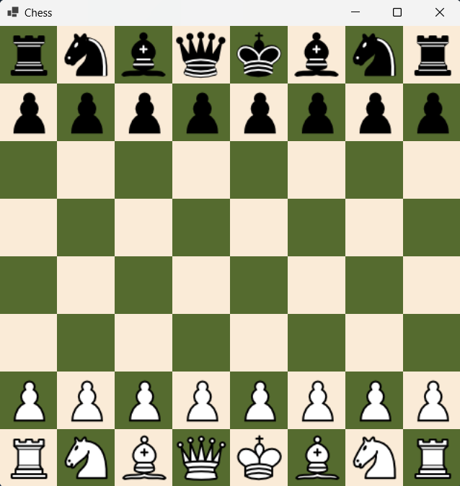 | The board was setup correctly | PASS
T2.1 | Step 2,3 &4 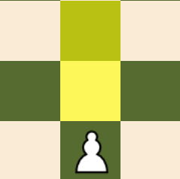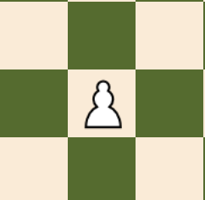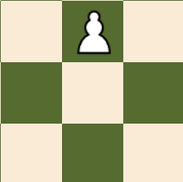  Step 5 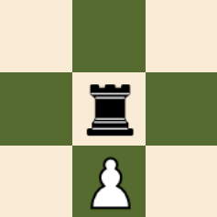  Step 7 & 9 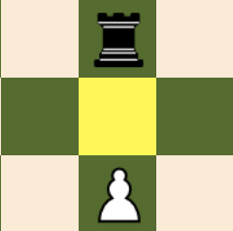 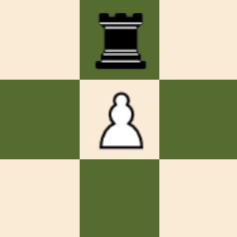 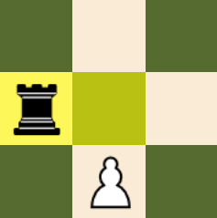 | Step 5 – When clicked upon, no squares were highlighted (as expected) and the pawn could not move. If other squares were clicked, the pawn would not move to them.  Step 2 & 3 – When clicked the following squares were highlighted, and when clicked on the pawn could move to these squares. When other squares were clicked nothing happened.  Step 7 & 9 – When first clicking on the pawn, it has the option to move one square forwards, but not two as the rook is blocking it. After making the moves, and then clicking on the pawn once again, the option to double move is no longer available (since the pawn has already moved). When non-highlighted squares were clicked, the selected piece did not move to them. | Step 2 – PASS  Step 3 – PASS  Step 5 – PASS  Step 7 – PASS  Step 9 – PASS
T2.2 | Step 2,3 & 4  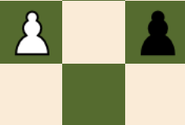 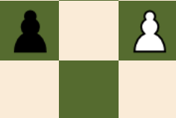  Step 6 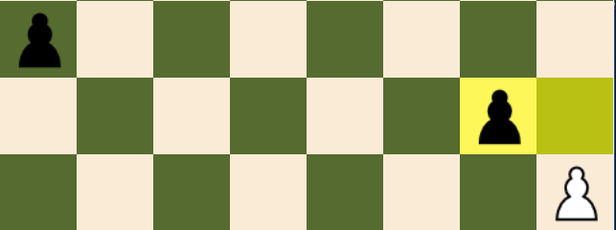  Step 8 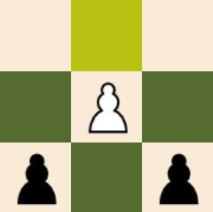 | Step 2, 3 & 4 – When the pawn was clicked on, the following squares were highlighted. When the squares highlighted, with the black pawns were clicked on, the pawn moved to these squares, and the black pawns were removed from the board. When non-highlighted squares were clicked, the pawn did not move to them.  Step 6 – When the white pawn was clicked, the shown squares were highlighted, and not the pawn that would cause a wrap-around error. When the non-highlighted pawn was clicked, the pawn did not move to it. When the highlighted pawn was clicked, the white pawn captured it.  Step 8 – When the white pawn was clicked, the only square highlighted was the forward move. After this, when trying to click on the black pawns, the white pawn would not capture them. | (Setup 1)  4.2 – PASS  4.3.3 – PASS  (Setup 2)  4.2 – PASS  4.3.3 – PASS  (Setup 3)  4.2 – PASS  4.3.3 – PASS
T3 | Step 2 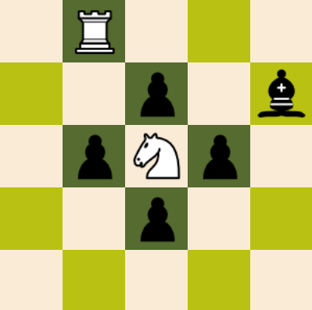 Step 3 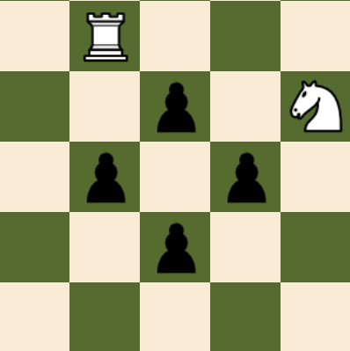  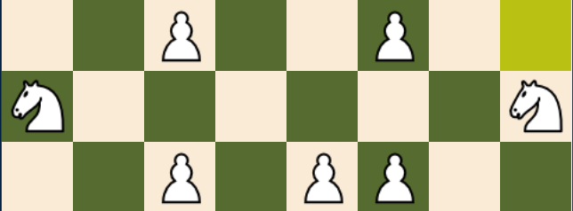  Step 5 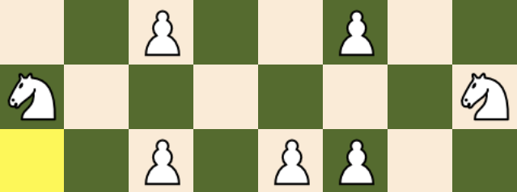 | Step 2 – When the white knight was clicked upon, the correct moves were highlighted, showing that the knight can move in an ‘L’ shape in a range of three squares and can jump over other pieces. The white rook square was not highlighted, but the black bishop was, showing that the knight can capture opponent pieces but not friendly ones. Furthermore, the Knight was not able to capture adjacent black pawns.  Step 3 – The knight can take the bishop.  Step 5 – When the knights on the top and bottom ranks (not shown in the screenshots) were clicked, no squares were highlighted indicating that there were no valid moves. However, when the knights on the far left and right files were clicked, squares at the edges of the board were highlighted, indicating that there is a wrap-around error. | Step 2 – PASS  Step 3 – PASS  Step 5 – FAIL
T3 Repeat 1 | Step 2 & 3 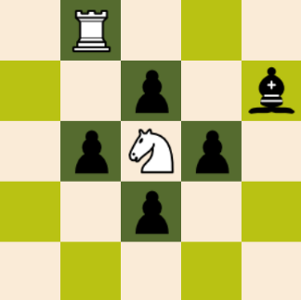 Step 5 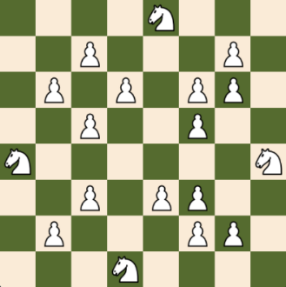 | Step 2 - When the knight is clicked, the correct possible moves are highlighted, showing that the Knight can move in an ‘L’ shape with a range of three squares.  Step 3 – The knight can take the bishop  Step 5 - When each of the Knights were clicked, no squares were highlighted, showing that the wrap-around error has been fixed, and is no longer present. | Step 2 – PASS  Step 3 - PASS  Step 5 - PASS
T4 | Step 2 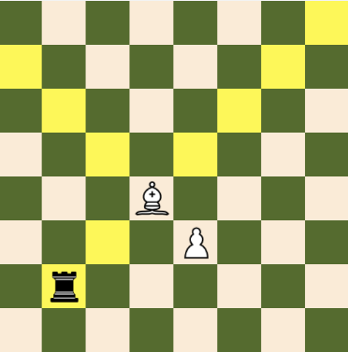  Step 3 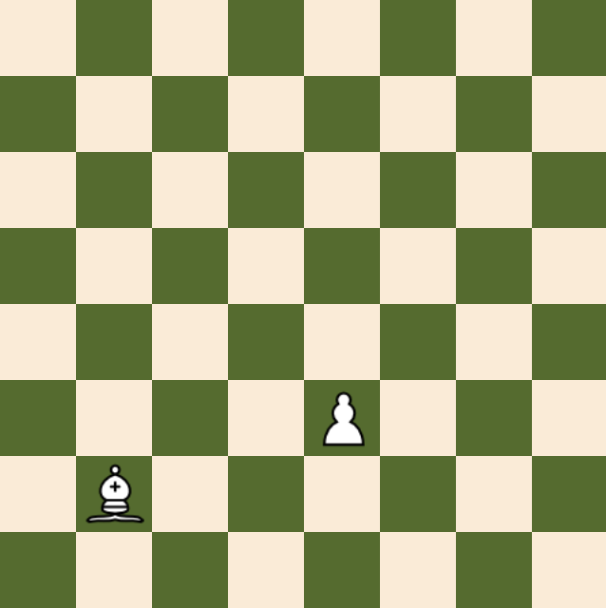  Step 5 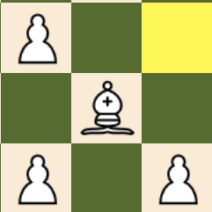 | Step 2 - When the bishop is clicked the correct possible moves are highlighted. The bishop was able to move diagonally forward to the edges of the board. The bishop was able to capture the black rook and move up to it’s square but not further, and the bishop was not able to move backwards diagonally right at all, because the white pawn is next to it, and blocks its path.  Step 3 – The bishop can take the rook  Step 5 - When the white bishop was clicked, it could only make one move, which is to move one square diagonally forward to the edge of the board, indicating that there is not a wrap-around error. | Step 2 – PASS  Step 3 - PASS  Step 5 - PASS
T5 | Step 2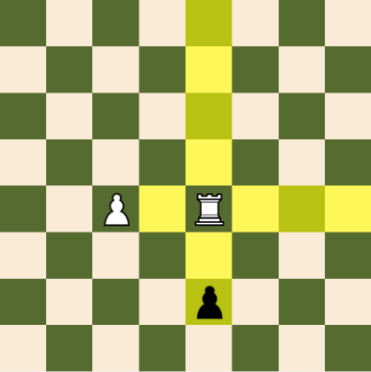  Step 3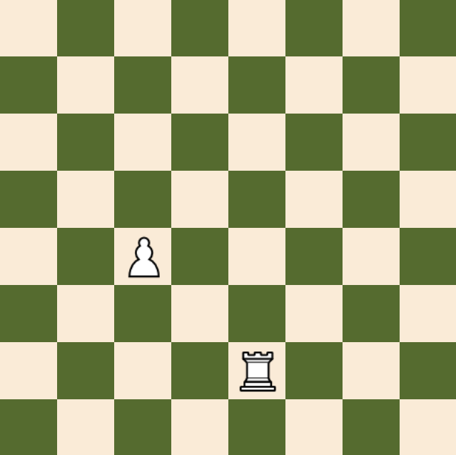 | Step 2 - When the rook was clicked, as you can see, its orthogonal movement is working completely fine, it can travel to the edges of the board, unless blocked by another piece, and no further, meaning there is not a wrap-around error. Furthermore, the rook can capture the black pawn but not the white pawn.  Step 3 – The rook captured the pawn. | Step 2 – PASS  Step 3 - PASS
T6 | Step 2 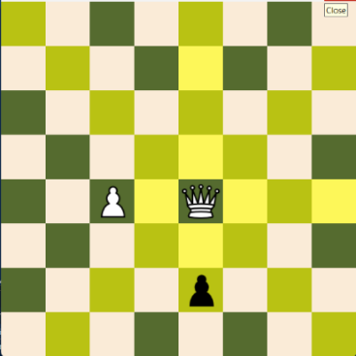  Step 3 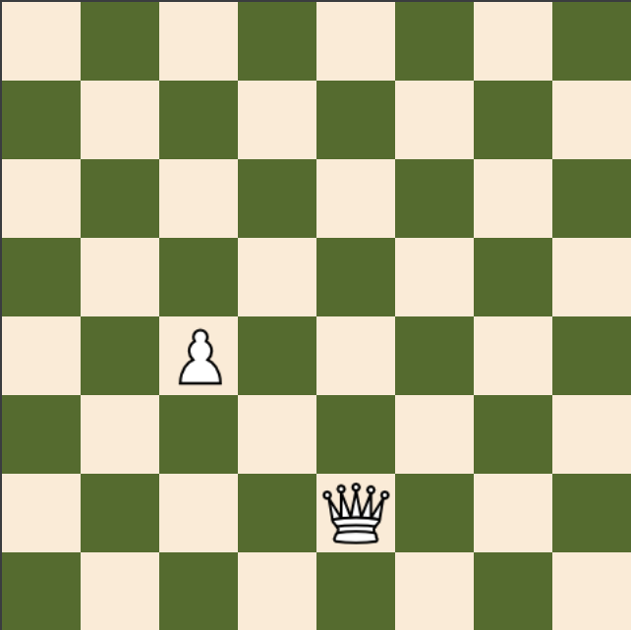 | Step 2 - When the queen is clicked the correct squares are highlighted, showing that the queen can move in any diagonal or orthogonal line, all the way to the edge of the board, unless blocked by another piece. It also shows that the queen can capture opponent piece but not friendly pieces.  Step 3 – The queen captured the pawn | Step 2 – PASS  Step 3 - PASS
T7 | Step 2 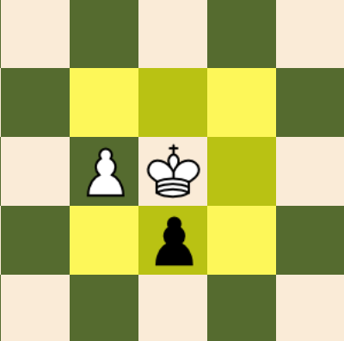  Step 3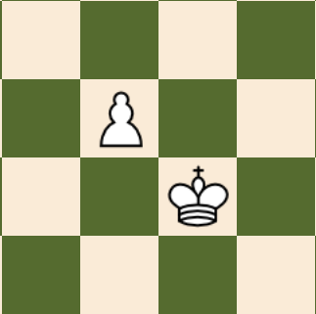  Step 5 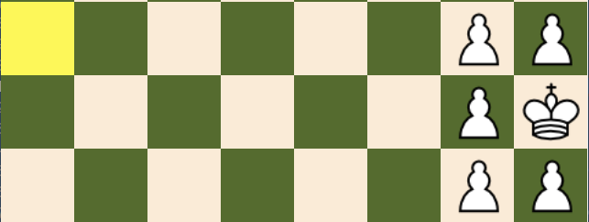 | Step 2 - When the king was clicked the correct squares were highlighted, showing that the King piece can move to any of it’s surrounding squares, provided it is not occupied by a friendly piece.  Step 3 – The king captured the pawn  Step 5 - When the King was clicked, this square was highlighted, indicating that there was a wrap-around error in the King’s movement that needed to be fixed. | Step 2 – PASS  Step 3 - PASS  Step 5 - FAIL
T7 Repeat 1 | Step 2  Step 3  Step 5 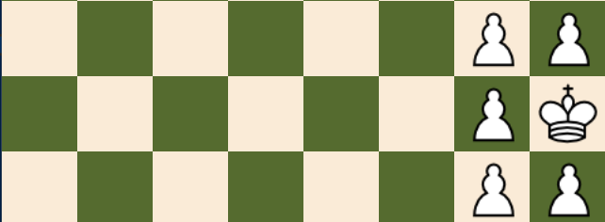 | Step 2 - When retested, the King’s regular movement pattern still worked as intended.  Step 3 – The king captured the pawn  Step 5 - When the King was clicked once again, no squares were highlighted indicating that the wrap-around error has been fixed. | Step 2 – PASS  Step 3 - PASS  Step 5 - PASS
T8 | 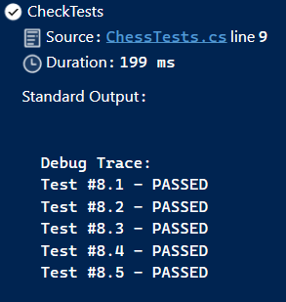 | The test was automated and when the test function was run, it looped through all the test setups, ran the check detection function, and compared the list of checks generated to the expected result, and failed the test if they were not equal. This message provided by visual studio shows that all the setups passed their test. | 8.1 – PASS  8.2 – PASS  8.3 – PASS  8.4 – PASS  8.5 – PASS
T9 | 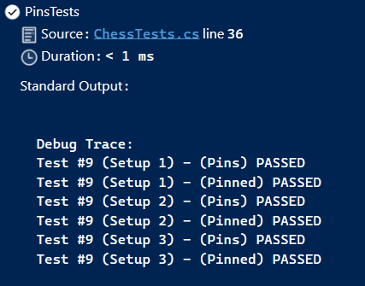 | This test was automated and when the unit test was run, all setups passed for both the pins and pinned pieces, showing that the computer can detect pinned and pinning pieces correctly. | Step 2  (Setup 1)  PASS  Step 4  (Setup 2)  PASS  Step 6  (Setup 3)  PASS
T10.1 | 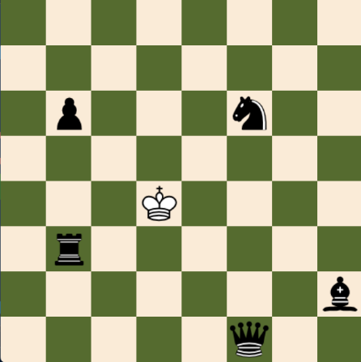 | When the white king was clicked no square was highlighted, this shows that the king piece cannot make any moves that will land itself in check. It also ensures, that this works for every different type of pieces, since all the squares are covered by a different piece type. | Step 2 - PASS
T10.2 | Step 2 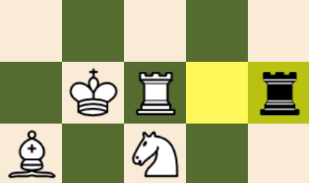 Step 3 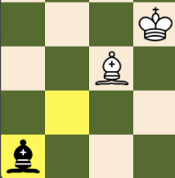  Step 4 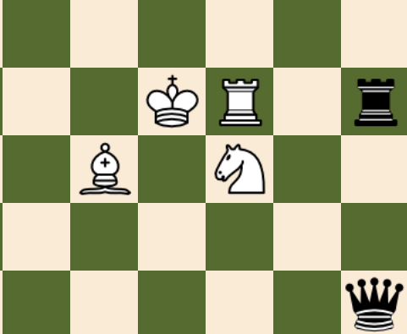 | When the white rook was clicked, it was only permitted to move one square to the right, or to capture the pinning black rook. When the white knight was clicked, there were no legal moves since it was pinned to the king, and no moves that could capture or block it. When the white bishop was clicked it could move one square diagonally to the left (backwards) or it could capture the pinning black bishop. | Step 2 – PASS  Step 3 – PASS  Step 4 - PASS
T11 | Step 2 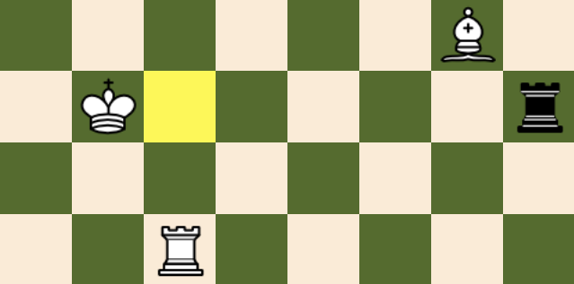  Step 3 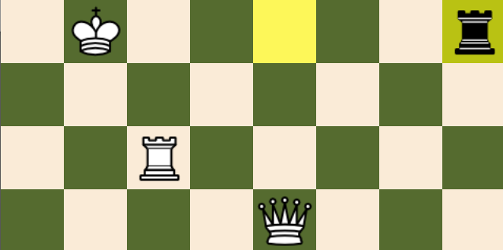  Step 4 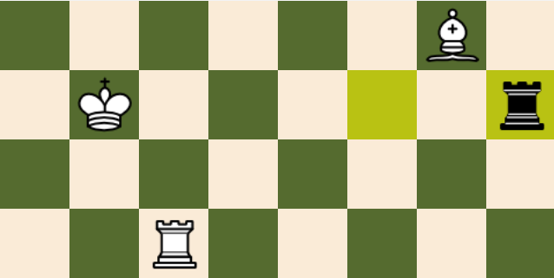  Step 5 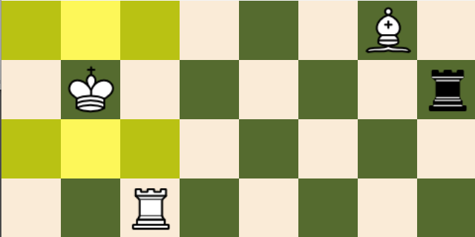  Step 7 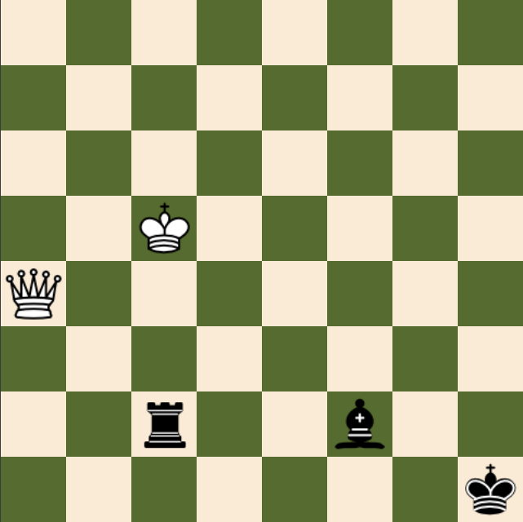  Step 8 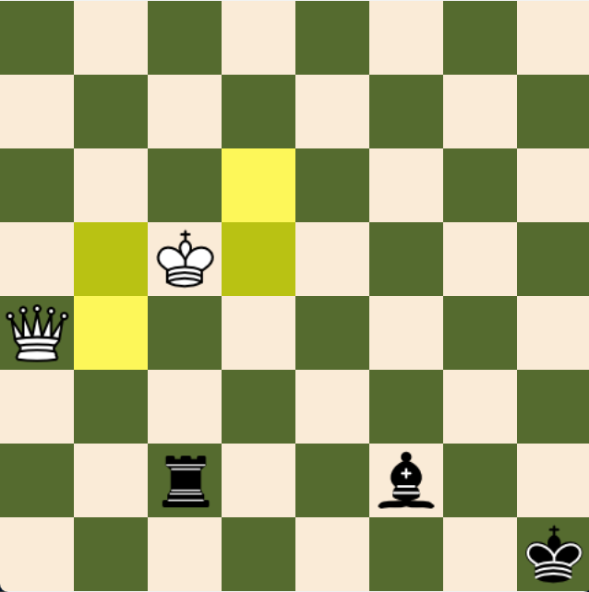 | Step 2 to 5 - When the white king was clicked it could move to any of the adjacent squares in the adjacent ranks, where it is not attacked by the black rook. When the white queen was clicked it could either block the rook’s attack or capture the black rook. When the white rook was clicked, it could block the attack of the black rook. When the white bishop was clicked it could block the attack or capture the rook.  Step 7 - When the white king was clicked it could move to any squares that were not attacked by an opponent piece. When the white queen was clicked it could not make any moves, since the king is attacked by two pieces, so no move it makes will resolve both checks. | Step 2 – PASS  Step 3 – PASS  Step 4 – PASS  Step 5 – PASS  Step 7 – PASS  Step 8 - PASS
T12 | 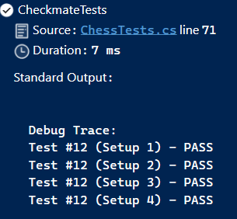 | A unit test was written, see screen shot below, to execute the test, which passed for all the steps  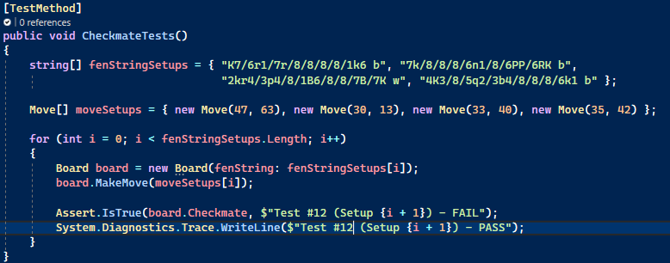 | Setup 1  Step 2 – PASS  Setup 2  Step 4 – PASS  Setup 3  Step 6 – PASS  Setup 4  Step 8 – PASS
T13 | 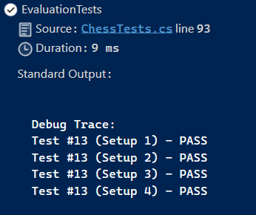 | A unit test was written, see screen shot below, to execute the test, which passed for all the steps  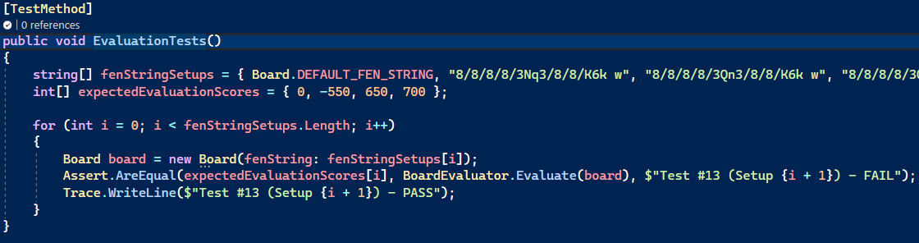 | Setup 1  Step 2 – PASS  Setup 2  Step 4 – PASS  Setup 3  Step 6 – PASS  Setup 4  Step 8 – PASS
T14.1 | 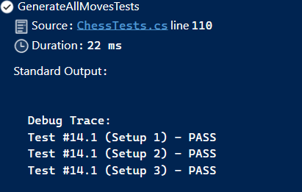 | A unit test was written, see screen shot below, to execute the test, which passed for all the steps  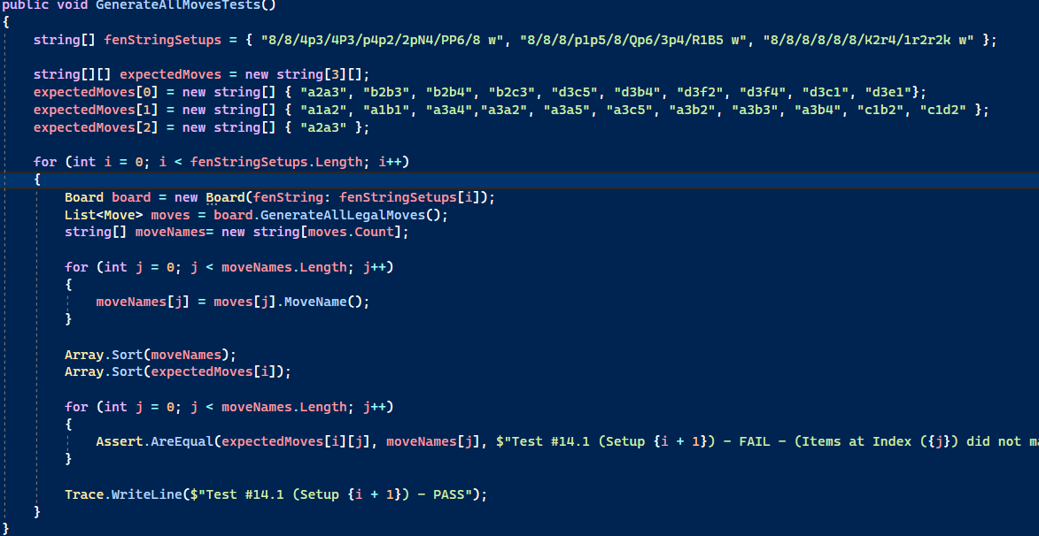 | Setup 1  Step 2 – PASS  Setup 2  Step 4 – PASS  Setup 3  Step 6 – PASS
T14.2 | 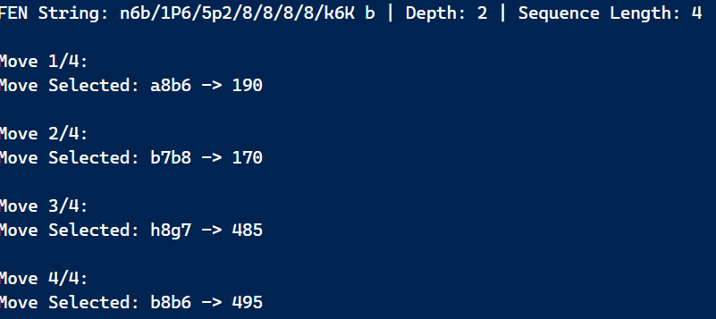 | When the test was performed on setup 1 the following moves were made, as expected. | Move 1/4  Step 2 – PASS  Move 2/4  Step 4 – PASS  Move 3/4  Step 6 – PASS  Move 4/4  Step 8 – PASS
T15 | 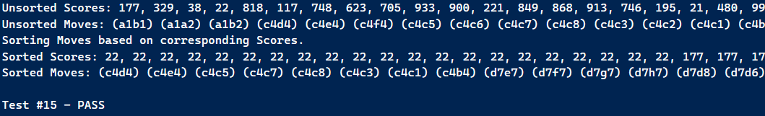 |  | Step 5 – PASS
T16.1 | Step 2   Step 3   Step 4   Step 5  | When both the white and black kings were selected, the option to castle Kingside and Queenside appeared for both pieces. As can be seen, the kingside castle for white was successful, moving both the king and rook to their correct positions. When the queenside castle for black was performed, it was also successful, leading the king and rook to the correct positions. | Step 2 – PASS  Step 3 – PASS  Step 4 – PASS  Step 5 – PASS
T16.2 | Step 3 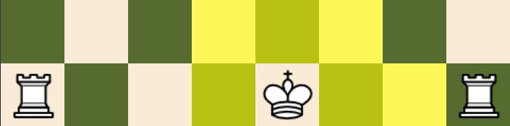  Step 6 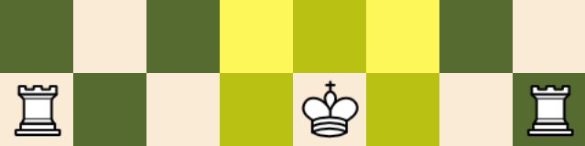  Step 9 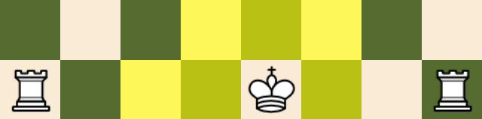 | When the queenside rook was moved and then returned to its original position, the king lost the ability to queenside castle.  When the king piece was moved and returned to it’s original position it lost the rights to castle either side (as expected).  When the kingside rook was moved, and then returned to it’s original position, the king lost the ability to kingside castle. | Step 3 – PASS  Step 6 – PASS  Step 9 – PASS
T16.3 | Step 2 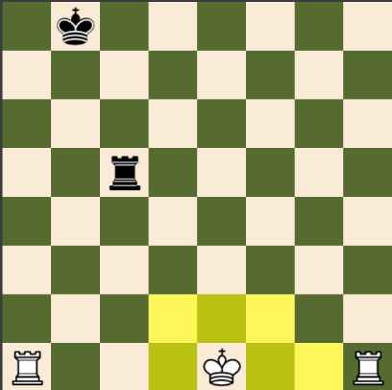  Step 4 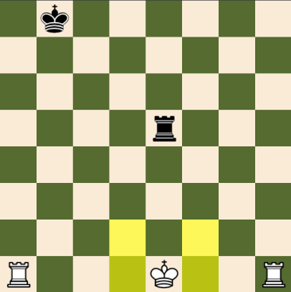 | When not in check the white king could kingside castle but when in check this option was not available | Step 2 – PASS  Step 4 – PASS
T17 | 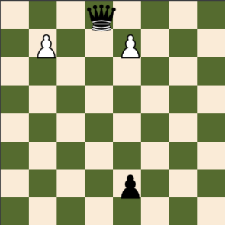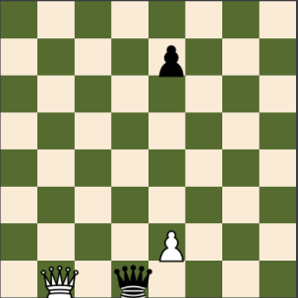  Steps 1 & 2  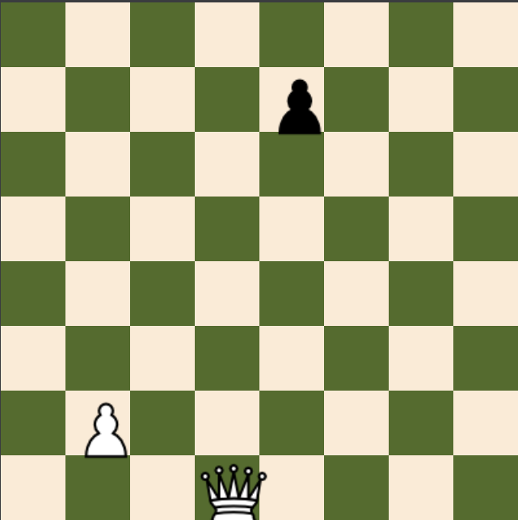  Steps 3 & 4  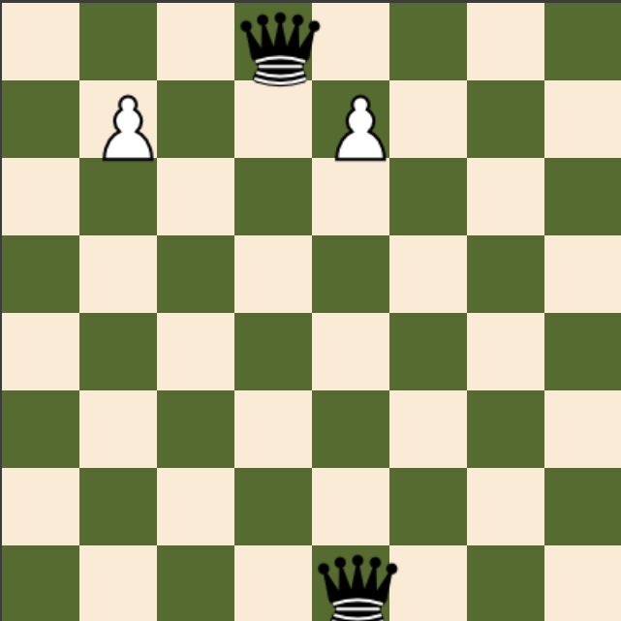  Steps 5 & 6 | Steps 2 & 4: It should be noted that after white make’s its move that the board’s orientation is flipped, hence why the two queens are at the bottom of the board as opposed to the top. | Step 2 – PASS  Step 4 – PASS  Step 6 - PASS
T18 | 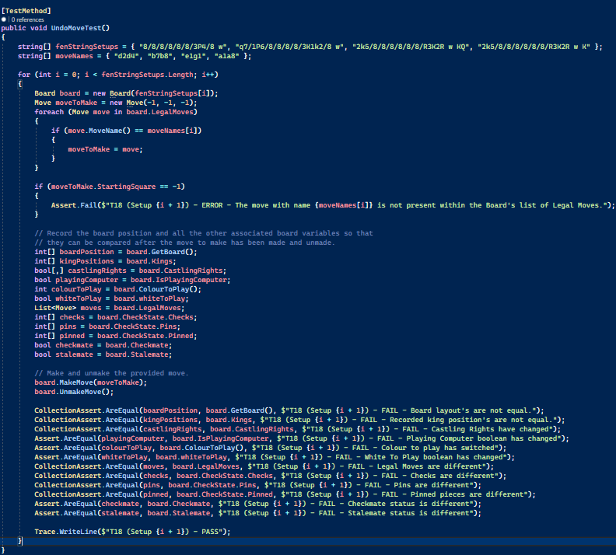  Unit Test Code  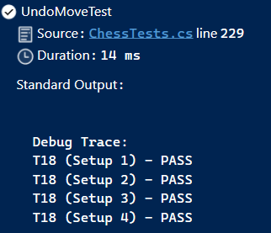  Unit Test Results | The unit test code is rather simple. Two arrays are created, one containing the fen string setup, another containing the name’s of the moves to be made within each setup.  For each setup, a new board using the correct fen string is made, the legal moves on this board position are iterated over until a move with the corresponding name is found, and this is then assigned to a move variable. This is done to ensure the move has the all the correct data (captured piece, flags etc). If this move is not found, an error message is displayed.  After this, all the board’s variables are copied and stored within new variable. The provided move is then made by calling the MakeMove function and unmade by calling the UnmakeMove function. All the recorded variables are then compared to the current corresponding variable of the board object, and if they are not equal a relevant error message is displayed.  If all variables are equal, then the test is a success. | (Setup 1)  Step 4 – PASS  (Setup 2)  Step 8 – PASS  (Setup 3)  Step 12 – PASS  (Setup 4)  Step 16 – PASS
T19 | See Test Video Ref 6 |  | Step 2 – PASS  Step 3 – PASS
T20.1 | See Test Video Ref 7 | Note: The Chess Bot move selection appears slower than it is in reality on the video as the computer was also recording the video at the same time and this caused a level of buffering which slowed down the game. | Step 6 – PASS  Step 7 – PASS  Step 8 – PASS
T20.2 | See Test Video Ref 8 | Note: The Chess Bot move selection appears slower than it is in reality on the video as the computer was also recording the video at the same time and this caused a level of buffering which slowed down the game. | Step 12 – PASS
T20.3 | See Test Video Ref 9 |  | Step 4 – PASS  Step 5 – PASS  Step 6 – PASS  Step 7 – PASS  Step 8 – PASS
T21 | See Test Video Ref 10 |  | Step 3 – PASS  Step 4 – PASS  Step 5 – PASS  Step 6 – PASS
T22.1 | See Test Video Ref 11 |  | Step 6 – PASS  Step 7 – PASS
T22.2 | See Test Video Ref 12 | Note: The Chess Bot move selection appears slower than it is in reality on the video as the computer was also recording the video at the same time and this caused a level of buffering which slowed down the game. | Step 6 – PASS  Step 7 – PASS  Step 8 – PASS

Evaluation

Reflections & Achievements

Achievement of Objectives
All objectives were achieved. The Chess Game developed is easy to use and allows a user to either play against a friend or against the computer. When playing against the computer it is possible to select a difficulty setting which ensures a beginner doesn’t become demoralised by losing to the compute every time, but also challenges an intermediate player preventing boredom. Playing against the computer is engaging and realistic with the Chess Bot choosing its moves within a matter of seconds ensuring the player doesn’t lose interest. Additionally, to help the player to develop their skills, there is the option to get Move Hints, which shows the player the best possible move to make for the current board configuration. This will help a beginner to think about the best move themselves and then look to see if there was a better option available.

Achievement of Requirements
Req. No | Status
R1 | These requirements cover the Main Menu. All requirements were achieved, and the menu structure is well designed and easy to navigate.
R2 | These requirements cover the Game Selection Menu. All mandatory requirements were achieved. The optional requirement to include Time play was not implemented.
R3 | These requirements cover the Game Display. All mandatory requirements were achieved. One optional requirement was implemented to provide Hints for the user helping to satisfy one of the primary user needs which was to help a player to develop.
R4 | These requirements cover the Game Mechanics. All mandatory requirements were achieved. The game play functions easily and effectively allowing more advanced moves such as castling and pawn promotion.
R5 | These requirements cover the Chess Bot. All requirements were achieved. The Chess Bot quickly (within a matter of seconds) chooses a move which reflects the difficulty setting chosen. This is achieved in a similar fashion to a human player in that for lower levels of difficulty the Chess Bot only looks 1 or 2 moves ahead whereas for higher difficulty settings the Chess Bot looks 5 or 6 moves ahead.

Learning
This project has been a great learning experience and has taught me a lot about the structure of a program, and how different aspects interact with each other. Throughout the course of the project, I have had to learn how to be efficient with my code repetition and data storage, as these are factors that greatly affect the performance of a chess bot. I learnt that the use of data structures to store important game-related information greatly reduces the number of times that particular subroutines need to be called.
On top of this, I feel that this project has greatly improved my understanding of how to use recursive functions in a program, not only to be time efficient, but to also carry out particular tasks that would be nearly impossible without the use of recursion.
Finally, I feel as though my debugging skills have also greatly improved over the course of the project, as I learnt to make use of automated unit tests, and as I learnt how to properly write test cases, so that all aspects of a function are tested.
If I were to start my project from the very beginning, there are a few things I would do differently the second time round. Firstly, I would make sure to plan every aspect of my program’s structure as this greatly reduces time wasted, trying to establish how different objects should interact with each other (a problem that I faced at the beginning of my project). Secondly, I would alter some classes within my project to use a more object-oriented approach to greater encapsulate data about the board, and also to make the code more readable and compact. Finally, the last change I would make would be to use version control more effectively when implementing new changes, which would save time and reduce errors, when reverting a piece of code to it’s original state, if a new change did not work as intended.

Feedback
I spoke to Tom after completing the project and showed him the Chess Game. Tom played a number of games against the Chess Bot and commented
“The game is great. Its really easy to use and playing against the computer will let me practice by myself. I thought it was going to be too easy to beat the computer at first, but when I increased the difficulty setting it was actually quite difficult at times and the hint was really helpful as when I was struggling to choose a move I was able to see what a good move might be. I think this will really help me to improve my Chess game. Thanks”

Future Improvements
Whilst the overall result of the project was a great success, with all the objectives being met, and all mandatory requirements being achieved, there are areas within the project that could be improved that would lead to an even better end result.
The biggest area that could be improved in the program would be the evaluation function used when determining the best move on the board for the chess bot. The first alteration that could be made is changing the material evaluation to be updated incrementally throughout the game history rather than from scratch whenever the evaluation function is called. This alteration would also require the Board Evaluator class to be changed to an object (an instance of which would be stored in the board class) instead of being used as a static class, as it is now.
On top of this, a big alteration to the program, that would lead to great improvements would be to create a data structure to store the tree-like structure of board positions (and their states) generated as all the possible moves on the board are explored. This alteration would mean, whenever the computer attempts to make a move on the board, it would only have to search one move deeper than it already has (and re-evaluate) since the data of all the other positions has already been explored.
Another way to improve the evaluation function in the program, would be to evaluate more factors of the current board position. There are many factors that be considered when evaluating a chess position (e.g. doubled pawns, control of open files, passed pawns etc.) each of which affect the value of a position for a particular colour and piece. A lot of these factors would be relatively easy to implement but would help to improve move selection, improving the capability of the Chess Bot. An example of an easy to implement addition, would be the use of two different Piece-Square tables for every piece type, one for the opening of the game, and the other for the end game, with these two board being interpolated as the game progresses. These additions would lead to a greater variance in evaluation scores, which in turn would cause the alpha-beta pruning to prune more branches, and thus the move selection algorithm would become faster/more efficient.
The main benefit of these alterations would be to greatly increase the speed and effectiveness of the move selection algorithm, since less searching would be carried out due to the move tree data structure and improved evaluation scores. Additionally, less evaluation would be carried out due to incremental updates of the board material. By having faster move searching, it would increase the speed of Hint generation and it would be possible to search to a greater depth (i.e. look ahead more moves) within the same time frame, allowing additional difficulty settings for advanced players.

